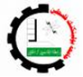
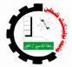Microbiology lab (4418)
Outline for winter Term, 2015
Applied Biology Program,
College of applied sciences,
Palestine Polytechnic University
___________

Contact Information:
Instructor: Arwa Mujahed, MSc.
Office: B+412 Office Hours: Monday, Wednesday (9-12)
Email: arwam@ppu.edu one Credit hour (3 hours/week)
Facebook group: Microbiology lab-PPU https://www.facebook.com/groups/960983917256150/

Course Summary and description:

A microbiology laboratory is valuable because it actually gives you the chance to see and study microorganisms firsthand. The laboratory exercises that follow are selected from “Microbiology Experiments: A Health Science Perspective”, 4/e by Kleyn-Becknell. These exercises will introduce you to the practical field of microbial basics with most of the emphasis upon bacteriology.

The first aim of this course is to guide you to develop ‘hands-on’ practical skills in microbiology work, and the second aim is to develop an ‘applied’ scientific mentality.

These ambitious aims will mean two things for you, the student: first, each and every student should gain extensive experience of handling microbes in a safe and effective manner; second, what you do and achieve will depend upon your own input and this will include each group of students discussing and choosing their own project for implementation during the course built upon the ‘Community based learning (CBL)’ philosophy, that is an academic type of experiential learning which combines community service with explicit academic learning objectives, preparation for community work and deliberate reflection. So, while the communities provide the work site as an extension of the class room, the students help the organizations diagnose and solve their problems through project proposed based on both side’s interests. To match that the 3 sections students will be break into 6 work teams; here after, Academic Partner, directly connected to a Community Partner CP and managed by a student from as a Project Manager.
One of the unique things about microbiology is that you will be working with living organisms that require additional attention outside of the assigned laboratory schedule. So you can be fully prepared to cooperate amongst yourselves and with the laboratory supervisor to find mutually acceptable times for your laboratory visits.

Finally, good science is safe science, and you are able to pay attention to all the safety information and instructions that are given to you, and enjoy the course!
Course Objectives:
• To develop student’s basic skills required for working with bacteria in the lab, such as culturing methods, sterile procedures, cell counting, microscopy and microbe detection.
• To give students hands-on experience with a number of classical and new, cutting edge microbiological techniques, for example: Plate screening, PCR typing, immune-detection e.g. fluorescent in situ hybridization, and ELIZA testing.
CBL activity objectives:
- Asses own perceptions and evolving attitudes
- Articulate learning outcomes and connect to experience
- Draw generalizations on significance of experience
- Demonstrate critical thinking and meta-cognitive analysis

Course (CBL) outcomes:
- Personal outcomes.
- Social outcomes.
- Learning outcomes “Intended Learning Outcomes, ILOs”:
Upon completion of the course, the student demonstrates the ability to:
- Identify and use lab equipment used in microbial culture and detection.
- Culture microbes under sterile environment.
- Distinguish between gram-positive and gram-negative bacteria using appropriate biochemical and molecular tests.
- Qualitate and quantitate the presence of microorganisms in food and environment.
- Work safely in the lab and be able to use microbiology lab equipment.
- Analyze scientific papers and article.
- Acquire the following skills:
- Critical inquiry, analysis and reasoning
- Quantitative reasoning
- Gathering and evaluating multiple sources of evidence
- Seeking, engaging, and being informed by multiple perspectives
- Written, oral and multiple media communication
- Collaborative decision-making
- Communication skills
- Career development

Values (Acquired from this course):
- Empathy
- Open mindedness
- Tolerance
- Bioethical integrity
- Responsibility to a larger good
- Collaboration and team work spirit
- Respect
COURSE SCHEDULE
Week No. | Exercise |  | Project
1 | Introduction and microscopy |  | Introduction (Course + CBL)
2 | Multiple and differential stains |  | Searching community problems
3 | Microbial growth and culturing |  | Searching community problems
4 | Quantification of microorganisms |  | Searching community partner(CP)
5 | Aerobic and anaerobic growth |  | Searching CP
6 | The effect of incubation temperature on generation time |  | Community partner determination+ Visits to coordinate with CP
7 | Moist and dry heat sterilization:  Thermal death point and thermal death time |  | Project title discussion
8 | Antiseptics and antibiotics |  | Project title determination  + Guest speaker: MSc. Khawla Al-Mohtaseb- introducing experimental design and biostatistics.
9 | Sample collection
10 | Sample analysis
11 | Sample analysis and testing | Guest speaker MSc. Khawla Al-Mohtaseb- introducing data statistical analysis.
12 | Interpretation of the results
13 | Group Project Presentations | Projects Presentations by the work groups.
 | End of the course workshop | Attended by CP.

Modes of Teaching and Learning
Given the goals and outcomes described above, the primary formats, modes, and methods for
teaching and learning that may be used in the course are:
a. project implementation and reflection (as CBL), which is attained by the following steps:
- Introduction about CBL
- Searching community problems
- Searching community partner (CP)
- Community partner determination+ Visits to coordinate with CP
- Project title discussion and determination
- Guest speaker: introducing experimental design and biostatistics.
- Sample collection
- Sample analysis
- Sample analysis and testing
- Interpretation of the results
- Group Project Presentations and reflection discussion
- End of the course (project) workshop
b. small-group work in the lab
c. student oral presentations
d. independent study

Grade determination and assessment instruments
The following will be used to determine the final grade:
No. | Criteria | Grade
1. | Semester exams and quizzes | 20%
2. | Student presentation of research ”project” findings (midpoint at week no.7 and final presentation at week no.14) | 15% (5% + 10%)
3. | Project and reflection evaluation | 30%
4. | Community partner evaluation | 5%
5. | Laboratory notebooks & reports | 20%
6. | Analysis of reading assignments | 5%
7. | Performance of laboratory techniques | 5%
 | Total | 100%
Note: Evaluation criteria of presentations and project (Rubrics) will be provided at the beginning of the work.

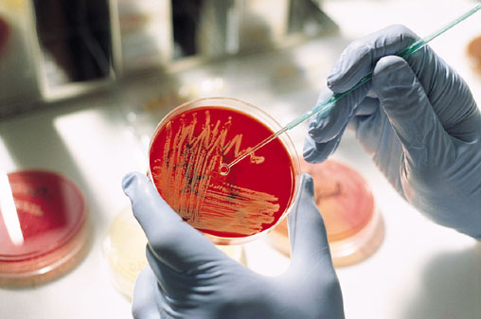

Good luck

