Skills for Life! Pursuing your Dreams with Confidence & Determination
(“Life Skills Orientation”)

TEACHING NOTES to Accompany Major Curriculum Activities

Symbols Used Throughout PPT Slides

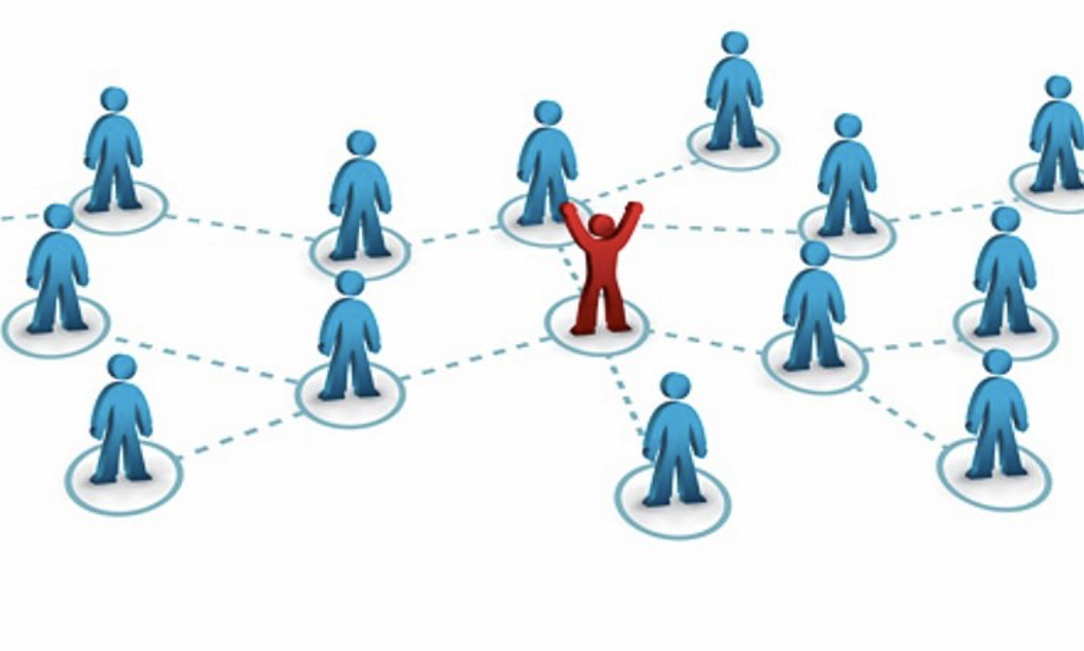
Class Discussion Workbook Activity Individual Thought/ Team Work Homework
Team Discussion

The font in lighter blue relates to the Teaching Notes. These will not be included in the Student Workbook.

The font in darker blue relates to the activities that students will see in the Student Workbook.

Table of Contents

Daily Timing of Activities 5
Module: Transition from High School to the University 7
Activity: Introductions 8
Video: The Milk Bum 9
Activity: Difference between High School and University 10
Homework: Beyond the Books 11
Homework: Lessons Learned - Difference between High School and the University 12
Module: Collaboration - Working in High-performing Teams 13
Activity: Considering Previous Team Membership 14
Activity: Stranded on a Desert Island 15
Activity: Abilene Paradox – The Management of Agreement 17
Activity: Planning for IT Team Assignment Part I 19
Activity: The Case of the Missing Team Member 20
Activity: Planning for IT Team Assignment Part II 22
Homework: Lessons Learned - Working in High-performing Teams 25
Module: Developing Effective Presentation Skills 26
Activity: Assessing Body Language 27
Homework: How Can I Help? 30
Homework: Lessons Learned - Developing Effective Presentations 30
Team Presentations - Time Management and Organizational Skills 31
Module: Meeting Life’s Challenges with Confidence and Determination 33
Activity: “Know thyself” Values, Social Identity & Vision 34
Values Exercise 34
Social Identity 37
Self-reflection- Your personal vision 38
Homework: How to Increase your Self-Confidence 40
Video: An Exercise in Empathy 41
Activity: When your Emotions Worked Against You 42
Activity: How Emotionally Intelligent Are You? 43
Activity: Relational Civility “Mirror” Measurement 49
Activity: Are you Trustworthy? 57
Homework: At the End of the Day… 58
Homework: Lessons Learned - Meeting Life’s Challenges with Confidence and Determination 59
Module: Effective Interpersonal Communication 60
Activity: Let’s Draw 61
Activity: Contradicting Messages 63
Activity: The Train Left the Station 64
Activity: Choosing your Words Carefully - Late for the Movies, Again… 65
Activity: Listening Bad Habits 67
Activity: Interpersonal Communication Skills Inventory 69
Activity: Interpersonal Communication Skills - Developing an Improvement Plan 75
Homework: Improving your Communication by Observing Others 76
Homework: Lessons Learned - Effective Interpersonal Communication 76
Individual Student “TED” Talks 77

Daily Timing of Activities

Week #1

Session #1 Transition from High School to the University Part 1 (3 hrs)

- Student Introductions 75 minutes
- Review Syllabus and Workbook 15 minutes
- PPT slides 20 minutes
- Milk Bum 15 minutes
Activity: Differences btw HS & University 35 minutes

Session #2 Transition from High School to the University Part 2 (1 hr)
PPU Student Panel
Collaboration: Working in High Performing Teams Part 1 (2 hrs)

- PPU Student Panel 50 minutes
- Debrief 15 minutes
- PPT Slides 25 minutes
- Activity: Consider a Team you 25 minutes
Were a Member of
- Activity: Desert Island 45 minutes

Session #3 Collaboration: Working in High Performing Teams Part 2 (3 hrs)

- Debrief 15 minutes
- PPT Slides 20 minutes
- Activity: Abilene Paradox 10 minutes
- Activity: IT Assignment Part 1 30 minutes
- Activity: Case of the Missing 25 minutes
Team Member
- Activity: IT Assignment Part 2 25 minutes
- Premortem: What Went Wrong? 15 minutes
- Assemble Student Teams 20 minutes

Session #4 Developing Effective Presentation Skills (1.5 hrs)
Meeting Life’s Challenges Confidence & Determination Part 1 (1.5hrs)

- Debrief 15 minutes
- PPT Slides - Presentation Skills 30 minutes
- TED Videos Non-Verbals 42 minutes
- PPT Slides - Life’s Challenges 8 minutes
(through Values, Social Identity & Vision)
- Activity: Values, Social Identity & Vision 70 minutes
Session #5 Meeting Life’s Challenges with Confidence and Determination Part 2 (3 hours)

- PPT Slides - Life’s Challenges 30 minutes
(after Values, Social Identity & Vision)
- Video: An Exercise in Empathy 12 minutes
- Activity: When your Emotions 25 minutes
Worked Against You
- Activity: How Emotionally 30 minutes
Intelligent Are You?
- Activity: Relational Civility Mirror 15 minutes
- Activity: Are you Trustworthy? 5 minutes
- Time for Student Team Meetings 40 minutes
(Final preparation for presentations)

Week #2

Session #6 Team Presentations - Time Management & Organizational Skills (3 hrs)

Session #7 Interpersonal Communication for Positive Relationships Part 1 (3hrs)

- PPT Slides 45 minutes
- Debrief 25 minutes
- Activity: Let’s Draw 30 minutes
- Activity: Contradicting Messages 3 minutes
- Activity: The Train Left the Station 5 minutes
- Mini-Case: Choosing your Words 20 minutes
Carefully
- Activity: Listening Bad Habits 10 minutes
- Video: Good Listening 8 minutes

Session #8 Interpersonal Communication Skills for Positive Relationships Part 2 (3hrs)

- Debrief 15 minutes
- Activity: Interpersonal 50 minutes
Comm. Skills Inventory
- Activity: Improving Comm. Skills 25 minutes
- Moving Forward 60 minutes

Session #9 Student “TED” Talks (3hrs)

Session #10 Student “TED” Talks (3hrs)
Saying Goodbye

Module: Transition from High School to the University

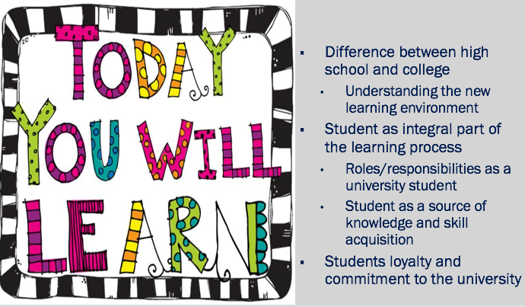

Activity: Introductions

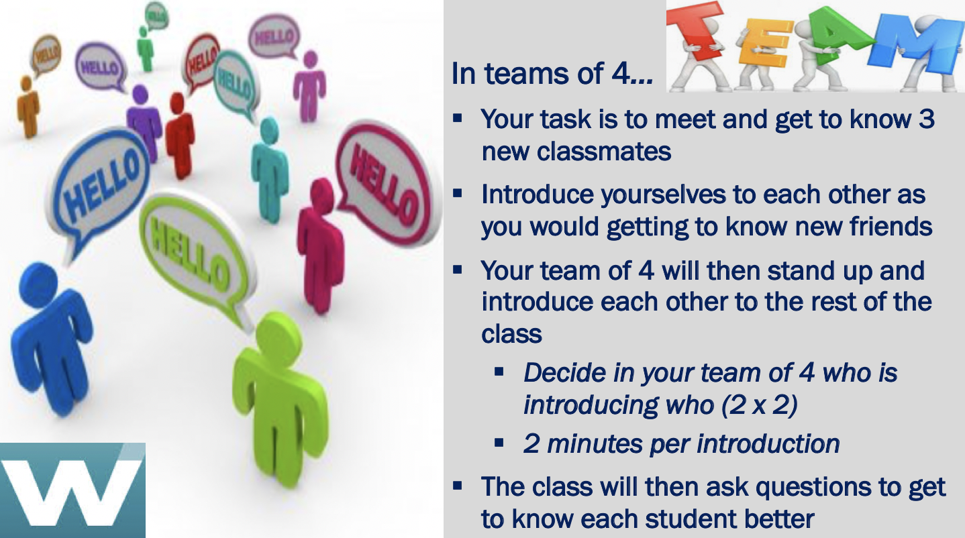

Have students partner in groups of 4 (one group of three if there is an odd number of students) and introduce each other as if they were meeting potential friends for the first time. They in turn are going to introduce their “new friend” to the rest of the class.

Desired Learning
The university is a learning community. Students learn a great deal from each other, and must support each other. In order to do so, they must make a point to get to know others, reach out to others, help others… sometimes this means moving out of their comfort zone. Sometimes it means befriending someone who is not like themselves, or befriending someone who may need a friend. Having students seek out others is a way of getting them more comfortable making new acquaintances.

Also, it is the goal of this course to get students to become more comfortable and skilled in talking in front of larger groups, that takes practice, therefore get them started doing so on the first day of the class.

Encourage students to get up and walk around and find others that they do not know, or do not know well, and to share contact information.
Encourage students to share with one another about their personal backgrounds to the extent that they feel comfortable.

Time 75 minutes
- 25 minutes for small team introductions
- 50 minutes for introductions to class

Video: The Milk Bum

https://www.youtube.com/watch?v=uJEctnzOOxE

You can use the Milk Bum Video to address students’ biases, perceptions, and preconceived ideas, all which they bring into class, and all which shape how they interpret people, events, and their surroundings - and all which is a part of learning. The goal is to try to get students to get beyond what they think they know, and see other realities. The video is just under 8 minutes long. Before starting the video, ask students to think about what they are seeing here; What is happening in this video?
***Stop video at just before 7 minutes*** Discussion Question: What do you see? What is going on here? [RECORD participants’ answers] ***Finish the video***

Discussion Question: What was the point of this video?

RECORD participants’ answers.

Discussion Question: Ask students to share if they have ever had an experience where they misperceived a situation and the reality was not what they thought it was. What kind of problems did this cause?

Desired Learning
Students at University, and in life in general, tend to base their actions on their interpretations of reality, rather than reality itself, and how people interpret reality is based on their perceptual system which is influenced by their experiences, interests, emotional states, biases, etc. Sometimes we have to challenge our own ideas and assumptions. Ask students to be open to new ideas and new ways of learning in this course.

Time 15 minutes
- Video: 8 minutes
- Class Discussion: 7 minutes

Activity: Difference between High School and University

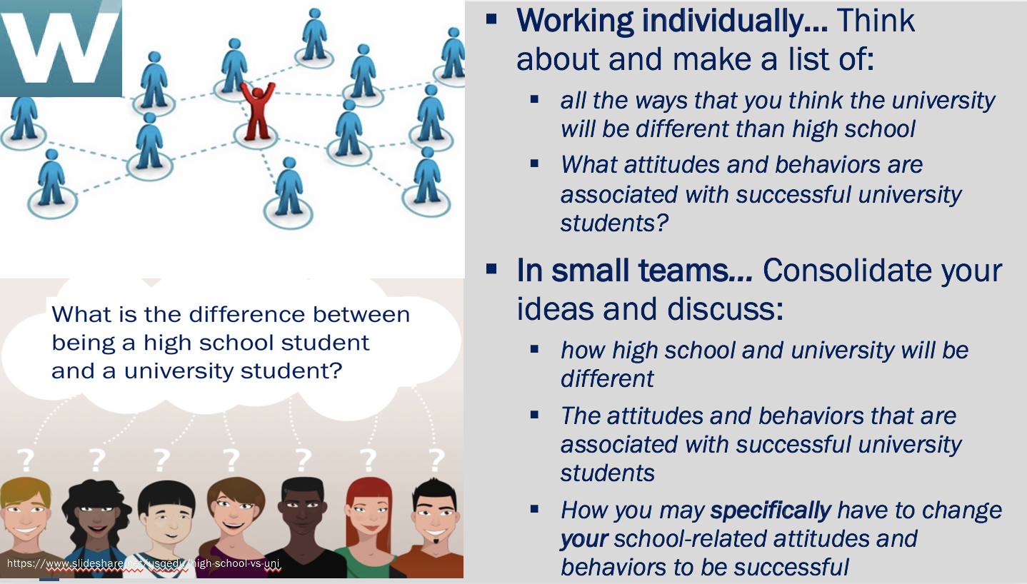

Desired Learning
To get students to begin to realize more deeply that PPU will be quite different from their High School experience. Although many students already know this at some basic level, especially if they have family and friends who have gone before them, they probably have not given too much thought about how the differences. And even if students are somewhat aware of the differences, they may have not yet personalized the new situation to themselves, in particular how they may have to change their school-related attitudes and behaviors.

Time 35 minutes
- Individual Thought: 10 minutes
- Small Groups: 15 minutes
- Class Debrief: 10 minutes
  - Make a list on the board of the ideas that students have generated

NOTE: At various points during the course to encourage active participation, consider asking different students, especially those who may be quieter than others, to act as note takers to write the lists on the board. This gets even the shyer students to take “center stage” in a non-threatening way.

Homework: Beyond the Books

As background for this homework assignment, discuss with students beforehand, the types of opportunities they may find: Helping others (community service), teaching others (tutoring), research and other projects with faculty and other students, becoming involved in student organizations, especially as leaders, international programs, service to PPU.

Desired Learning
Students not only represent themselves and their families, they also now represent PPU, and they must do so with pride and accomplishment. As they grow into adulthood, their obligations begin to grow as well, with a transition of being cared for, to caring for others.

Learning not only comes from lessons and books, it comes from many sources, through interactions with the University and community. It is the student’s responsibility to actively seek out opportunities to learn, and to assist others.

NOTE: As part of the orientation course, it is the responsibility of the teachers to help to instill pride and loyalty for PPU in the incoming students. Teachers need to explain to students why they have a lot to be proud of being PPU students. For example, students are in the best place, even if their parents chose PPU; All Palestinian universities have seen enrollment declines except for PPU (2018 statistics).

Homework: Lessons Learned - Difference between High School and the University

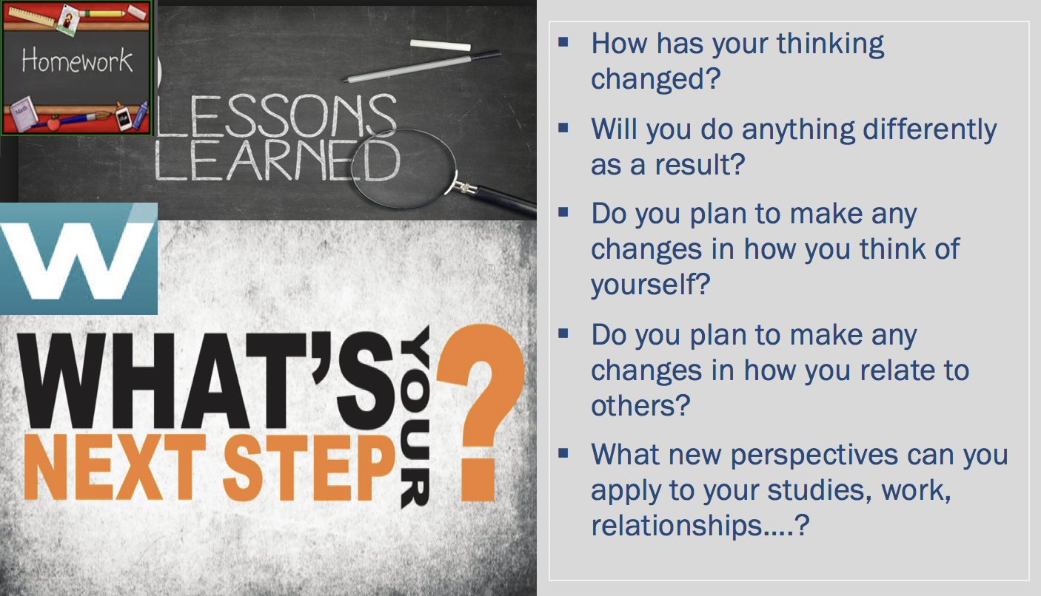

NOTE: After each class session, students should reflect on their learning and question if they should make changes in their attitudes, behaviors, relationships, as a result. They should write their thoughts in their workbooks. You can start the beginning of each class with a quick “debrief” with students’ insights.

Module: Collaboration - Working in High-performing Teams

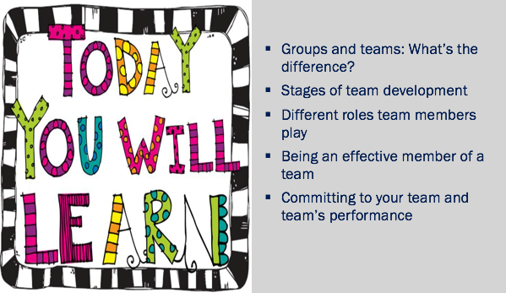

Activity: Considering Previous Team Membership

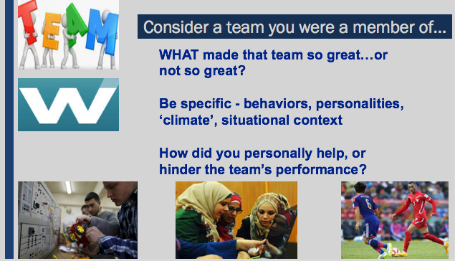

Have students assemble in small groups to discuss their experiences having been a member of a team. These experiences may have been positive, or not so. After the small group discussion, each group will report out to the class.
- Identify common themes that students have come up with
  - Categorize those aspects that led to positive versus negative outcomes
- Identify the different types of teams the students were associated with to underscore how prevalent teams are in life
  - Students may also realize that a family is a “team” as they work together for common goals

Desired Learning
Students are introduced to the concept of team. Although they have likely been members of teams in the past, they are not as likely to have thought about what influences team success or failure, and what they did in particular to contribute to the team. Students should also realize that it is not unusual for a team to have problems. That is normal. The goal is for students to be able to identify and develop within themselves the behaviors and characteristics of effective team members, which is a key focus of this module.

Possible themes
- Not pitching in/doing your best
- Not doing what you said you would do
- Conflict/tension on the team - members didn’t “get along”
- Not understanding what the team was supposed to do
- Team members did not have the right skills (they were not “good at”…)
- Team members didn’t like each other
- Negative personalities on the team
- Some team members were disruptive
- Not enough time to complete a project…

Time 25 minutes
- Small Groups: 15 minutes
- Class Debrief: 10 minutes

Activity: Stranded on a Desert Island

Student Instructions

Read through the following scenario:
Your work team earned a trip as a reward for exceeding your sales goals last year. You all boarded the S.S. Clipper for a relaxing week-long cruise in the Pacific Ocean. You encountered a bad storm and the ship just barely made it to shore and partially sank. Only the top of the ship is still visible off the north side of the island. You are all now stranded on an uninhabited island in the middle of the Ocean. The storm ruined most things on board, leaving very few items.
Your task is to choose 12 items that you think would be most useful to help you survive on this deserted island. First, write a list of 12 items that you would individually like to have on hand to survive on the island.
Next, work with your team to create a master list of items to choose from. Your next task is to work together to come up with a list of the 12 most important items you feel would help the group survive on this island for the next six months. Hopefully by then you will be rescued. Rate the final list of items in order of importance, with 1 being most important through 12 being the least important item on your list.
Desired Learning
The goal of this activity is to show students that working together as a team often produces superior results than simply working alone. Also, it gives students an opportunity to experience and appreciate the dynamics of teamwork.

Debrief Questions:
Q: Do you think your original list is better, as good, or worse, than the list the team ultimately came up with?

Q: Why was the team’s list better?

- Team members have different:
  - experiences
  - knowledge-base
  - ways of seeing problems and thinking of solutions

- Discussing a problem with others may result in generating ideas that no one had thought of individually

These factors often contribute to better outcomes.

Q: What did you notice about the dynamics of your team? For example…
- How did your team go about accomplishing their task?
- Did you get down to work quickly?
- Did a team leader emerge?
- Were everyone’s ideas well-received?
- Did/How did the time limit impact the team’s work?

Time 45 minutes
- Individual Thought: 10 minutes
- Small Groups: 25 minutes
- Class Debrief: 10 minutes

NOTE: Students may look to you for the “right answers” to this activity. You can suggest that they Google “How to survive on a desert island” or “What you need to survive on a desert island”, etc. (on their own time) and see what they can come up with.

Activity: Abilene Paradox – The Management of Agreement

The story…
On a hot afternoon visiting in Coleman, Texas, the family is comfortably playing dominoes on a porch, until the father-in-law suggests that they take a trip to Abilene [53 miles north] for dinner. The daughter says, “Sounds like a great idea.” The son-in-law, despite having reservations because the drive is long and hot, thinks that his preferences must be out-of-step with the group and says, “Sounds good to me. I just hope your mother wants to go.” The mother-in-law then says, “Of course I want to go. I haven’t been to Abilene in a long time.”
The drive is hot, dusty, and long. When they arrive at the cafeteria, the food is as bad as the drive. They arrive back home four hours later, exhausted and still hungry. One of them dishonestly says, “It was a great trip, wasn’t it?” The mother-in-law says that, actually, she would rather have stayed home, but went along since the other three were so enthusiastic. The husband says, “I wasn’t delighted to be doing what we were doing. I only went to satisfy the rest of you.” The wife says, “I just went along to keep you happy. I would have had to be crazy to want to go out in the heat like that.” The father-in-law then says that he only suggested it because he thought the others might be bored.
The group sits back, perplexed that they together decided to take a trip which none of them wanted. They each would have preferred to sit comfortably, but did not admit to it when they still had time to enjoy the afternoon.

TEACHING NOTE: The Abilene Paradox
Have students read the story, then lead the entire class in a discussion.

CLASS DISCUSSION:
A group of people all went ahead and did something that no one wanted to do, not even the person who suggested the idea.

Question: Why does this happen?
Answer: No one wants to speak up their real opinion, doesn’t want to hurt others, doesn’t want to get in trouble, doesn’t want to cause conflict, doesn’t want to be the only one not going along, doesn’t really care about the issue.

Question: Have any of you ever experienced this in your own life?
Participants are likely to have a lot of experiences they can share. If the students are slow to speak up, then share an experience you have had in the past in order to get the discussion going.

Desired Learning
From this very simple example, students can begin to understand why people do keep quiet, but why it hurts group/team interactions, relationships and effectiveness. This phenomenon can happen at home, school, work and results in suboptimal outcomes and decisions.

Time 10 minutes Class Discussion

Activity: Planning for IT Team Assignment Part I

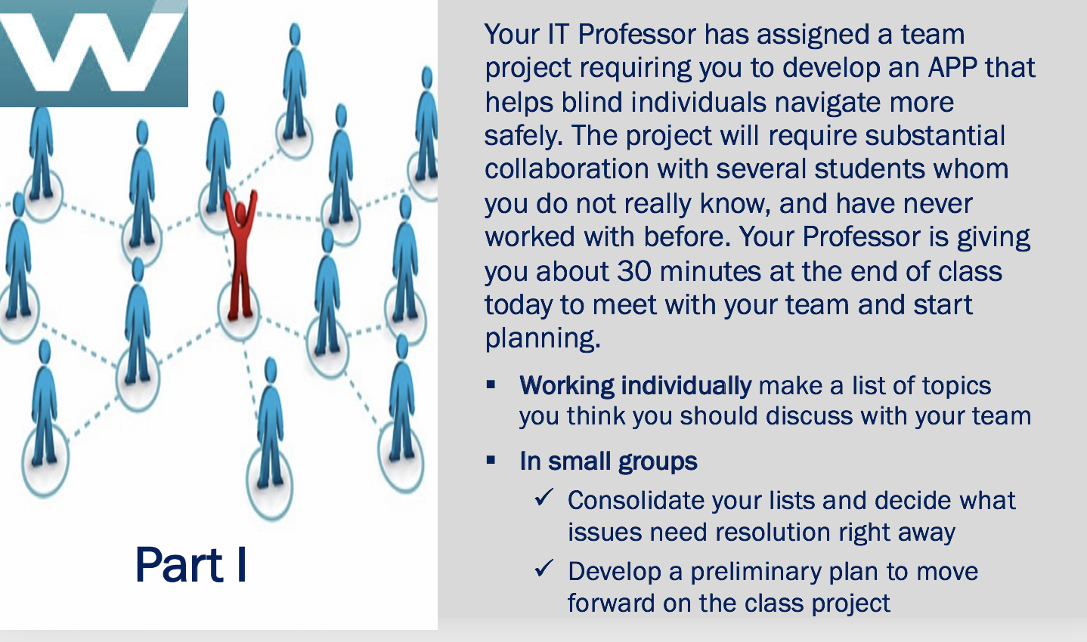

- After the small group discussion, where students share their lists, go around the room and ask for ONE action step from each group, until all the ideas have been shared. (Stop when there are no new ideas forthcoming).
- Record action steps on the board.
- At this point, do not offer any further suggestions. After a brief “lecture” about working in teams, students will add to their lists.

Desired Learning
Students realize that when working in a team, a successful outcome requires communication, coordination and planning in advance. By doing this activity both individually as well as in a small group, they also can see how many “heads” are better than just one. Students will offer good suggestions that others had not thought of, and all can learn from.

Time 30 minutes
- Individual Thought: 5 minutes
- Small Groups: 15 minutes
- Class Debrief: 10 minutes

Activity: The Case of the Missing Team Member

The story…
Your Environmental Studies Professor has assigned the class a case study to analyze. She has assigned four-person teams to complete the project which requires a 20-page paper as well as a presentation to the class. Your team met during class to discuss the project and begin to lay out a plan. Everybody on the team appears enthusiastic and commits to working hard. Not long after this preliminary meeting, the team can see that there is a problem with one of the members. He does not show up at most meetings and doesn’t let team members know in advance if he cannot attend. When he does come, he generally has either not done the work that he was supposed to, or the quality is so poor that it is not usable. He always has an excuse for his performance and promises to do better.

What should the team do?

POSSIBLE SOLUTIONS
  - Try to find out if there is something going on in his life that he is having difficulty with, if so, encourage him to share with the teacher and get help
  - Tell him how important he is, team needs him and his skills
  - Ask him to think of other members of the team and how his behavior is impacting them
  - Team needs to do soul searching -- Make sure team is not ostracizing him, and so he reacts negatively
  - Build mini-deadlines in the project so that the problem doesn’t go on too long
  - Each team member just takes on more work -- not fair but real life
  - Talk to the teacher, but only after you have attempted to resolve the project yourself… be prepared to tell the teacher what you have done to try to resolve the problem

TEACHING NOTE: This activity provides a good opportunity to get students involved in a role play. Ask for two sets of volunteers (or select students) to play the roles of the “problem” team member and a concerned member of the team.

Desired Learning
When working in a team, sometimes there will be someone (a student, a coworker) who does not pull their fair share of the work. This happens in real life. Other team members are faced with what to do about it. Often, the team suffers in silence before it is too late. It is the responsibility of the team to try to resolve the issue, but if they are not successful, at some point they should talk with the teacher.

One point that students often do not think of is having to look internally to evaluate how they have treated the team member. Sometimes, especially if the team member is “different” in some ways, the others begin to exclude him, ignore his ideas, and in general treat him poorly.

Time 25 minutes
- Small Groups: 10 minutes
- Class Debrief/Role Play: 15 minutes

Activity: Planning for IT Team Assignment Part II

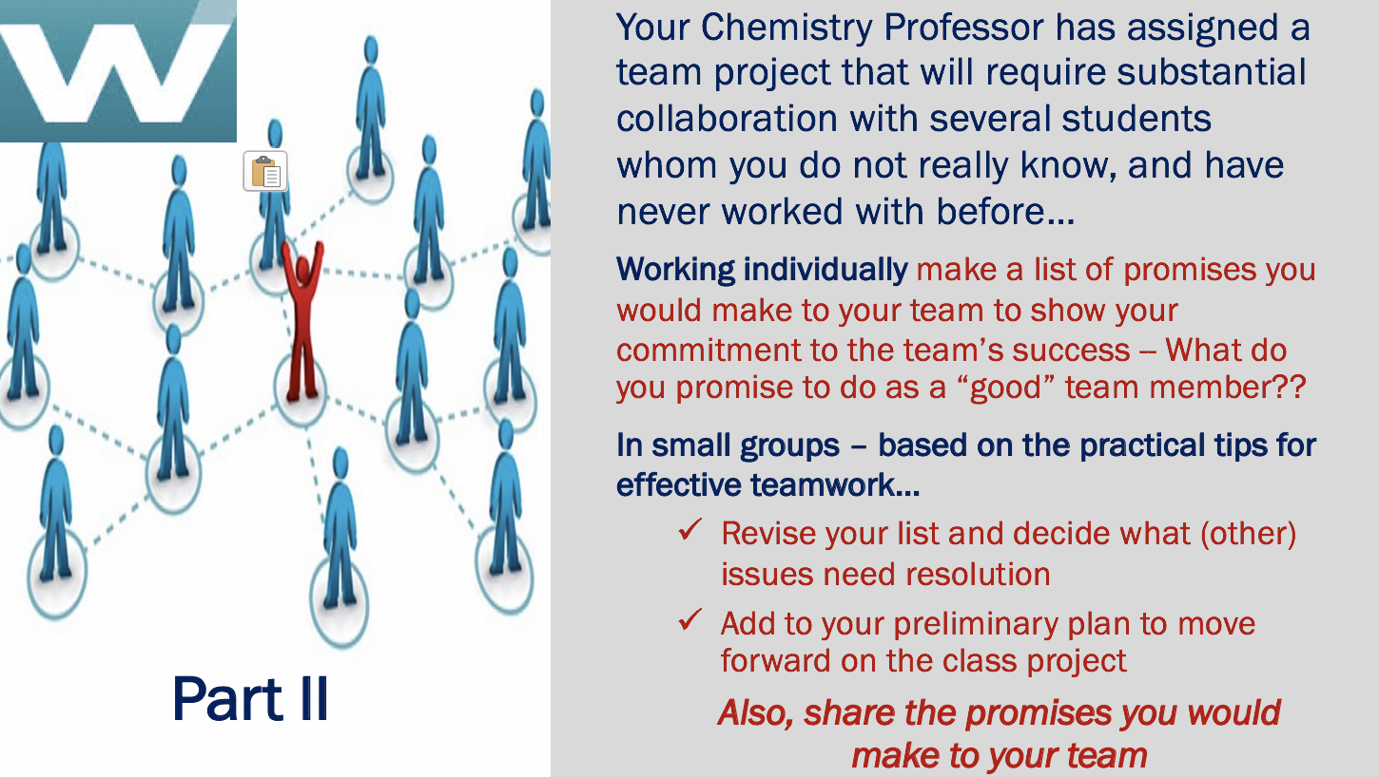

This is a continuation of Part I, adding in promises (commitments) that team members should make to each other. Students reassemble in the same team as Part I of this activity. In the class debrief, ask students to share their promises.

Desired Learning
Students realize that when working in a team, other students are depending on them. They need to take their role as a student team member very seriously, because their actions are going to not only impact themselves, but their student colleagues as well. As students at PPU, they have an obligation to do their best work, even in teams, where sometimes others will cover for them, even if they do not do their fair share.
Using your experience as a teacher, you can call out the gaps in the list, and advise students what they are missing. Additionally, below is an excellent overview of student team process from which you can get additional ideas. Source: http://libguides.usc.edu/writingguide/groupprojects
NOTE: You may want to share this source with your students.

I. Getting Started
To ensure that your group gets off to a good start, it may be beneficial to:
- Take time for all members to introduce themselves, including name, background, and stating specific strengths in contributing to the overall goals of the assignment.
- Nominate or vote to have someone act as the group leader or facilitator or scheduler. If the burden might be too great, consider deciding to rotate this responsibility among all group members.
- Exchange current contact information, such as, email addresses, social media information, and cell phone numbers.
- Consider creating an online workspace account to facilitate discussions, editing documents, sharing files, exchanging ideas, and to manage a group calendar. There are many free online platforms available for this type of work such as Google docs.

II. Discussing Goals and Tasks
After you and the other members of the group agree about how to approach the assignment, take time to make sure everyone understands what it is they will need to achieve. Consider the following:
- What are the goals of the assignment? Develop a shared understanding of the assignment's expected learning outcomes to ensure that everyone knows what their role is supposed to be within the group.
- Note when the assignment is due [or when each part is due] so that everyone is on the same schedule and any potential conflicts with other class assignment due dates can be addressed ahead of time by members of the group.
- Discuss how you are going to specifically meet the requirements of the assignment.
- If your professor allows considerable flexibility in pursuing the goals of the assignment, it often helps to brainstorm a number of ideas and then assess the merits of each one separately. Ask yourselves as a group: How much do you know about this topic already? Is the topic interesting to everyone? If it is not interesting to some, they may not be motivated to work as hard as they might on a topic they found interesting. Can you do a good job on this topic in the available time? With the available people? With the available resources? How easy or hard would it be to obtain good information on the topic?

III. Planning and Preparation
This is the stage when your group should plan exactly what needs to be done, how it needs to be done, and who should do what. Pay attention to the following:
- Work together to break the project up into separate tasks and decide on the tasks or sub-tasks each member is responsible for. Make sure that work is equally distributed among the group.
- Assign due-dates for each task, keeping in mind that members will need time to review any draft documents and the group must have time at the end to pull everything together.
- Develop mechanisms for keeping in touch, meeting periodically, and the preferred methods for sharing information. Discuss and identify any potential stumbling blocks that may arise that could hinder your work.

NOTE: Try to achieve steps 1, 2, and 3 in a group meeting that is scheduled as soon as possible after you have received the assignment and your group is formed. The sooner these preliminary tasks are completed, the sooner each group member can focus on their particular responsibilities.

IV. Implementation
Effective communication is vital, particularly when your group activity extends over an extended period of time. Here are some tips to promote good communication.
- Keep in touch with each other frequently, reporting progress regularly. When the group meets for the first time, think about setting up a specific day and time of the week for people to report on their progress [either in-person or online].
- If someone is having trouble completing his or her area of responsibility, work with that person to figure out how to solve the problem. Be supportive and helpful, but don't offer to do other people's work.
- At the same time, make it clear that the group is depending on everyone doing their part; all group members should agree that it is detrimental to everyone in the group for one person to show up at the last minute without his or her work done.

V. Finishing Up
Be sure to leave enough time to put all the pieces together before the group assignment is due and to make sure nothing has been forgotten [e.g., someone forgot to correct a chart or a page is missing]. Technically, this can be done online, but it is better to meet in person to ensure that everyone is actively involved in the process.
If your group has to give a presentation, go through the same process--decide who is going to do what and give everyone enough time to prepare and practice ahead of time [preferably together]. At this point, it is vital to ensure that you pay particular attention to detail, tie up any loose ends, and review the project together as a whole rather than just looking over individual contributions.

VI. Writing Up Your Project
It is critical that you leave enough time for this final stage. If your group decided to divide responsibility for drafting sections, you will need to nominate [if not done already] a member to pull the final piece together so that the narrative flows well. It is best to choose whomever in your group is the best writer because careful copy editing at this stage is essential to ensure that the final document is well organized and logically structured.
Focus on the following:
- Have all the writers in your group use the same writing style [e.g., verb tense, diction or word choice, tone, voice, etc.]?
- Are there smooth transitions between individual sections?
- Are the citations to sources, abbreviations, and non-textual elements [charts, graphs, tables, etc.] consistent?

Time 25 minutes
- Individual Thought: 5 minutes
- Small Groups: 15 minutes
- Class Debrief: 5 minutes

Homework: Lessons Learned - Working in High-performing Teams

Module: Developing Effective Presentation Skills

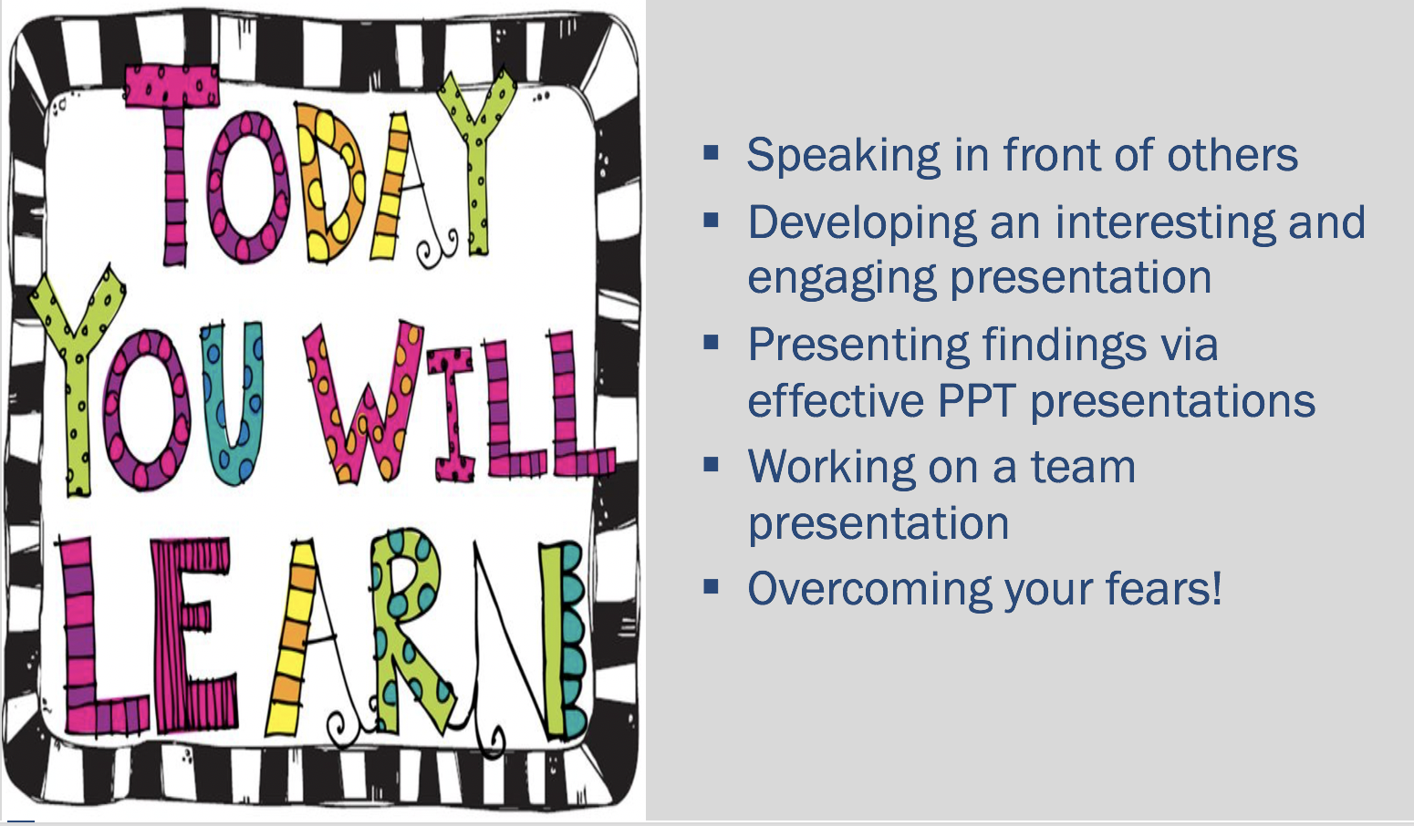

Activity: Assessing Body Language

https://www.ted.com/talks/bill_gates_unplugged?language=en
https://www.ted.com/talks/bjorn_lomborg_sets_global_priorities?language=en#t-2777
https://www.ted.com/talks/jamie_oliver?language=en

Using the rubric below, discuss each of the non-verbal characteristics/skills shown across the top of the rubric and ask students to visualize in their minds what each would look like, ideally.
TURN OFF THE VOLUME and have students watch about 3-4 minutes of the Bill Gates presentation by just watching the physical movements (the skills at top) without listening to the content.
Stop the TED Talk and ask students to score Gates using a 1-5 rating (1=bad,3= average 5=excellent) across the six non-verbals and indicate why they awarded the particular scores.
Do the same exercise with Lomborg and Oliver TED talks.

Gates doesn’t move around much and keeps his arms in one place most of the time. It is hard for students to give such an iconic figure a low score, but keep them focused on what he truly deserves.
Oliver moves around, a lot. He also waves his flashcards around so that when you are not listening to his content, it can be very distracting.

Debrief
Q: What would you recommend to each of these speakers to improve their presentation skills?
Q: What have you learned that you can use to improve your presentation skills?

Desired Learning
Presentation effectiveness is not only about what you say, but it is influenced by the non-verbal messages you send as well. You need to be aware of these messages to make sure they enhance your words and ideas, not take away from them.
- Always dress neatly and cleanly, and try to understand, in advance, the formality of the environment. When in doubt, dress “up” rather than “down”.
- Vary your facial expressions and make sure they are appropriate to what you are saying. Ex. If you are talking about something very serious, your expression has to match; Smile if appropriate.
- Make eye contact with members of the audience. Try to scan the audience frequently.
- Stand up straight; do not “hide” behind a podium; Use your hands to gesture when making a point, but not in a way that is distracting; Move around when you are talking, but again, in a way that appears natural and does not take attention away from your ideas.

Time 42 minutes
- Discussion: 15 minutes
- Videos: 12 minutes
- Class Debrief: 15 minutes

Speaker: | Professional Appearance | Facial Expression | Eye-Contact | Posture | Gestures | Movement
Bill Gates: Mosquitos, Malaria, and Education
Bjorn Lomberg: Set Global Priorities
Jamie Oliver: Teach Every Child About Food

Homework: How Can I Help?

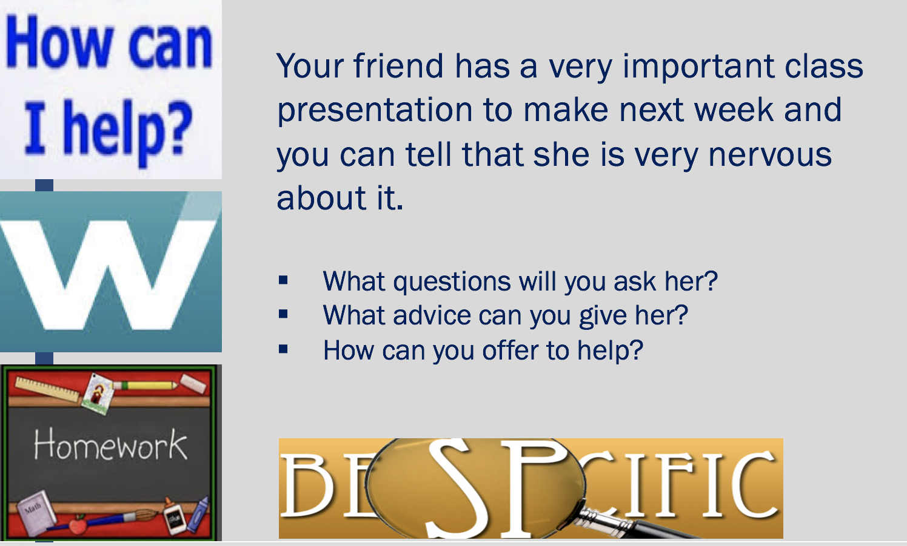

As background for this homework activity, remind students that as a PPU student, they are committed to helping others. Although your friend has not asked for your help, you sense something is troubling her, and that you should offer to at least listen, and then give some help in a supportive way. You should expect that the students will use some of the techniques discussed in class about overcoming glossophobia. The “offer to help” could come in a number of ways including acting as the “audience” while the friend practices, offering encouragement and positive suggestions for improvement, reviewing with her the flow of the presentation to assure there is a logical flow. Students should be reminded to give advice gently, and not say or do anything that would hurt the friend’s feelings or diminish their self-confidence, which is probably low at the moment.

Desired Learning
Very powerful learning can result from teaching others. This gives students the opportunity to alleviate some of their own fears by thinking about helping a friend.

Homework: Lessons Learned - Developing Effective Presentations

Team Presentations - Time Management and Organizational Skills
Note: There is no slide for this. Instructions are on the syllabus.

Instructions
Students will be assigned into teams of approximately 4 students. Each student team will be responsible for developing and delivering a learning module for the class, on a topic related to Time Management and Organizational Skills. One topic will be randomly assigned to each team. You have very broad latitude on what you want to focus on, as long as your learning module is relevant to the topic you have been assigned.
Your goal is to facilitate the learning of your classmates with a 20-minute learning module supported with PPT slides. Consider the lessons you learned in the module about Effective Presentations to guide your work.

Make sure that you have a balance of content and active learning. Be as creative as possible. Role-plays, theatrical skits, short games, mini-cases, quizzes, videos and/or other interactive activities are strongly encouraged.

The success of your learning module will be based on ability to engage students in a relevant discussion, identification of important issues (and solutions if applicable), preparedness, quality of the presentation and PowerPoint slides, and contributions by all team members.

- Content - Does the basic content of the learning module adequately cover the topic?
- Level of detail - is the material presented at an appropriate level of detail? (Recognizing this is only a 20-minute module, it is best to “go deep” on a more narrow topic.)
- Clarity - is the presentation easy to understand?
- Organization - is the module well-organized?
- Delivery - is the delivery engaging and interesting?
- Engagement - Is the class actively involved?

I (and your team members) expect that each of you will contribute roughly the same amount of quality effort to this project, although it may be in very different ways. Work together in a way that capitalizes on your unique strengths. Some students excel in analyzing, organizing, planning, and follow-up, others in research, or writing, or using technology. However, all team members must actively lead the in-class discussion.

Teaching Notes
- Students may ask how many slides are needed. Suggest you don’t answer the question specifically, only to say the team needs to make that decision based on their desired learning outcomes.
- Need to consider if you will you stop the team at 20 minutes? If so, make that clear to the students. Remind them it is very important to practice.
- With a three-hour class session, there is approximately 27 minutes per team, for a 20-minute presentation. The remaining 7 minutes is easily taken up with questions, overruns (if allowed) and transitioning from one team to the next.
- If the class is sufficiently diverse, you may make students responsible for assembling their own “most diverse” teams possible. Start by having all students stand in the center of the room and instruct them to come up with the most diverse teams possible. They will be frustrated by this, but it is a good learning experience about the formation of teams.
- Alternately you can assign teams (have students go around the room and count 1,2,3,4,5,6.. and all the 1’s are in a team, all the 2’s etc.) It is preferable that students work in teams with folks they do not know, or do not know well. That way they can get a first-hand experience of team formation, working with others who are not well known, and they can expand their network.

Possible Topics:

- Managing your time
- Getting and staying organized
- Managing Stress
- Working under pressure
- Eliminating procrastination
- Eliminating distractions
- Setting SMART Goals
- Managing multiple projects and assignments
- Developing routines
- Prioritizing work
- Setting and meeting deadlines
- Being self-motivated

Module: Meeting Life’s Challenges with Confidence and Determination

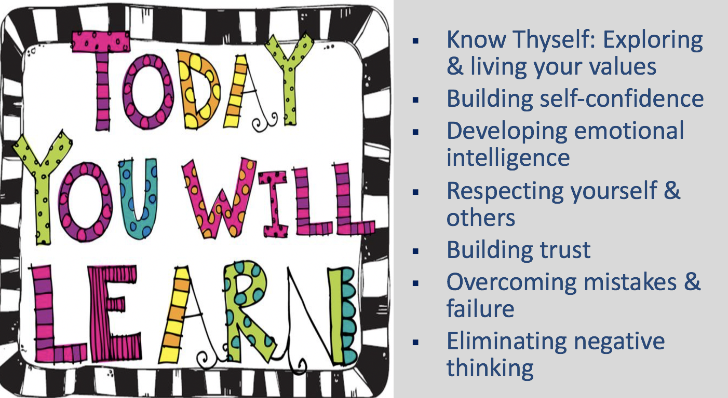

Activity: “Know thyself” Values, Social Identity & Vision

TEACHING NOTE - “Know thyself” Values, Social Identity, and Vision: This involves several self-reflective exercises, and some writing.

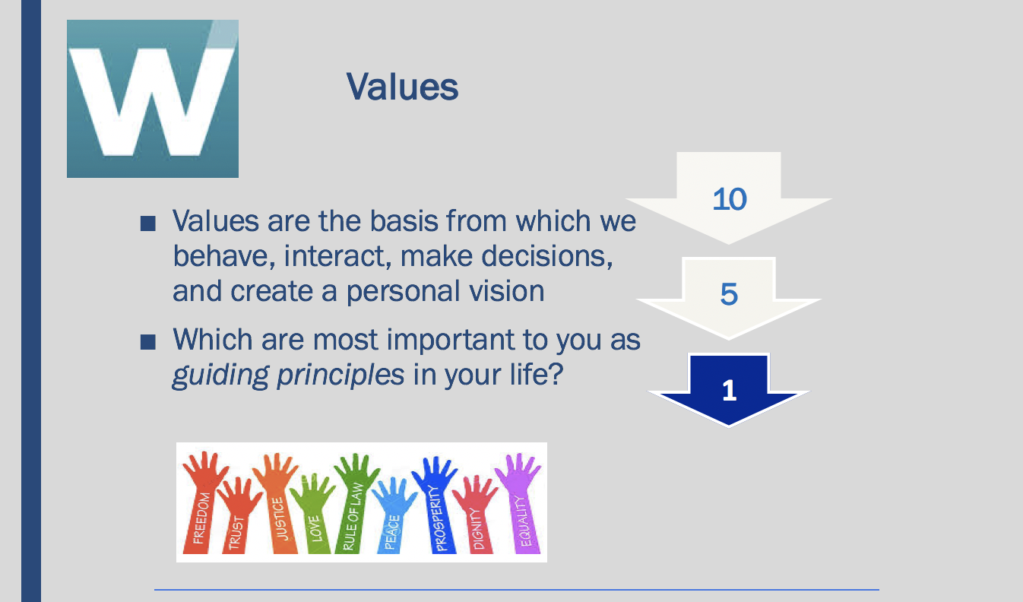

Values Exercise

The objective of this exercise is to help you clarify your values, or beliefs, at this time. Although our values and beliefs are relatively stable over time, they may change after deep reflection or after certain significant life events. Values are the basis from which we live, make decisions, behave, relate to others, and create a personal vision for our lives.

Attached is a list of about 50 values, beliefs or personal characteristics for your consideration. The following steps should help you identify which are most important to you as guiding principles in your life. You might find it useful to determine degrees of importance by considering whether you would be upset or elated if your present state or condition in life regarding a particular value would be significantly changed. Or, you might find it helpful to consider two values at a time, asking yourself about the relative importance of one over the other. The objective of this exercise is to help you clarify your values, or beliefs, at this time.

STEP #1:
- Please identify the 10 values that are most important to you.
- From this list of 10, identify the 5 that are the most important to you; and
- Rank each of the five most important (from 1 to 5), with “1” being THE most important of all.

You may add values if you do not see them on the list below.

ACHIEVEMENT | sense of accomplishment, success, contribution
AMBITIOUS | aspiring to promotion or progress within career
ADVENTURE | new and challenging experiences
AFFECTION | love, caring
BEAUTY | in nature, art or life
BROAD MINDED | open-minded
CHEERFUL | joyful
CLEAN | tidy, sanitary
COMPETENT | capable, effective
COMPETITIVENESS | winning, taking risks
COMFORTABLE LIFE | prosperous or easy life
COOPERATION | working well with others, teamwork
CREATIVITY | being imaginative, innovative
DISCIPLINED | self-controlled, restrained
DIVERSITY | appreciates differences
ECONOMIC SECURITY | steady, adequate income
EQUALITY | egalitarianism in life, equal opportunity for all
EXCITING LIFE | a stimulating or challenging life
FAME | being famous, well known
FAMILY HAPPINESS | nuclear and/or extended family that is happy
FAMILY SECURITY | nuclear and/or extended family that is safe
FORGIVING | willing to forget a judgment of others
FREEDOM | independence, free choice, self-reliant
FRIENDSHIP | close relationships, companionship
HAPPINESS | contentedness with life
HEALTH | being physically and mentally well
HELPFULNESS | assisting others, improving society
INNER HARMONY | being at peace with yourself
INTEGRITY | honesty, sincerity, genuineness
INVOLVEMENT | participating with others, belonging
INTELLECTUAL | conceptual, abstract, or symbolic
LOGICAL | rational
LOVING | affectionate, tender
LOYALTY | duty, respectfulness, obedience
NATIONAL SECURITY | protection from attack
ORDER | tranquility, stability, conformity
PEACE | a world at peace, without war or conflict
PERSONAL DEVELOPMENT | personal growth
PLEASURE | fun, an enjoyable, leisurely life-style
POLITE | courteous, well-mannered
POWER | control, authority, influence over others
RECOGNITION | social recognition, respect from others, status
RELATIONSHIPS | connections with or among others
RELIGION | strong religious beliefs
RESPONSIBLE | dependable, reliable
SALVATION | eternal peace
SELF-RESPECT | self-esteem, pride, sense of personal identity
SERVICE | work done to help others achieve
WEALTH | making money, getting rich
WISDOM | understanding life, discovering knowledge

STEP #2:
- Support why you selected the five most important values, answering the question “Why are each of these values so important to me?”

TEACHING NOTE - Values Exercise

Individuals know what their values are, however this exercise requires students to identify those values that are crucial in the way they live their lives. There is a list of about 50 values, or beliefs, and the goal is to ultimately identify that ONE value or belief that an individual holds most dear. In order to make it easier to select just one value, and also to illustrate people have multiple values that can be rank ordered in importance (value system) have participants start by identifying the top 10, then from those 10, narrow it down to 5, then rank the 5 most important from 1 to 5 with 1 being most important. Also have participants describe briefly why they selected the top 5.

DEBRIEF: Go around the room and ask each participant to say what his/her #1 Value is, and record on whiteboard/flipchart. There will likely be some overlap and some variance.

Desired Learning

- Although we all have strong and meaningful values, we do not often think about them deeply. It is important to understand our most important values, to then assure ourselves we are living a life in a way that expresses these values.
- Good people have different values.
- We should respect the values of others, even if we do not have the same values.

ALTERNATIVE DISCUSSION QUESTIONS:
- What is the source of our values?
- Values are stable over time, but do values ever change? What would cause a change in our values?
- How do our values impact our career choices? Significant decisions?

Social Identity
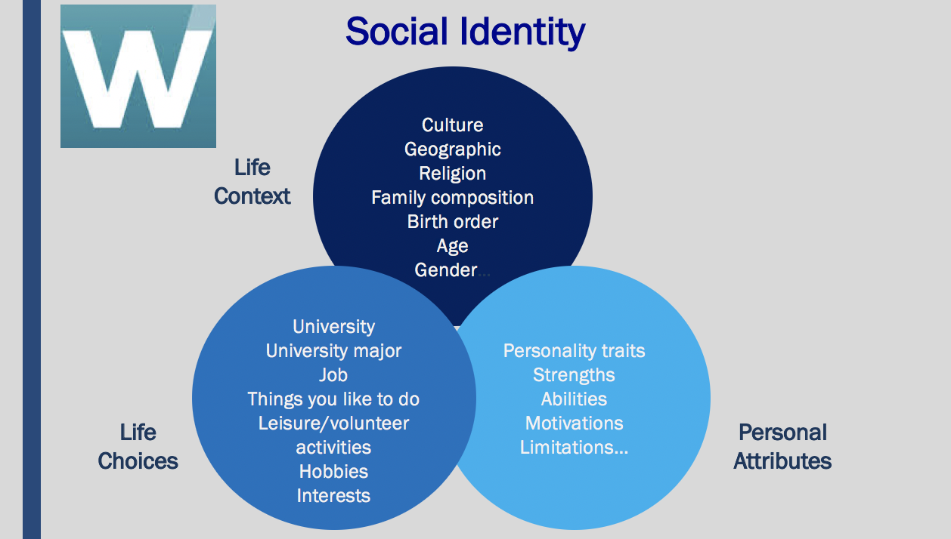

STEP 3:
- Map your “social identity” which includes your life context, life choices, and personal attributes - begin by simply describing your life context, personal attributes and significant choices you have made so far.

Source: Derived from the work of Dr. Jackie Stavros, Lawrence Technological University

Step 4:
Self-reflection-Values and Social Identity
- Write a one-two page biography of yourself articulating “who you are” and what is your “life story” as reflected in your social identity; meaning describe what personal characteristics, contextual factors, and life choices and experiences have most greatly influenced who you are as a person and professional.
- Reflect in writing on the following:
  - Do/how do your values and social identity influence one another?
  - How are your values reflected in the way you live your life and in the choices you have made?

Self-reflection- Your personal vision

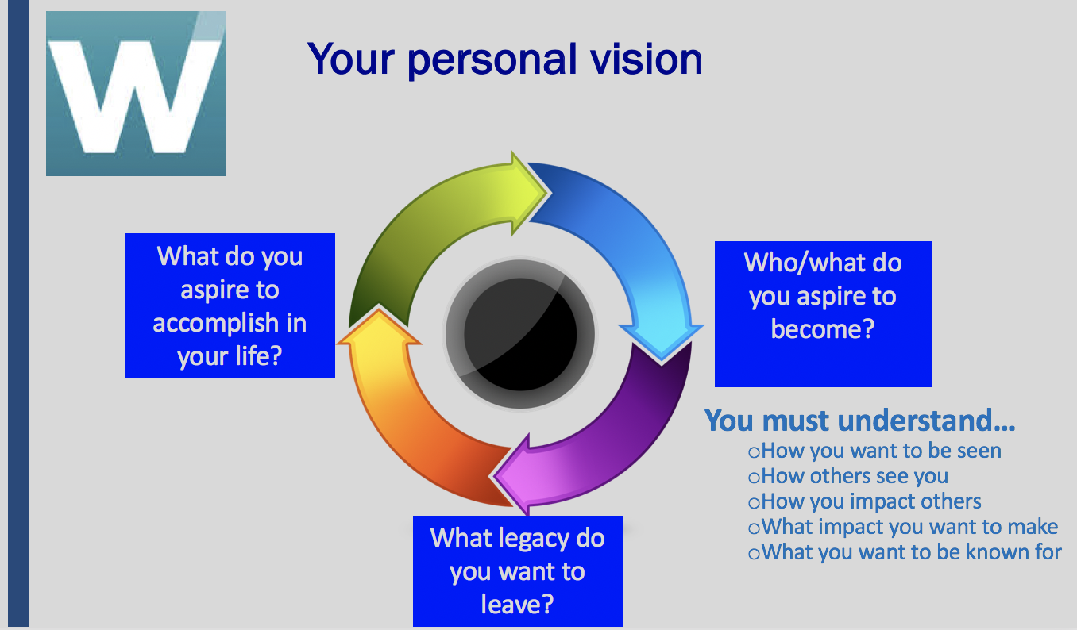

STEP 5:
- Incorporating your values and social identity, write a personal vision statement describing who/what you aspire to become, how you want to be known by others and what you aspire to accomplish in your life. What kind of person do you want to be and how do you want to live your life? What do you want to be remembered for?

TEACHING NOTE - Social Identity

- This activity builds on the Values activity. You are asking students to dig deeply and to reflect and write about themselves. It has a component of a biography, but much more than that. Students are also reflecting on their life experiences thus far, and how those experiences have influenced who they are. Often individuals have what is called a “Crucible Moment”, some very significant life event that had a large impact on the person and how they live their life. This activity also requires participants to look at the choices they have made so far in life.
- As a part of this reflection, you might ask students to think about “how do other people experience you”? Really meaning, “how do your behaviors, attitudes, strengths, weaknesses, impact other people?” This can be a very powerful learning tool to carry forward in life. Basically here, we are trying to get students to think about the effect they have on other people, and is that positive, negative, or neutral? And whether they may want to make changes going forward.

TEACHING NOTE - Your personal vision

- As the final component of this self-reflection activity “Know thyself” participants will write a personal vision, which articulates “what do you aspire to become, what do you want to accomplish, what do you want people to remember you for, and what legacy do you want to leave?”
- Students can be encouraged to evaluate their lives in the context of this vision. “Are you living your life in a way that you will reach your aspirations and be remembered

TEACHING NOTE - Values, social identity & vision DEBRIEF

- Ask students to debrief first in small groups, then with the entire class, answering the following questions:
- What is the value of periodically undertaking an activity such as this?
- Describe your thoughts as you went through this process -- any challenges, surprises?
- How will you go about making your vision a reality? What do you need to do, or do differently, going forward?
- Remind students that by putting a vision statement on paper, they are committing themselves to a future course of action, and the question becomes, “how can you make your vision a reality? What do you need to do today, tomorrow, a month, a year from now?”
- FINAL THOUGHT: Visions require a plan, they just don’t happen, but visions also will influence the choices we make, so they guide us in our lives, and they can be very powerful if we are committed to making them happen.

NOTE: As an alternative, you can have students complete some portions of this three-stage activity at home.

Desired Learning
Building effective personal relationships and meeting life’s challenges is at the foundation of a successful life. Often, we get so busy in the day to day aspects of life that we do not stop and reflect on who we are, how we are living, and the impact we have on others, our community and beyond. By taking time to reflect, we can get a better understanding about who we are, and what we value. Further, and this is especially important for students, we have the opportunity to ask who we want to become, how are we going to get there and how we will contribute to the lives of others. Self-reflection builds self-awareness and through self-awareness we can more honestly appraise our own strengths, weaknesses, and motivating factors. Reflecting on our core values, and particularly, whether we are living these values, leads to greater integrity.

Time 70 minutes
- Values: 15 minutes
- Social Identity: 25 minutes
- Personal Vision 15 minutes
- Class Debrief: 15 minutes

Homework: How to Increase your Self-Confidence

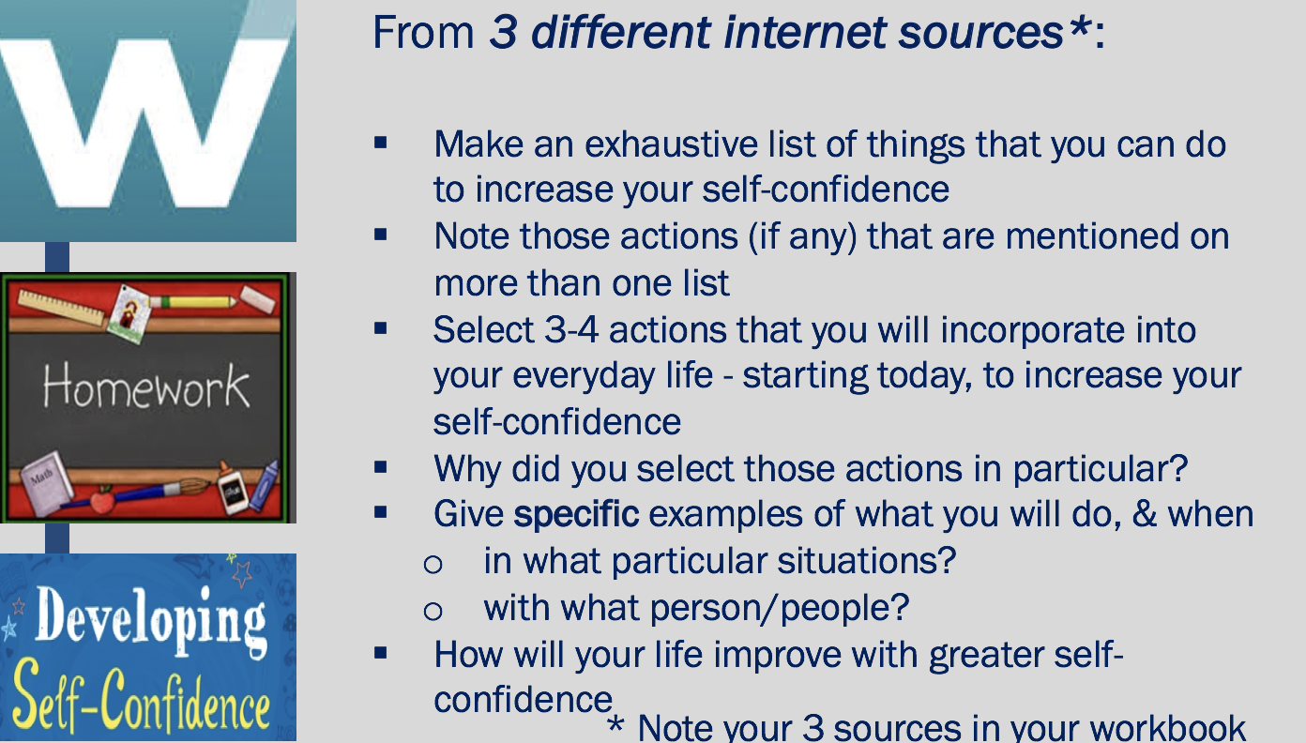

As background for this homework assignment, discuss with students beforehand the importance of considering multiple, and credible sources when using the internet to gain knowledge and information. The internet is an excellent source of learning, but students have to assess the reliability of the information they access. One way to do so is to use several different internet sources. They can become more comfortable if multiple sources are reflecting similar information. Further, students should dig deeply to find disconfirming evidence, contrary to their own understanding/perceptions, to consider.

Desired Learning
The desired learning for this internet search activity is two-fold. First, is to underscore that students are responsible for their own learning. In this module, techniques for increasing self-confidence are purposely not provided, rather we make student’s accountable. Second, this activity provides students with the opportunity to think about how they need to change something about themselves, and set up a plan to do so. This will help them in the development process to mature adults.

Homework Debrief

At the start of the next class, go around the room one-by-one until all the student’s ideas have been listed on whiteboard
Again, going around the room, ask each student to share specifically one action they will take, trying to identify as many different actions as possible

NOTE: May need to delve into their responses to make sure they are specific
Ex. If the action is “I’m going to ask for help” … What kind of help? Help from whom? When will you do this?
Ex. If the action is “I am going to take a small risk”… What kind of risk, when?

Time: Class Debrief 10 minutes

Video: An Exercise in Empathy

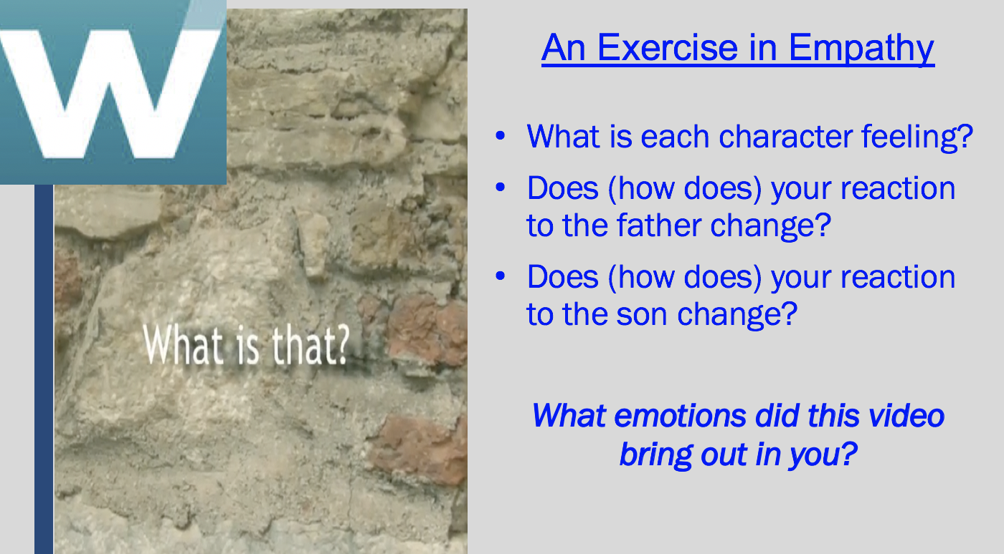

This video, about 5 ½ minutes, shows an elderly father and adult son sitting on a bench, and the father continues to ask the same question over and over. It shows a myriad of emotions, and can evoke emotions of those who are watching the video.

Before beginning the video, as students the question “What is empathy”?
Answer:
- Being aware of and sensitive to the feelings of others.
- The ability to understand and share the feelings of others.

Debrief: After the video, ask the students:
- What emotions were characters in the video were displaying?
- What emotions were they feeling while watching the video?
- Why is empathy important?
- Empathy allows us to understand what emotions others are feeling so we can respond appropriately to them. Empathy can lead to helping behaviors towards others, which builds and benefits social relationships.

Desired Learning
Being empathetic is at the foundation of Emotional Intelligence. People can be sensitive to the feelings of others, even if they have not had the same experiences. Students have an opportunity, through this video, to sense (read) the emotions of the two individual - Love, frustration, anger, patience, sorrow. Being able to sense the emotions of others is a characteristic of being emotionally intelligent.

Time 12 minutes
Discussion Q: What is Empathy: 1.5 minutes
Video: 5.5 minutes
Class Debrief: 5 minutes

Activity: When your Emotions Worked Against You

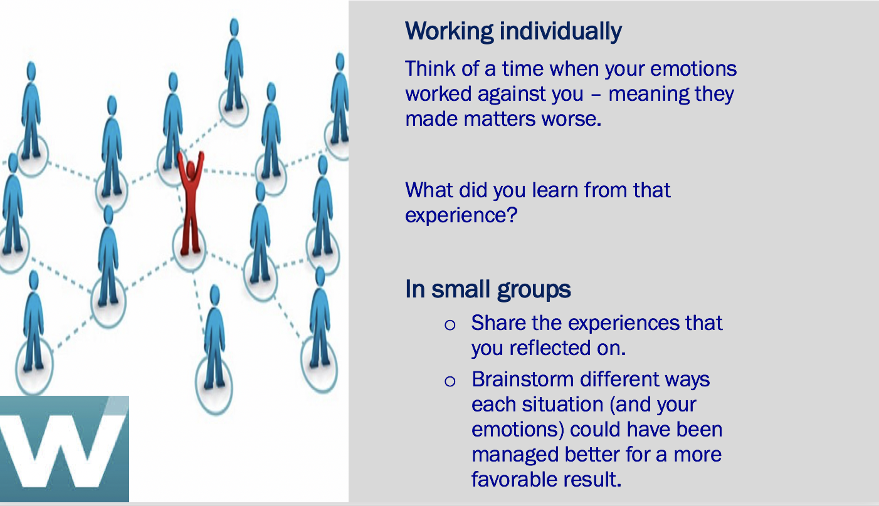

Desired Learning
This activity helps students to apply the theoretical concept of Emotional Intelligence to themselves personally, making it more real. Most everyone has had experiences where their emotions “got away from them”. We want students to recognize that is a normal part of life but to understand that there are times when we do not manage our emotions well. When they don’t negative consequences can follow. This activity also supports the theme of self-reflection, in particular, what they can learn for the experience, and how might they might behave differently in the future. By sharing experiences with other students, they can learn from each other, so the learning becomes exponential.

Debrief

TEACHING NOTE: This activity provides a good opportunity to get students involved in a role play. Ask for two sets of volunteers (or select students) to role play in two different scenarios.
- Team A selects the scenario (one that was discussed in small group) and both students act in an emotionally unintelligent way
- Team B follows with that same scenario, though both students act in an emotionally intelligent way

Time 25 minutes

- Individual Thought: 5 minutes
- Small Groups: 15 minutes
- Role Play/Class Debrief: 7 minutes

Activity: How Emotionally Intelligent Are You?

TEACHING NOTE - How emotionally intelligent are you?
Now that students have a conceptual understanding of EI, they are ready to assess their own level of EI using an illustrative scale measuring the components of EI: self-awareness, -managing emotions (regulation), motivating oneself, empathy and social (relationship) skills.

Encourage students to try to be as accurate as possible in the self-assessment, how they really are, not how they would like to be, or how others think they should be. Remind them there are no right or wrong answers, and also that their current emotional state could influence their responses.

Individual scores closest to 5 show high levels of EI. Those near the lower end of the scale (1 and 2) provide opportunities for improvement. The higher the total scores, the stronger the Emotional Intelligence.

Students should identify where their strengths lie, and what areas they may want to work on. Specifically, they should consider their results and identify one or two actions they can take immediately to strengthen emotional intelligence.

SMALL GROUP DISCUSSION:
Share a few “needs improvement areas” and talk in your small groups why you think it is important to gain some strength in those areas, and what specific steps you might take to actually improve these EI competencies. Group members should help brainstorm specific actions for improvement.

Class Debrief
Overall intelligence is something you are born with; EI develops over time based on maturity, life experiences, etc. You can improve EI, but only if you want to, and if it is important to you.
You may be emotionally intelligent in some areas, but not in others. Ex., a person might be very aware of his/her own emotions, but show little empathy for others. Identify your strengths and your weaknesses, and work towards greater emotional intelligence.

Let the students know this assessment is not intended to be shared with others (of course they can if they choose), but provides an opportunity for personal reflection, and individual action.

Desired Learning
Through the simple yet powerful statements on the EI questionnaire, students can get a stronger understanding of the behaviors associated with emotional intelligence, and to see how these behaviors apply to themselves personally. By scoring the assessment, areas in need of improvement are exposed. With these actual results, students are challenged to take some action steps to strengthen their emotional intelligence.

Time 30 minutes
Instructions and Debrief: 5 minutes
Individual student assessment/reflection: 25 minutes

(EI) Emotional intelligence questionnaire
This self-assessment is designed to get you thinking about the various competences of emotional intelligence as they apply to you.
A high degree of emotional intelligence includes:
Self-awareness
The ability to recognize what you are feeling, to understand your habitual emotional responses to events and to recognize how your emotions affect your behavior and performance. When you are self-aware, you see yourself as others see you, and have a good sense of your own abilities and current limitations.
Managing emotions
The ability to stay focused and think clearly even when experiencing powerful emotions. Being able to manage your own emotional state is essential for taking responsibility for your actions, and can save you from hasty decisions that you later regret.
Motivating oneself
The ability to use your deepest emotions to move and guide you towards your goals. This ability enables you to take the initiative and to persevere in the face of obstacles and setbacks.
Empathy
The ability to sense, understand and respond to what other people are feeling. Self-awareness is essential to having empathy with others. If you are not aware of your own emotions, you will not be able to read the emotions of others.
Social Skill
The ability to manage, influence and inspire emotions in others. Being able to handle emotions in relationships and being able to influence and inspire others are essential foundation skills for successful relationships.
What to do
- Assess and score each of the questionnaire's statements.
1 indicates that the statement does NOT apply at all
2 indicates that the statement normally does not apply
3 indicates that the statement applies “sometimes” (about half the time)
4 indicates the statement usually applies
- indicates that the statement ALWAYS applies to you

- Total and interpret your results
Transfer your scores to the calculation table and total your results.
- Consider your results and identify one or two actions you can take immediately to strengthen your emotional intelligence. 3 = Applies half the time ~ 5
Remember to respond to these statements as accurately as possible, about how you generally behave. Your current emotional state can influence your answer.
____ 1 I realize immediately when I lose my temper
____ 2 I can 'reframe' bad situations quickly
____ 3 I am able to always motive myself to do difficult tasks
____ 4 I am always able to see things from the other person's viewpoint
____ 5 I am an excellent listener
____ 6 I know when I am happy
____ 7 I do not openly show emotions
____ 8 I am usually able to prioritize important activities to get them done
____ 9 I am excellent at empathizing with someone else's problem
____ 10 I never interrupt other people's conversations
____ 11 I usually recognize when I am stressed
____ 12 Others can rarely tell what kind of mood I am in
____ 13 I always meet deadlines
____ 14 I can tell if someone is not happy with me
____ 15 I am good at adapting and mixing with a variety of people
____ 16 When I am being 'emotional' I am aware of this
____ 17 I rarely lose my temper with other people
____ 18 I never waste time
____ 19 I can tell if a group of people are not getting along with each other
____ 20 People are the most interesting thing in life for me
____ 21 When I feel anxious I usually can account for the reason(s)
____ 22 Difficult people do not annoy me
____ 23 I am not evasive
____ 24 I can usually understand why people are being difficult towards me
____ 25 I like to meet new people and get to know what makes them act like they do
____ 26 I always know when I'm being unreasonable
____ 27 I can consciously alter my frame of mind or mood
____ 28 I believe you should do the difficult things first
____ 29 Other individuals are not 'difficult' just 'different'
____ 30 I need a variety of friends to make my life interesting
____ 31 Awareness of my own emotions is very important to me
____ 32 I do not let stressful situations or people affect me
____ 33 Delayed gratification is a virtue that I believe in
____ 34 I can understand if I am being unreasonable
____ 35 I like to ask questions to find out what it is important to people
____ 36 I can tell if someone has upset or annoyed me
____ 37 I rarely worry about school, work or life in general
____ 38 I believe in taking action each day
____ 39 I can understand why my actions sometimes offend others
____ 40 I see working with difficult people as simply a challenge to win them over
____ 41 I can let anger 'go' quickly so that it no longer affects me
____ 42 I can suppress my emotions when I need to
____ 43 I can always motivate myself even when I feel low
____ 44 I can sometimes see things from others' point of view
____ 45 I am good at reconciling differences with other people
____ 46 I know what makes me happy
____ 47 Others often do not know how I am feeling about things
____ 48 Motivation has been the key to my success
____ 49 Reasons for disagreements are always clear to me
____ 50 I generally build solid relationships with those I am around
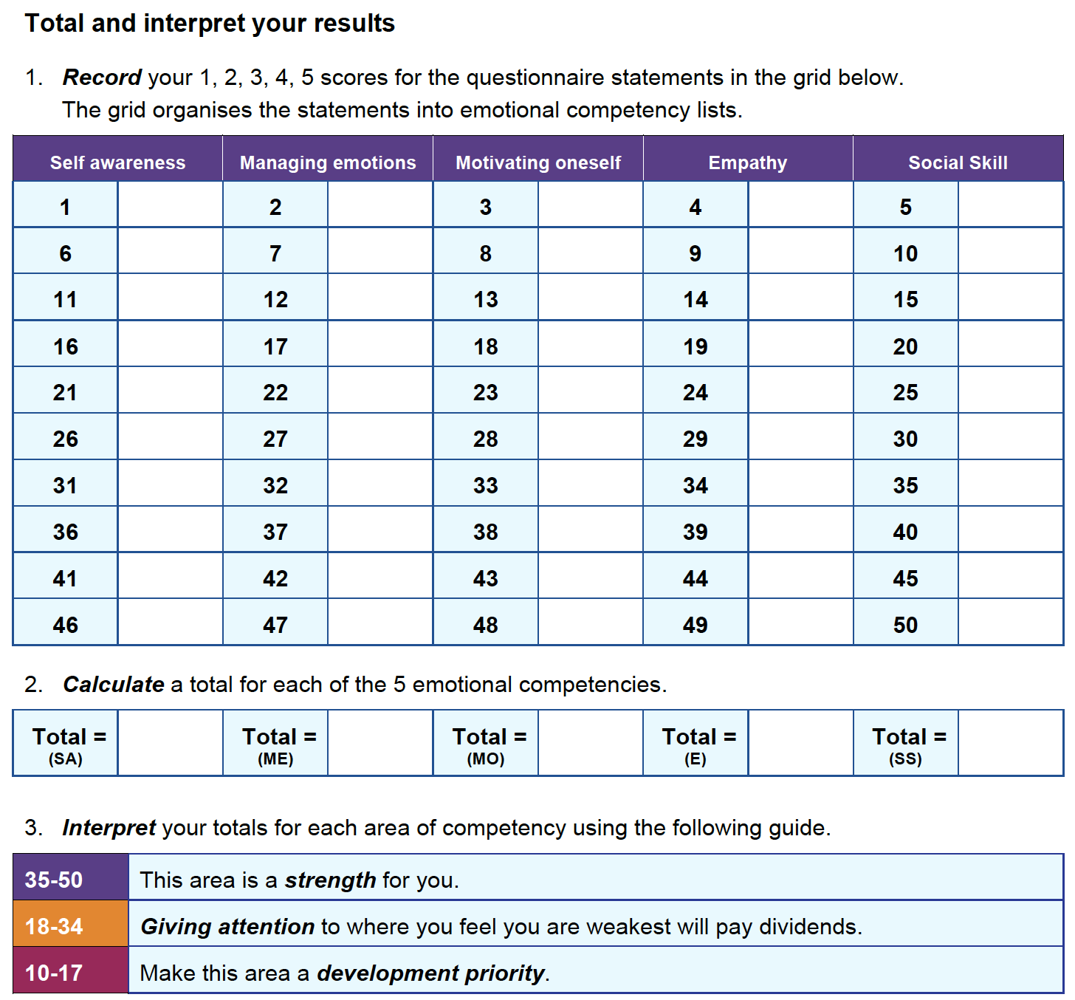

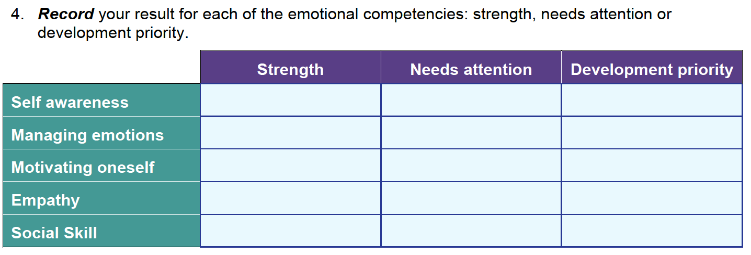
Read the brief article that follows, How to Increase your Emotional Intelligence, then consider your results and identify one or two actions you can take immediately to strengthen your emotional intelligence.

How to Increase Your Emotional Intelligence

A short guide to start making emotions work for you, instead of against you.

By Justin BarisoFounder, Insight@JustinJBariso

Emotional intelligence, also known as EI or EQ (for Emotional Intelligence Quotient), describes a person's ability to recognize emotions, to understand their powerful effect, and to use that information to guide thinking and behavior. Since EI helps you to better understand yourself--and others--a high EQ increases your chances for successfully achieving goals.
But is there a way to increase your emotional intelligence?
In their seminal research and publication, The Emotionally Intelligent Manager, professors David R. Caruso and Peter Salovey broke down four of the core skills involved in developing emotional intelligence:
1. Identifying your feelings and those of others
2. Using feelings to guide your own thinking and reasoning, along with others
3. Understanding how feelings might change and develop as events unfold
4. Managing to stay open to the data of feelings and integrate this into decisions and actions
Here are a series of practical steps that can help you develop these core skills, thereby increasing your EQ.

Reflect on your own emotions.
Take some time to sit down and reflect on your own use of emotions. For example, think about how you would typically respond if:
- You read an email that implies you made a mistake
- Someone blames you for something you feel is unfair
- Another driver cuts you off on the road
- Someone yelled at you
- You get angry if you think someone is criticizing you
- A close friend or associate begins to cry unexpectedly
By first identifying your own emotions and reactions, you become more mindful and start the process of building control.

Ask others for perspective.
Often, we don't realize that other people view us much differently than we view ourselves, and vice versa. It's not about right or wrong; it's simply understanding how perceptions differ, and the consequences those differences create.
By asking those close to us--like a family member or close friend or workmate--about our interactions with them, we can learn from their perspective. For example, we could think about a specific time when we were in a highly emotional state. Ask the other person: Did I act out of the ordinary during that time? Could you describe how?
Then, ask them to relate experiences regarding when they were going through an emotional situation.
You can ask:
- How did I deal with you at that time?
- Would you say I was sensitive to your feelings and emotions?
Getting the answers to these questions will help us to see ourselves more like others see us--and help us to understand others better, too. You can then use that knowledge to adjust your dealings with others. (Here's a little more on learning from others to build your own EQ.)

Be observant.
With this newly acquired knowledge, you can now be more observant of your current emotions. Your self-reflection and what others have shared will help you to be more in tune with what you're feeling.
If you make any new discoveries, make sure to repeat step one. You can even write down your experience; doing so will help clarify your thinking and keep you in "learning mode".

"The pause".
"The pause" may be as simple as taking a moment to stop and think before we act or speak. If everyone made that a practice, imagine how much shorter emails could be, how much time would be saved in meetings, and how many incendiary comments on social media would be eliminated.
But remember: The pause is easy in theory, difficult to practice.
Even if we're generally good at managing our emotions, factors like added stress or a bad day can inhibit our ability to do so at any given time. And we're not just talking about upsetting situations; we are often tempted to jump on opportunities that look really good at the time but that we haven't really thought through.
When you work on pausing before speaking or acting, you create a habit of thinking first.

Explore the "why".
Most of us would agree that qualities like empathy and compassion are valuable ingredients to healthy relationships. So, why do we often neglect to show those qualities when it matters most--like when we fail to show understanding to a close friend or partner when they're going through a difficult time?
Scientists have studied what psychologist and fellow author Adam Grant calls, "the perspective gap". In short, this term describes the fact that it's extremely challenging to put ourselves in another person's shoes. We often forget how specific situations feel, even if we've experienced very similar circumstances. (If we've never experienced something similar, you can imagine how that limits our perspective.)
So, how do we bridge the gap?
Demonstrating qualities such as empathy and compassion means that we try our best to see a situation through another person's eyes. But we have to go further than drawing on our own experiences; showing true empathy means exploring the "why":
- Why does this person feel the way (s)he does?
- What is he or she dealing with that I don't see?
- Why do I feel differently than (s)he does?
If you can't effectively answer those questions, consider working alongside the person for a period of time to truly understand what's going on, as viewed from that person's perspective. Doing so will help you see your team and family members, not as complainers, but more accurately for who they really are, struggling individuals that need help.

When criticized, don't take offense. Instead, ask: What can I learn?

Criticism is never easy to take. But the truth is, criticism is often rooted in truth--even when it's not delivered in an ideal manner. When you receive negative feedback, there are two choices: You can put your feelings aside and try to learn from the situation, or you can get angry and let emotion get the best of you.
When we are on the receiving end of criticism, whether it's delivered ideally or not, it's invaluable to consider the following:
- Putting my personal feelings aside, what can I learn from this alternate perspective?
- Instead of focusing on the delivery, how can I use this feedback to help me or my team improve?
There are times when you shouldn't listen to criticism--for example, when it's based on falsehood or given in a way that's meant to destroy your sense of self-worth. But in reality, that's not usually the case.
If your goal is to truly get better, don't let emotion close your mind to negative feedback. Instead, learn from it.
Practice, practice, practice.
Like any other skill or ability, practice makes...
Better. Of course, it's impossible to have perfect control over your emotions. And learning to improve your emotional intelligence isn't a process that happens overnight.
However, consistently practicing these steps will allow you to begin harnessing the power of emotions--and use that power to work for you, instead of against you.
PUBLISHED ON: APR 11, 2016

Q: What are one or two actions you can take immediately to strengthen your emotional intelligence? Be specific. When, with who, etc.

Activity: Relational Civility “Mirror” Measurement

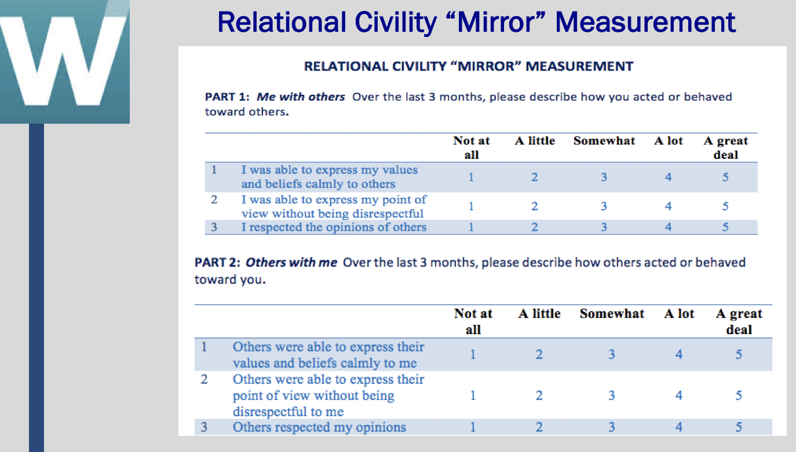

The Relational Civility Mirror Measurement considers incivility from two different individual perspectives - Part 1 is designed for individuals to assess their behaviors towards others and Part 2 is designed to assess others’ behaviors towards themselves. Let students know that the “mirror” aspect of this measurement is especially important because it is always important to look inward first, how do they behave towards others? You cannot expect to be treated well by others if you do not treat others well.

Students may not be familiar with the idea of reverse scoring on items 11 through 16 (see below) so you will want to clarify how it works.

The higher the score on both parts (scores closest to 5) the more civil the behavior is

Part 1 You are always acting civilly towards others =5
Part 2 Others are always acting civilly towards you = 5

Debrief
Students do not need to share their scores, but you may ask them if they found the results at all surprising.

Desired Learning
Through this assessment, students get greater exposure to what “good” versus “bad” behavior is. They can personally consider how they are treating others, and how others are treating them. Even if respondents are not totally honest in their responses about how (well) they treat others, they will likely feel a bit of anxiety or guilt that could result in behavioral changes.

Time 15 minutes
Individual assessment: 10 minutes
Reflection: 5 minutes

RELATIONAL CIVILITY “MIRROR” MEASUREMENT

Complete Part 1 and Part 2 of this questionnaire by circling the number that best corresponds to your experiences over the past three months; From 1 “Not at all” to 5 “A great deal”. As always, try to be as accurate as possible with your responses - how you really are, not how you wish you were, or think you should be. Note that Part A describes how you acted or behaved towards others and Part B describes how others acted and behaved towards you.

When you have completed both parts, score your results.

PART 1: Me with others Over the last 3 months, please describe how you acted or behaved toward others.
 |  | Not at all | A little | Somewhat | A lot | A great deal
1 | I was able to express my values and beliefs calmly to others | 1 | 2 | 3 | 4 | 5
2 | I was able to express my point of view without being disrespectful | 1 | 2 | 3 | 4 | 5
3 | I respected the opinions of others | 1 | 2 | 3 | 4 | 5
4 | I communicated my disagreement with others without being aggressive | 1 | 2 | 3 | 4 | 5
5 | I was polite toward others | 1 | 2 | 3 | 4 | 5
6 | I was generally kind toward others | 1 | 2 | 3 | 4 | 5
7 | I always behaved mannerly towards others | 1 | 2 | 3 | 4 | 5
8 | I made comments that validated others | 1 | 2 | 3 | 4 | 5
9 | I realized the effect of my words on others | 1 | 2 | 3 | 4 | 5
10 | I realized the effect of my behaviors on others | 1 | 2 | 3 | 4 | 5
11 | I was condescending towards someone | 1 | 2 | 3 | 4 | 5
12 | I paid little attention to someone | 1 | 2 | 3 | 4 | 5
13 | I paid little attention to someone else’s opinion | 1 | 2 | 3 | 4 | 5
14 | I made demeaning or derogatory remarks about someone | 1 | 2 | 3 | 4 | 5
15 | I addressed someone in derogatory terms | 1 | 2 | 3 | 4 | 5
16 | I ignored or excluded someone | 1 | 2 | 3 | 4 | 5

PART 2: Others with me Over the last 3 months, please describe how others acted or behaved toward you.
 |  | Not at all | A little | Somewhat | A lot | A great deal
1 | Others were able to express their values and beliefs calmly to me | 1 | 2 | 3 | 4 | 5
2 | Others were able to express their point of view without being disrespectful to me | 1 | 2 | 3 | 4 | 5
3 | Others respected my opinions | 1 | 2 | 3 | 4 | 5
4 | Others communicated their disagreement with me without being aggressive | 1 | 2 | 3 | 4 | 5
5 | Others were polite toward others | 1 | 2 | 3 | 4 | 5
6 | Others were generally kind toward me | 1 | 2 | 3 | 4 | 5
7 | Others always behaved mannerly toward me | 1 | 2 | 3 | 4 | 5
8 | Others made comments that validated me | 1 | 2 | 3 | 4 | 5
9 | Others realized the effect of their words on me | 1 | 2 | 3 | 4 | 5
10 | Others realized the effect of their behaviors on me | 1 | 2 | 3 | 4 | 5
11 | Others were condescending toward me | 1 | 2 | 3 | 4 | 5
12 | Others paid little attention to me | 1 | 2 | 3 | 4 | 5
13 | Others paid little attention to my opinion | 1 | 2 | 3 | 4 | 5
14 | Others made demeaning or derogatory remarks about me | 1 | 2 | 3 | 4 | 5
15 | Others addressed me in derogatory terms | 1 | 2 | 3 | 4 | 5
16 | Others ignored or excluded me | 1 | 2 | 3 | 4 | 5

Source: Adapted from De Fabio and Gori, 2016 and Cortina et al, 2001

SCORING
- For Parts 1 and 2 separately, compute the average of the 16 statements.
- When computing averages, reverse score items 11 through 16.

If you circled… When averaging count as…
- 5
- 4
- 3
- 2
- 1

Me with others Others with me
AVERAGE SCORE ____________ ____________

Reflection

Do I need to change the way I treat others? If so, how?

Am I allowing others to treat me poorly? If yes, what can I do about it?

Activity: Are you Trustworthy?

This brief survey is designed to get students to think about their own level of honesty when dealing with others.

Answer the following questions (True/False)

____ I keep my promises. I am a person of my word.
____ I am reliable. I follow through on my commitments.
____ I am honest. I do not lie.
____ I keep secrets. I never betray a trust or confidence.
____ I have integrity and live according to my principles.
____ I am consistent in what I say and do, not trying to “pretend” to act like someone else to impress others.

Debrief
Ask students “Is it ever ok to lie?” Student responses may range from “no” to “yes”, to it depends. Yes answers are likely to include that it’s acceptable to lie so as not to hurt someone, to protect someone, or as a necessity to do some good. There will also be students who believe it is never acceptable to lie. These responses reflect different values.

Time 5 minutes
Individual student assessment/reflection: 1 minutes
Debrief Question: 4 minutes

Homework: At the End of the Day…

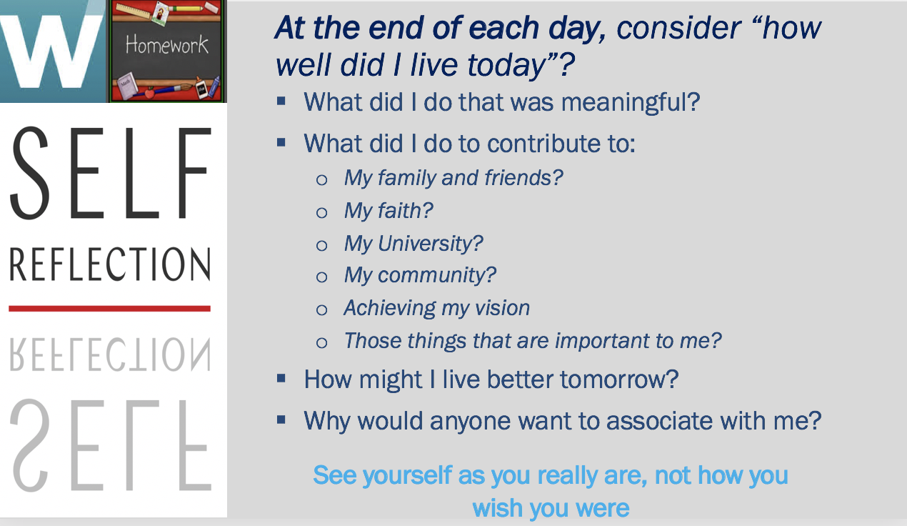

We have spent a great deal of time on self-reflection. Look back on this day and consider “How well did I live today”?

- What did I do that was meaningful?

- What did I do to contribute to:
  - My family and friends?
  - My faith?
  - My University?
  - My community?
  - Achieving my vision?
  - Those things that are important to me?

- How might I live better tomorrow?

- Why would anyone want to associate with me?

This is a habit that you should get into regularly. You may not always write something down, but spend a few moments every day, considering these questions.

Homework: Lessons Learned - Meeting Life’s Challenges with Confidence and Determination

Module: Effective Interpersonal Communication

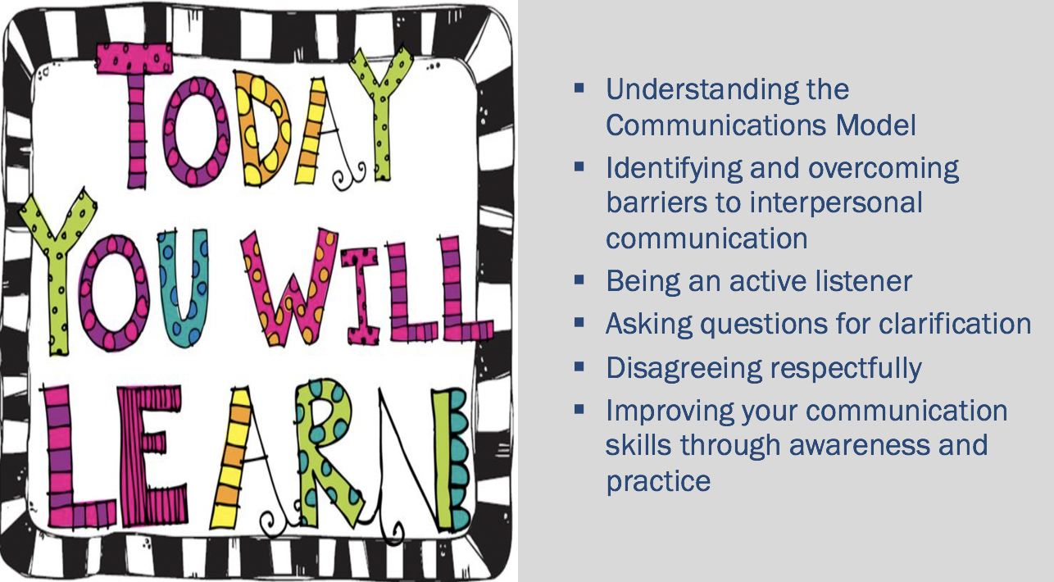

Activity: Let’s Draw

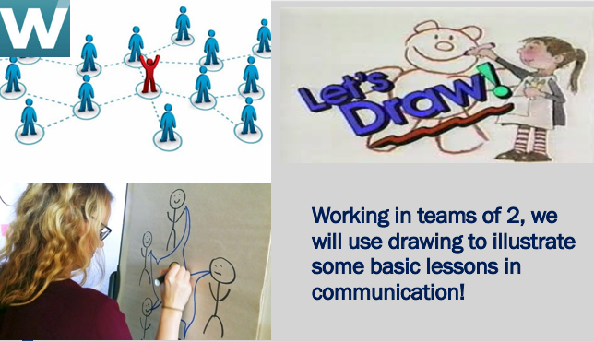

Drawing Lessons Improve Communication Skills: Listen, Interpret, Draw

This activity gives students a chance to draw while practicing their communication, team work, listening and inference skills.

Activity Part A
- Each student will need three pieces of paper, plus pens/pencils.
- Arrange students into pairs. Have each pair of students sit at their desks back-to-back, with the writing surfaces of their desks in front of them. Tell students that one of them will be Student "A" and the other will be Student "B." Have students in each pair choose one of the letters.
- After students have chosen their letters, ask each student to write his or her letter in the top corner of a blank sheet of paper. Next, instruct all "A's" to spend two minutes drawing something on their papers. Students need not be good at drawing; even stick drawings will suffice for this activity.
- Partners may not look at or talk to each other during this part of the activity. While "A's" are drawing, "B's" should remain in their seats.
- At the end of the two-minute drawing period, instruct "A's" to stop drawing.
- Next, tell "B's" to pick up their pens/pencils. Instruct "A's" to give a clear description of their drawings to their respective partners. Instruct "B's" to listen only to their partners' instructions.
- Each "B" will use the oral instructions to try to re-create his/her partner's drawing. Allow five minutes for this next step.
- Remember: The only means of communication is for each "A" to provide description of the drawing to his or her partner. "B's" can only listen and draw. They cannot ask questions.
- Partners should remain sitting back-to-back at all times during this part of the activity.
- At the end of the five-minute time period, instruct "B's" to stop.
- Allow a few minutes for partners to show each other their drawings and discuss the results.

Activity Part B
- Tell students that the second part of the activity will be different from the first part.
- Instruct partners to resume their back-to-back positions.
- Have "B's" spend three minutes drawing on their papers. Students should use the entire three minutes to draw something beyond a simple shape or two. When the three minutes are up, "B's" should put down their pens/pencils.
- Remind all pairs to remain seated back-to-back. Instruct all "A's" to prepare to draw. Tell students that this time the "A's" are going to reproduce their partners' drawings, but the only way they can obtain information about those drawings is by asking yes or no questions. Emphasize that only questions that can be answered yes or no are allowed!
- Allow students five minutes to complete this part of the activity. When time is up, have partners compare their drawings.

Debrief
Discuss the difficulties or successes experienced by the pairs.
Q: Which exercise was more difficult and why?
Q: What did you learn about the need for effective communication?
Have students share their pictures…

Desired Learning
Through this activity, students are developing their communication skills and gaining a greater understanding of the keys to effective communication, teamwork, cooperative learning skills and developing feedback skills. It demonstrates the importance of listening and asking the right questions (inquiry skills). Students should conclude that effective communication requires cooperation, honest listening, clear instructions, clarifying questions, proper feedback, and openness to divergent opinions.

Time 30 minutes
Drawing Activity: 20 minutes
Debrief: 10 minutes

Source: https://www.educationworld.com/a_tsl/archives/02-1/lesson020.shtml

Activity: Contradicting Messages

The purpose of the Contradicting Messages activity is to emphasize what happens when we are presented with too many contradictory messages at the same time.
- The names of various colors are displayed on the ppt slide. Do not let students see this until you are ready to begin the activity.
- The name of each color is shown using a different color than the name of the color displayed. Ex.in the first column/first position “Blue” is displayed using a red font.
- Present these colors to students and ask them to quickly write down the colors, not the words. In other words, using the example above, the participant should write down the color red, not the word blue. Give 10-15 seconds before darkening/advancing the slide
- Once students are done, go back to the slide to see how they have done. From top of column 1, down, and top of column 2, down…
Red, Blue, Green, Purple, Pink, Black, Yellow/Gold, Blue/Aqua
- You should expect that participants will have some difficulty performing this assignment as they will have a tendency to read the words, not the colors.

Debrief
Ask students to share if this was difficult, and if so, why. Explain that the reason why is that there are too many messages being presented to our brains between the meaning of the words and the actual colors that the words are printed in. This is similar to what happens when we are faced with communications overloads in our busy lives between texts, phone calls, e-mails, voice mail messages, etc.

Desired Learning
Communication can suffer due to information overload – too much information coming at us at once, and by conflicting information. By simplifying messages, we can often improve communication. It would have been much easier if both the printed words and the colors that these words were printed in were the same. Make sure that the messages we send via our communication is consistent, for example, that our words are consistent with our body language, and our behaviors. By doing so, we can avoid misinterpretation of our messages.

Time 3 minutes
Activity: 15 seconds
Debrief: 3 minutes

Source: https://www2.cortland.edu/dotAsset/c1a635f6-a099-4ede-8f15-79b86e315088.pdf

Activity: The Train Left the Station
A brief story is read to students and they are asked to answer a question concerning the content of the story. The question is likely not what the students were expecting.

- Tell students that you are going to read them a brief story about a train and that they need to pay close attention as you are going to ask them a question about the situation being described. Advise participants that they might want to make notes as you read the story.
- Read the following story to participants:
“A train leaves the station with 3 passengers and stops in Zurich and 5 more passengers get on. It next stops in Bern and 2 passengers get off. Next stop is Geneva and 23 new passengers get on board. The train makes its next stop in Lyon where 21 get off and no one gets on. The train chugs along until it reaches Toulouse where 3 more passengers get on. The next stops are Bordeaux where 6 get on and 4 get off; Paris where no one gets on or off; and Luxembourg where 24 passengers get on board. The train reaches the end of the route in Brussels where everyone gets off.”
After you have completed reading, ask this question: How many stops did the train make?
Debrief
Ask students if this was the question they anticipated. More likely, many students will have focused their attention on the number of passengers, not the number of stops the train made. By focusing on the passengers, they are missing a significant part of the message.

Desired Learning
This activity is intended to emphasize how important it is to listen intently to all information that is communicated, without preconceived ideas where the communicator is headed with the message. Also, is illustrates that sometimes what we are asked to do is not always what we are expecting.

Time 5 minutes
Activity (Reading story): 1 minute
Debrief: 4 minutes
https://www2.cortland.edu/dotAsset/c1a635f6-a099-4ede-8f15-79b86e315088.pdf

Activity: Choosing your Words Carefully - Late for the Movies, Again…

Mini-Case:
You have made plans to go to a movie with a friend. It’s a movie that you really want to see. The movie is very popular so you need to go early to be sure you get tickets and good seats. You explain this to your friend and ask him to come by your house at 7:00pm, which is early for the 8:00pm movie start. 7:00pm comes and passes, and no sign of your friend. At 7:40pm he arrives with an excuse for being late. By this time, you know it’s too late to get tickets for the movie. You are furious. This is not the first time this sort of situation has happened with this friend.
Individually: Write a script of what you would say to your friend in this situation. Do not write what you think you should say. Rather, try to think of similar experience you have had in the past, and express how you would typically respond. Also, anticipate how your friend might react to your words. (5 minutes)
Debrief: Ask for volunteers (or call on students) to share their scripts. Ask them to talk just as if they were really talking with their friend (don’t just read from their script). The goal is to try to get as many different responses as possible. Probe students by asking “Who has a different approach?” to see how many unique approaches the students came up with. Conversely, you may find that the approaches were similar. You would want to note that as well. If students’ scripts all reflect a positive communication approach, congratulate them, but suggest that outcome is not usual, especially when someone is upset. Critique responses in the context of tone, content and how the friend is likely to respond. Ex. anger, defensiveness
Ask for 2 sets of 2 students to role play this scenario in the front of the room
One using “poor” interpersonal communication skills
One using “good” interpersonal communication skills
Then show some examples of “poor” responses… (following slide)
Explain why these responses are negative
- Not saying how you really feel is a barrier to effective interpersonal communication.
- None of the responses is telling the friend how you really feel.
- The other person is likely to respond negatively in return.
Show some examples of “good” responses… (following slide)
For the poor and good responses…
Q: How would your friends respond to these comments?
Q: How would you respond if someone said these things to you?
Desired Learning
- To practice expressing thoughts and feelings through “I statements”.
- To practice communicating with respect.
- To understand how emotions can impact communication.
Time 20 minutes
Activity (Reading story): 5 minutes
Class discussion/Debrief: 15 minutes

Activity: Listening Bad Habits

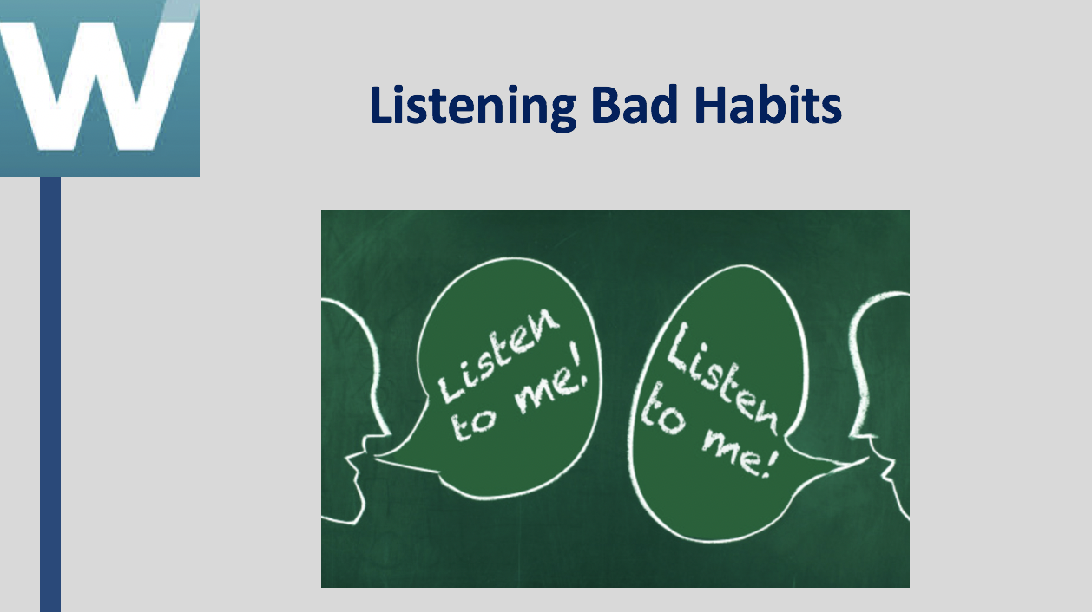

This activity of Listening Bad Habits is designed to honestly evaluate listening skills.
Listening Bad Habits
Following is a list of ten bad habits of listening. Check those listening bad habits that you are sometimes guilty of committing when communicating with others. Be honest with yourself!
____ I interrupt often or try to finish the other person’s sentences.
____ I jump to conclusions.
____ I am often overly “parental” and answer with advice, even when advice is not requested.
____ I make up my mind before I have all the information.
____ I do not give any response.
____ I am impatient.
____ I lose my temper when I hear things I do not agree with.
____ I try to change the subject to something that relates to my own experiences.
____ I try to change the subject to something I am interested in.
____ I think more about my reply while the other person is speaking, than what she/he is saying.

Discussion/Debrief

- Start by sharing with the students your results. That will encourage them to open up more readily as well. You don’t have to go into detail, perhaps something like “ I really struggle with wanting to give advice even if it is not asked for, and may not be appreciated. So, this is something I try to be aware of and am always working on…”
- Emphasize that most people have some problems being good listeners and these bad habits are not unusual for people to demonstrate. Many people are, at least from time to time, guilty of many or most of these listening bad habits. Tell students not to be too hard on themselves if they check many or even all of these bad habits. It is all part of human nature.
- Ask students what other listening bad habits they can think of.
- Reiterate that listening is a skill that can be improved through practice.
- Recommend that students share this list with friends/family, and ask for their help by calling out these negative habits when they are displayed by the student.

Desired Learning
This brief activity is designed to help students understand that they themselves may be “guilty” of not listening intently, and to identify specific habits that they would like to change. It is intended to heighten students’ awareness of poor listening behaviors. The most important thing is for students to be aware of their tendency to fall into these bad habits and consciously try to avoid making these mistakes. Like anything else, students need to practice better listening.

Time 10 minutes
Complete assessment: 1minute
Class discussion/Debrief: 9 minutes
https://www2.cortland.edu/dotAsset/c1a635f6-a099-4ede-8f15-79b86e315088.pdf

Activity: Interpersonal Communication Skills Inventory

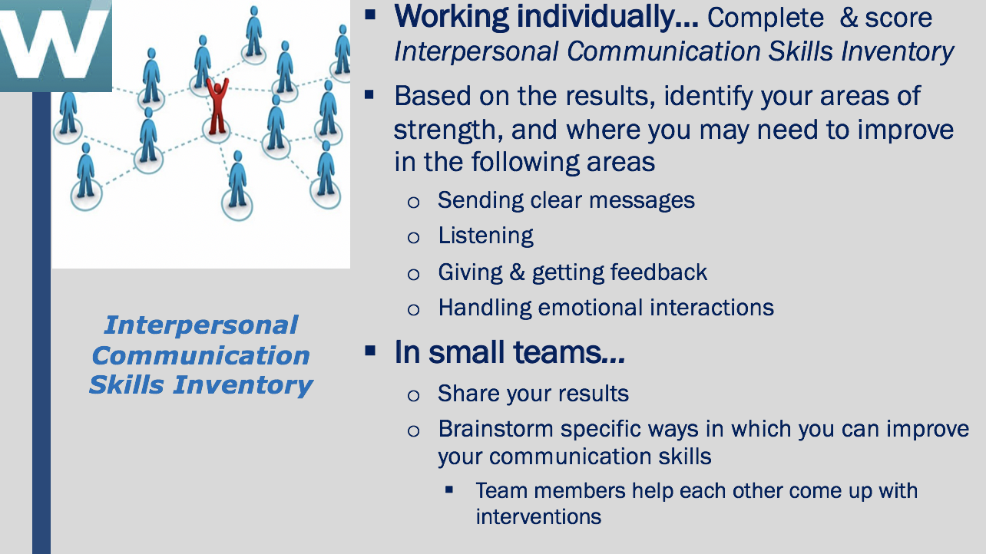
Interpersonal Communication Skills Inventory
This Interpersonal Communication Skills Inventory is designed to provide you with some insights into your communication strengths and potential areas for development. By answering each question candidly, you will receive a profile that displays your level of competence in four key communication areas:
- Sending clear messages
- Listening
- Giving and Getting Feedback
- Handling Emotional Interactions
How to Complete the Inventory
To complete this inventory, read each statement carefully and honestly assess how often the particular statement applies to you. Place a check mark in the column that best describes the frequency -- Usually, Sometimes, or Seldom
Complete all four sections of the inventory.

Section 1
 | Usually | Sometimes | Seldom
1. Is it difficult for you to talk to other people?
2. When you are trying to explain some- thing, do others tend to put words in your mouth, or finish your sentences for you?
3. In conversation, do your words usually come out the way you would like?
4. Do you find it difficult to express your ideas when they differ from the ideas of people around you?
5. Do you assume that the other person knows what you are trying to say, and leave it to him/her to ask you questions?
6. Do others seem interested and attentive when you are talking to them?
7. When speaking, is it easy for you to recognize how others are reacting to what you are saying?
8. Do you ask the other person to tell you how she/he feels about the point you are trying to make?
9. Are you aware of how your tone of voice may affect others?
10. In conversation, do you look to talk about things of interest to both you and the other person?
SCORE: SECTION 1 TOTAL ________
Section 2
 | Usually | Sometimes | Seldom
11. In conversation, do you tend to do more talking than the other person does?
12. In conversation, do you ask the other person questions when you don’t understand what they’ve said?
13. In conversation, do you often try to figure out what the other person is going to say before they’ve finished talking?
14. Do you find yourself not paying attention while in conversation with others?
15. In conversation, can you easily tell the difference between what the person is saying and how he/she may be feeling?
16. After the other person is done speaking, do you clarify what you heard them say before you offer a response?
17. In conversation, do you tend to finish sentences or supply words for the other person?
18. In conversation, do you find yourself paying most attention to facts and details, and frequently missing the emotional tone of the speakers’ voice?
19. In conversation, do you let the other person finish talking before reacting to what she/he says?
20. Is it difficult for you to see things from the other person’s point of view?
SCORE: SECTION 2 TOTAL ________
Section 3
 | Usually | Sometimes | Seldom
21. Is it difficult to hear or accept constructive criticism from the other person?
22. Do you refrain from saying some- thing that you think will upset someone or make matters worse?
23. When someone hurts your feelings, do you discuss this with him/her?
24. In conversation, do you try to put yourself in the other person’s shoes?
25. Do you become uneasy when someone pays you a compliment?
26. Do you find it difficult to disagree with others because you are afraid they will get angry?
27. Do you find it difficult to compliment or praise others?
28. Do others remark that you always seem to think you are right?
29. Do you find that others seem to get defensive when you disagree with their point of view?
30. Do you help others to understand you by saying how you feel?
SCORE: SECTION 3 TOTAL ________
Section 4
31. Do you have a tendency to change the subject when the other person’s feelings enter into the discussion? | Usually | Sometimes | Seldom
32. Does it upset you a great deal when someone disagrees with you?
33. Do you find it difficult to think clearly when you are angry with someone?
34. When a problem arises between you and another person, can you discuss it without getting angry?
35. Are you satisfied with the way you handle differences with others?
36. Do you sulk for a long time when someone upsets you?
37. Do you apologize to someone whose feelings you may have hurt?
38. Do you admit that you’re wrong when you know that you are/were wrong about something?
39. Do you avoid or change the topic if someone is expressing his or her feelings in a conversation?
40. When someone becomes upset, do you find it difficult to continue the conversation?
SCORE: SECTION 4 TOTAL ________
Scoring Key
Go back and look over your responses to each question. In front of each question, write the appropriate score (1, 2 or 3) using the Scoring Table below. For example, if you answered “Seldom” to Question 1, you would get 3 points. Write the number 3 in front of Question 1 on the inventory. If you answered “Usually” to Question 2, you would get 0 points and would write the number 0 in front of Question 2 on the inventory. Score all 10 questions in each section this way.
After scoring all questions, go back to Section 1. Total the score of Section 1 and put that number on the line “Score Section 1 Total.” Proceed to total all scores for all other sections.
Enter your TOTAL score for all 4 sections here: ________
Scoring Table
Question | Usually | Sometimes | Seldom |  | Question | Usually | Sometimes | Seldom
1 | 0 | 1 | 3 |  | 21 | 0 | 1 | 3
2 | 0 | 1 | 3 |  | 22 | 3 | 1 | 0
3 | 3 | 1 | 0 |  | 23 | 3 | 1 | 0
4 | 0 | 1 | 3 |  | 24 | 3 | 1 | 0
5 | 0 | 1 | 3 |  | 25 | 0 | 1 | 3
6 | 3 | 1 | 0 |  | 26 | 0 | 1 | 3
7 | 3 | 1 | 0 |  | 27 | 0 | 1 | 3
8 | 3 | 1 | 0 |  | 28 | 0 | 1 | 3
9 | 3 | 1 | 0 |  | 29 | 0 | 1 | 3
10 | 3 | 1 | 0 |  | 30 | 3 | 1 | 0
11 | 0 | 1 | 3 |  | 31 | 0 | 1 | 3
12 | 3 | 1 | 0 |  | 32 | 0 | 1 | 3
13 | 0 | 1 | 3 |  | 33 | 0 | 1 | 3
14 | 0 | 1 | 3 |  | 34 | 3 | 1 | 0
15 | 3 | 1 | 0 |  | 35 | 3 | 1 | 0
16 | 3 | 1 | 0 |  | 36 | 0 | 1 | 3
17 | 0 | 1 | 3 |  | 37 | 3 | 1 | 0
18 | 0 | 1 | 3 |  | 38 | 3 | 1 | 0
19 | 3 | 1 | 0 |  | 39 | 0 | 1 | 3
20 | 0 | 1 | 3 |  | 40 | 0 | 1 | 3
Interpersonal Communication Profile
Look at your score for each section as one indication of the degree to which you effectively communicate. Plot your scores on the table below using an “X” for each section score. Draw a line to connect them column to column. This will create a profile of your strengths and opportunities for improvement.
- Scores in the 1 > 15 range indicate areas of your communication skills that need improvement.
- Scores in the 16 > 21 range indicate areas of communication skills that need more consistent attention.
- Scores in the 22 > 30 range indicate areas of strength or potential strength.
Score Section 1 Total Sending Clear Messages | Score Section 2 Total Listening | Score Section 3 Total Giving and Getting Feedback | Score Section 4 Total Handling Emotional Interactions
30 | 30 | 30 | 30
29 | 29 | 29 | 29
28 | 28 | 28 | 28
27 | 27 | 27 | 27
26 | 26 | 26 | 26
25 | 25 | 25 | 25
24 | 24 | 24 | 24
23 | 23 | 23 | 23
22 | 22 | 22 | 22
21 | 21 | 21 | 21
20 | 20 | 20 | 20
19 | 19 | 19 | 19
18 | 18 | 18 | 18
17 | 17 | 17 | 17
16 | 16 | 16 | 16
15 | 15 | 15 | 15
14 | 14 | 14 | 14
13 | 13 | 13 | 13
12 | 12 | 12 | 12
11 | 11 | 11 | 11
10 | 10 | 10 | 10
9 | 9 | 9 | 9
8 | 8 | 8 | 8
7 | 7 | 7 | 7
6 | 6 | 6 | 6
5 | 5 | 5 | 5
4 | 4 | 4 | 4
3 | 3 | 3 | 3
2 | 2 | 2 | 2
1 | 1 | 1 | 1
Area(s) of Strength:

Area(s) of Improvement:

Class Debrief
- Explore with the students whether or not other team members had different strengths, and weaknesses, or were they pretty consistent among everyone on the team
- Ask students if the results of the inventory were consistent with their beliefs about their own interpersonal communication skills.

Desired Learning
The Interpersonal Communications Skills Inventory allows students to assess, much more deeply, their communication skills. It integrates four important areas of communication which underscores that communication is multi-dimensional; Sending clear messages, listening, giving and receiving feedback, and handling emotional interactions. With so many aspects of communication, it is easier to see how breakdowns in communication can occur. As the next stop in skill building, students will use the results of this assessment to develop a personal plan to strengthen their interpersonal communication skills.

Time 50 minutes
Complete Inventory: 15 minutes
Score Inventory: 15 minutes
Group Discussion: 15 minutes
Class Debrief: 5 minutes
Source: https://wicworks.fns.usda.gov/wicworks/Sharing_Center/CT/Inventory.pdf

Activity: Interpersonal Communication Skills - Developing an Improvement Plan

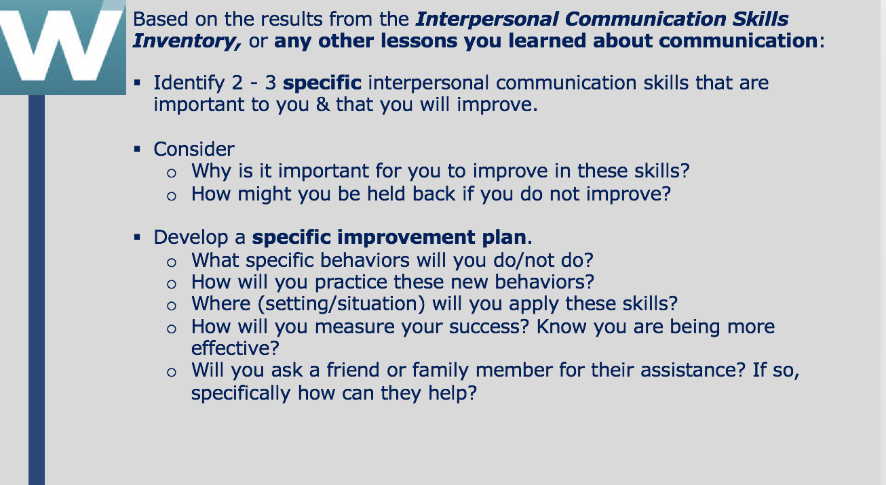
Desired Learning
This activity allows students to think about what communication skills they feel are most important for themselves at this stage of their lives, and make a very specific plan to strengthen those skills. It requires them to not only think about why these particular skills are so important, but what could be the negative consequences if they do not improve. It also makes students think about what success looks like, and how will they know that they are improving. This is their own internal feedback loop.

Time 25 minutes
Individual student work: 25 minutes

Homework: Improving your Communication by Observing Others

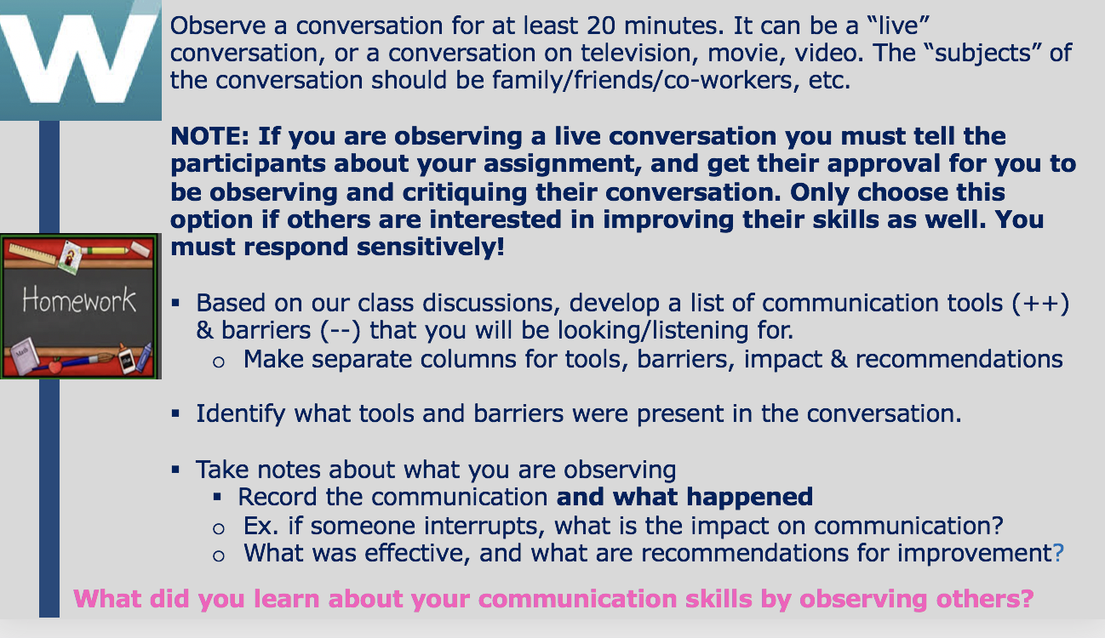
NOTE: There is about 60 minutes remaining in Class Session #8. This is a good time to have a conversation with the students about the time that you spent together in the class. Here are some discussion starters:
- What was the most important thing(s) that you learned in this class, and why are they so important to you?
- What did you learn about yourself? What surprised you most about yourself?
Next you can ask them to take a look at their Lessons Learned Homework from the past 7 days and share some of their insights.

Homework: Lessons Learned - Effective Interpersonal Communication

Individual Student “TED” Talks

Note: There is no slide for this. Instructions are on the syllabus.

Each student is going to prepare and give their own personal “TED” Talk. Here are the particulars:

- 5-6 minute talk with about 2 minutes for questions from the audience
- The talk must be built around an idea or story. Any idea or story you want to share, but it must be something important to you, and hopefully to the audience (other students) as well
- Up to five PPT slides can be used, but they should be for a backdrop only, not to talk from
- Review several TED Talks to get a feeling for them. However, each individual has their own idea and style, you are not trying to copy anyone, just trying to get a sense of what a TED talk is all about.

Desired Learning
The TED Talks will provide students with the experience of:
- Completing a project with very little guidance
- Selecting a topic that they care about (and they want others to care about) through self-reflection
- Speaking in front of others with confidence
- Overcoming discomfort

Teaching Notes
- The TED Talks will take place during the last two course modules.
- Plan on about 10 minutes per talk
  - 5-6 minute talk
  - 2 minutes Q and A
  - 2 minutes is easily taken up with overruns (if allowed) and transitioning from one student to the next

