Skills for Life! Pursuing your Dreams with Confidence & Determination
(“Life Skills Orientation”)

STUDENT WORKBOOK

Symbols Used Throughout PPT Slides

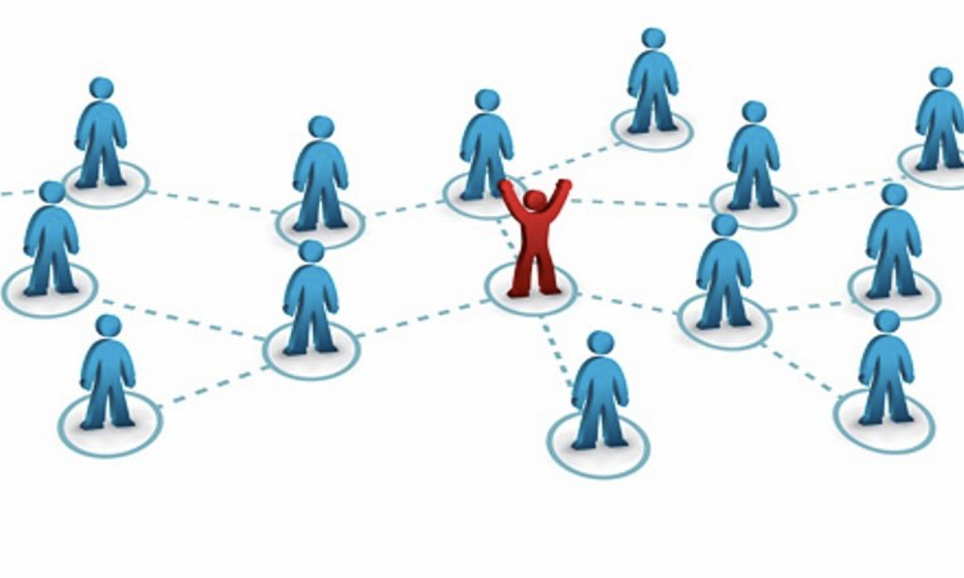
Class Discussion Workbook Activity Individual Thought/ Team Work Homework
Team Discussion

Table of Contents

Daily Schedule 5
Module: Transition from High School to the University 6
Activity: Introductions 7
Video: The Milk Bum 9
Activity: Difference between High School and University 10
Homework: Beyond the Books 12
Homework: Lessons Learned - Difference between High School and the University 14
Module: Collaboration - Working in High-performing Teams 16
Activity: Considering Previous Team Membership 17
Activity: Stranded on a Desert Island 18
Activity: Abilene Paradox – The Management of Agreement 20
Activity: Planning for IT Team Assignment Part I 22
Activity: The Case of the Missing Team Member 24
Activity: Planning for IT Team Assignment Part II 26
Homework: Lessons Learned - Working in High-performing Teams 28
Module: Developing Effective Presentation Skills 30
Activity: Assessing Body Language 31
Homework: How Can I Help? 35
Homework: Lessons Learned - Developing Effective Presentations 37
Team Presentations - Time Management and Organizational Skills 39
Module: Meeting Life’s Challenges with Confidence and Determination 40
Activity: “Know thyself” Values, Social Identity & Vision 41
Values Exercise 41
Self-reflection- Your personal vision 47
Homework: How to Increase your Self-Confidence 49
Video: An Exercise in Empathy 51
Activity: When your Emotions Worked Against You 52
Activity: How Emotionally Intelligent Are You? 54
Activity: Relational Civility “Mirror” Measurement 64
Activity: Are you Trustworthy? 68
Homework: At the End of the Day… 69
Homework: Lessons Learned - Meeting Life’s Challenges with Confidence and Determination 71
Module: Effective Interpersonal Communication 73
Activity: Let’s Draw 74
Activity: Contradicting Messages 79
Activity: The Train Left the Station 80
Activity: Choosing your Words Carefully - Late for the Movies, Again… 81
Activity: Listening Bad Habits 83
Activity: Interpersonal Communication Skills Inventory 85
Activity: Interpersonal Communication Skills - Developing an Improvement Plan 92
Homework: Improving your Communication by Observing Others 94
Homework: Lessons Learned - Effective Interpersonal Communication 96
Individual Student “TED” Talks 98

Daily Schedule

Week #1

Session #1 Transition from High School to the University Part 1

Session #2 Transition from High School to the University Part 2
PPU Student Panel

Collaboration: Working in High Performing Teams Part 1

Session #3 Collaboration: Working in High Performing Teams Part 2

Session #4 Developing Effective Presentation Skills
Meeting Life’s Challenges Confidence & Determination Part 1

Session #5 Meeting Life’s Challenges with Confidence and Determination Part 2

Week #2

Session #6 Team Presentations - Time Management & Organizational Skills

Session #7 Interpersonal Communication for Positive Relationships Part 1

Session #8 Interpersonal Communication Skills for Positive Relationships Part 2

Session #9 Student “TED” Talks

Session #10 Student “TED” Talks
Saying Goodbye

Module: Transition from High School to the University

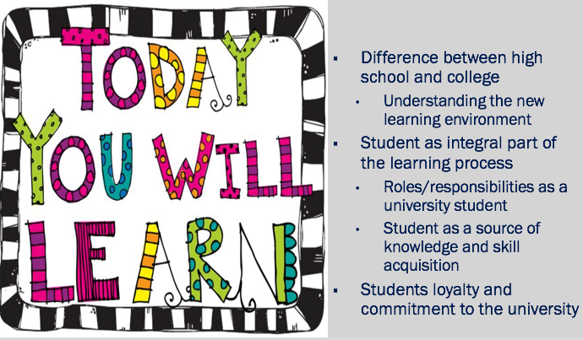

Activity: Introductions

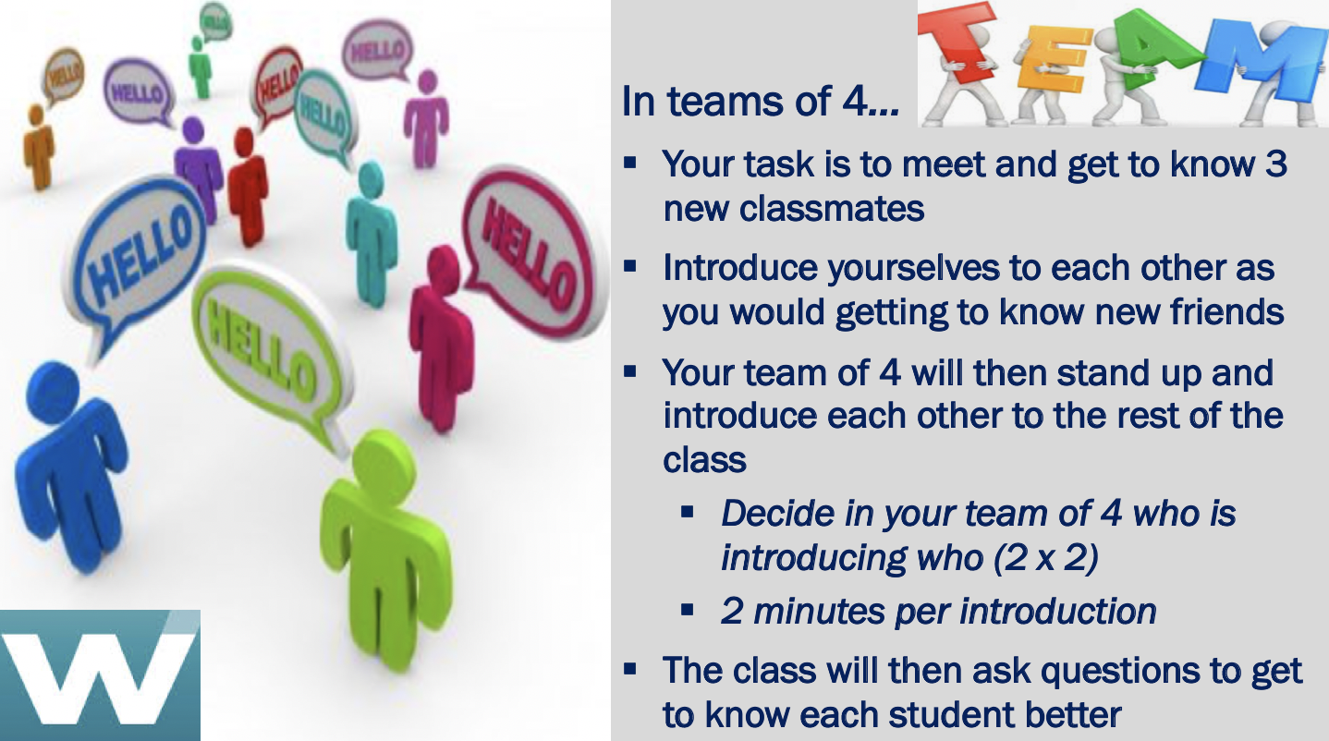

_______________________________________________________________________________________________________________________________________________________________________________________________________________________________________________________________________________________________________________________________________________________________________________________
_______________________________________________________________________________________________________________________________________________________________________________________________________________________________________________________________________________________________________________________________________________________________________________________
______________________________________________________________________________________________________________________________________________________________________________________________________________________________________________________________________________________________________________________________________________________________________________________________________________________________________________________________________________________________________________________________________________________________________________________________________________________________________________________________________________________________________________________________________________________________________________
_______________________________________________________________________________________________________________________________________________________________________________________________________________________________________________________________________________________________________________________________________________________________________________________
_______________________________________________________________________________________________________________________________________________________________________________________________________________________________________________________________________________________________________________________________________________________________________________________
_______________________________________________________________________________________________________________________________________________________________________________________________________________________________________________________________________________________________________________________________________________________________________________________
_______________________________________________________________________________________________________________________________________________________________________________________________________________________________________________________________________________________________________________________________________________________________________________________

Video: The Milk Bum

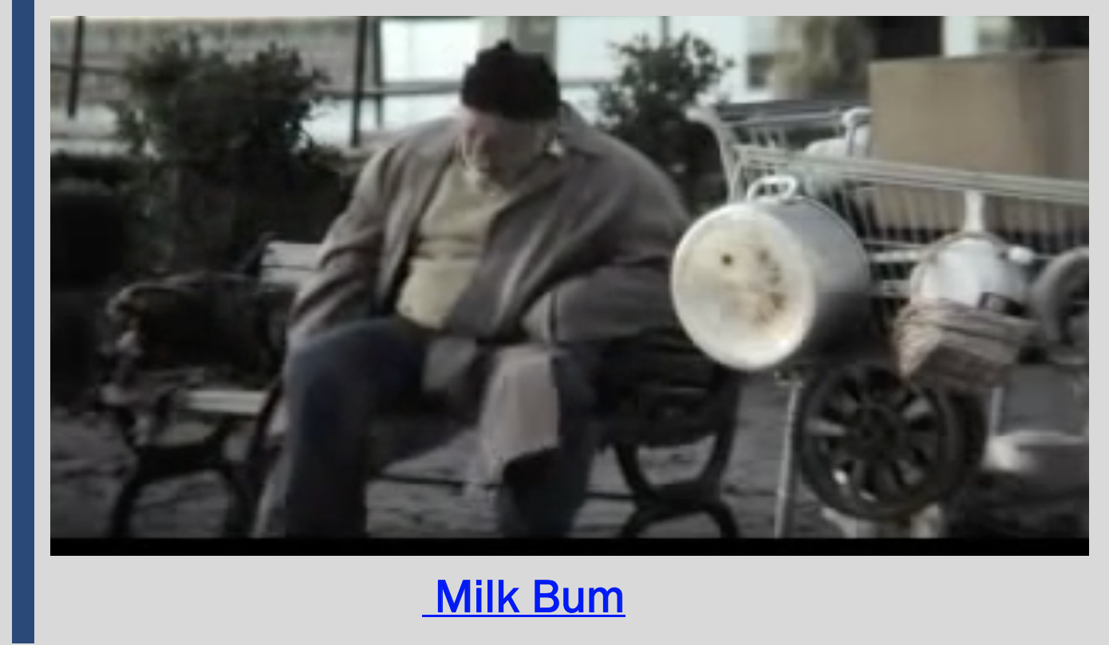
https://www.youtube.com/watch?v=uJEctnzOOxE

_______________________________________________________________________________________________________________________________________________________________________________________________________________________________________________________________________________________________________________________________________________________________________________________
_______________________________________________________________________________________________________________________________________________________________________________________________________________________________________________________________________________________________________________________________________________________________________________________
_______________________________________________________________________________________________________________________________________________________________________________________________________________________________________________________________________________________________________________________________________________________________________________________

Activity: Difference between High School and University

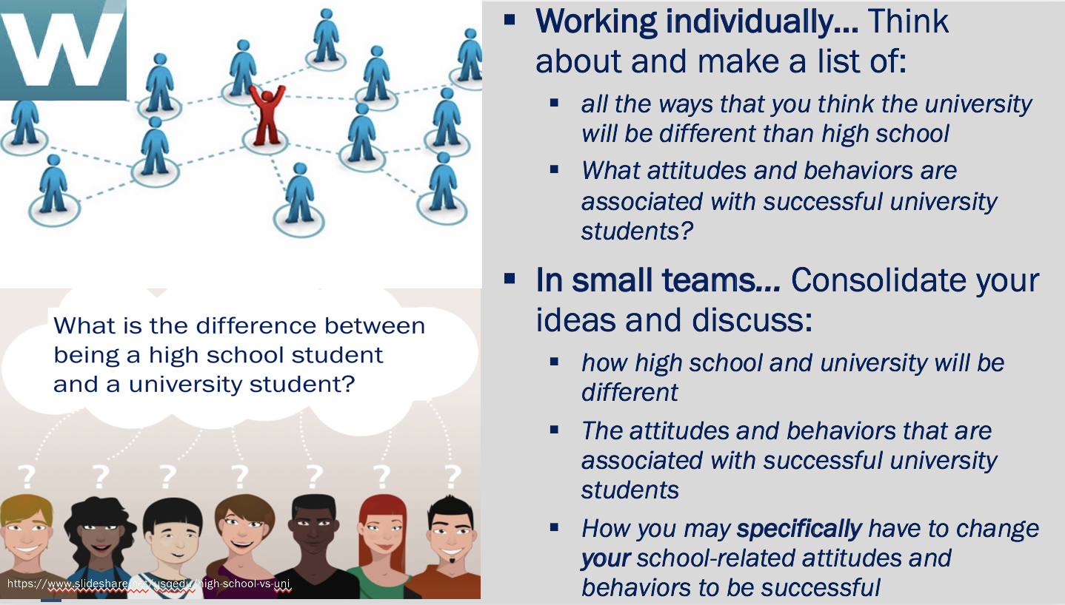

_______________________________________________________________________________________________________________________________________________________________________________________________________________________________________________________________________________________________________________________________________________________________________________________
_______________________________________________________________________________________________________________________________________________________________________________________________________________________________________________________________________________________________________________________________________________________________________________________
______________________________________________________________________________________________________________________________________________________________________________________________________________________________________________________________________________________________________________________________________________________________________________________________________________________________________________________________________________________________________________________________________________________________________________________________________________________________________________________________________________________________________________________________________________________________________________
_______________________________________________________________________________________________________________________________________________________________________________________________________________________________________________________________________________________________________________________________________________________________________________________
_______________________________________________________________________________________________________________________________________________________________________________________________________________________________________________________________________________________________________________________________________________________________________________________
_______________________________________________________________________________________________________________________________________________________________________________________________________________________________________________________________________________________________________________________________________________________________________________________
_______________________________________________________________________________________________________________________________________________________________________________________________________________________________________________________________________________________________________________________________________________________________________________________

Homework: Beyond the Books

_______________________________________________________________________________________________________________________________________________________________________________________________________________________________________________________________________________________________________________________________________________________________________________________
_______________________________________________________________________________________________________________________________________________________________________________________________________________________________________________________________________________________________________________________________________________________________________________________
_______________________________________________________________________________________________________________________________________________________________________________________________________________________________________________________________________________________________________________________________________________________________________________________
_______________________________________________________________________________________________________________________________________________________________________________________________________________________________________________________________________________________________________________________________________________________________________________________
_______________________________________________________________________________________________________________________________________________________________________________________________________________________________________________________________________________________________________________________________________________________________________________________
_______________________________________________________________________________________________________________________________________________________________________________________________________________________________________________________________________________________________________________________________________________________________________________________
_______________________________________________________________________________________________________________________________________________________________________________________________________________________________________________________________________________________________________________________________________________________________________________________
_______________________________________________________________________________________________________________________________________________________________________________________________________________________________________________________________________________________________________________________________________________________________________________________

Homework: Lessons Learned - Difference between High School and the University

_______________________________________________________________________________________________________________________________________________________________________________________________________________________________________________________________________________________________________________________________________________________________________________________
_______________________________________________________________________________________________________________________________________________________________________________________________________________________________________________________________________________________________________________________________________________________________________________________
_______________________________________________________________________________________________________________________________________________________________________________________________________________________________________________________________________________________________________________________________________________________________________________________
_______________________________________________________________________________________________________________________________________________________________________________________________________________________________________________________________________________________________________________________________________________________________________________________
_______________________________________________________________________________________________________________________________________________________________________________________________________________________________________________________________________________________________________________________________________________________________________________________
_______________________________________________________________________________________________________________________________________________________________________________________________________________________________________________________________________________________________________________________________________________________________________________________
_______________________________________________________________________________________________________________________________________________________________________________________________________________________________________________________________________________________________________________________________________________________________________________________
_______________________________________________________________________________________________________________________________________________________________________________________________________________________________________________________________________________________________________________________________________________________________________________________

Module: Collaboration - Working in High-performing Teams

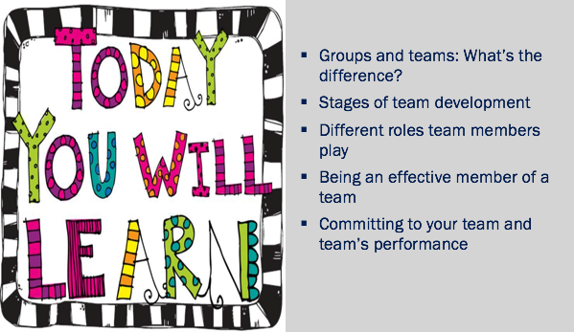

Activity: Considering Previous Team Membership

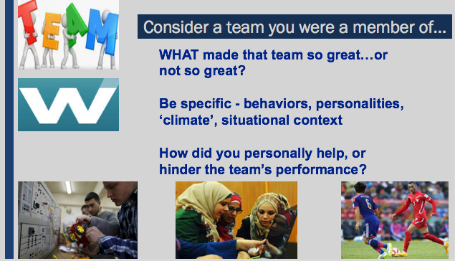

_______________________________________________________________________________________________________________________________________________________________________________________________________________________________________________________________________________________________________________________________________________________________________________________
_______________________________________________________________________________________________________________________________________________________________________________________________________________________________________________________________________________________________________________________________________________________________________________________
_______________________________________________________________________________________________________________________________________________________________________________________________________________________________________________________________________________________________________________________________________________________________________________________

Activity: Stranded on a Desert Island

Read through the following scenario:
Your work team earned a trip as a reward for exceeding your sales goals last year. You all boarded the S.S. Clipper for a relaxing week-long cruise in the Pacific Ocean. You encountered a bad storm and the ship just barely made it to shore and partially sank. Only the top of the ship is still visible off the north side of the island. You are all now stranded on an uninhabited island in the middle of the Ocean. The storm ruined most things on board, leaving very few items.
Your task is to choose 12 items that you think would be most useful to help you survive on this deserted island. First, write a list of 12 items that you would individually like to have on hand to survive on the island.
Next, work with your team to create a master list of items to choose from. Your next task is to work together to come up with a list of the 12 most important items you feel would help the group survive on this island for the next six months. Hopefully by then you will be rescued. Rate the final list of items in order of importance, with 1 being most important through 12 being the least important item on your list.
_______________________________________________________________________________________________________________________________________________________________________________________________________________________________________________________________________________________________________________________________________________________________________________________
_______________________________________________________________________________________________________________________________________________________________________________________________________________________________________________________________________________________________________________________________________________________________________________________
_______________________________________________________________________________________________________________________________________________________________________________________________________________________________________________________________________________________________________________________________________________________________________________________
_______________________________________________________________________________________________________________________________________________________________________________________________________________________________________________________________________________________________________________________________________________________________________________________
_______________________________________________________________________________________________________________________________________________________________________________________________________________________________________________________________________________________________________________________________________________________________________________________
_______________________________________________________________________________________________________________________________________________________________________________________________________________________________________________________________________________________________________________________________________________________________________________________

Activity: Abilene Paradox – The Management of Agreement

The story…
On a hot afternoon visiting in Coleman, Texas, the family is comfortably playing dominoes on a porch, until the father-in-law suggests that they take a trip to Abilene [53 miles north] for dinner. The daughter says, “Sounds like a great idea.” The son-in-law, despite having reservations because the drive is long and hot, thinks that his preferences must be out-of-step with the group and says, “Sounds good to me. I just hope your mother wants to go.” The mother-in-law then says, “Of course I want to go. I haven’t been to Abilene in a long time.”
The drive is hot, dusty, and long. When they arrive at the cafeteria, the food is as bad as the drive. They arrive back home four hours later, exhausted and still hungry. One of them dishonestly says, “It was a great trip, wasn’t it?” The mother-in-law says that, actually, she would rather have stayed home, but went along since the other three were so enthusiastic. The husband says, “I wasn’t delighted to be doing what we were doing. I only went to satisfy the rest of you.” The wife says, “I just went along to keep you happy. I would have had to be crazy to want to go out in the heat like that.” The father-in-law then says that he only suggested it because he thought the others might be bored.
The group sits back, perplexed that they together decided to take a trip which none of them wanted. They each would have preferred to sit comfortably, but did not admit to it when they still had time to enjoy the afternoon.

Why did this happen?

___________________________________________________________________________________________________________________________________________________________________________________________________________________________________________________________________________________________________________________________________________________________________________________
_______________________________________________________________________________________________________________________________________________________________________________________________________________________________________________________________________________________________________________________________________________________________________________________
______________________________________________________________________________________________________________________________________________________________________________________________________________________________________________________________________________________________________________________________________________________________________________________________________________________________________________________________________________________________________________________________________________________________________________________________________________________________________________________________________________________________________________________________________________________________________________
_______________________________________________________________________________________________________________________________________________________________________________________________________________________________________________________________________________________________________________________________________________________________________________________
_________________________________________________________________________________________________________________________________________________________________________________________________________________________________

Activity: Planning for IT Team Assignment Part I

_______________________________________________________________________________________________________________________________________________________________________________________________________________________________________________________________________________________________________________________________________________________________________________________
_______________________________________________________________________________________________________________________________________________________________________________________________________________________________________________________________________________________________________________________________________________________________________________________
_______________________________________________________________________________________________________________________________________________________________________________________________________________________________________________________________________________________________________________________________________________________________________________________
_______________________________________________________________________________________________________________________________________________________________________________________________________________________________________________________________________________________________________________________________________________________________________________________
_______________________________________________________________________________________________________________________________________________________________________________________________________________________________________________________________________________________________________________________________________________________________________________________
_______________________________________________________________________________________________________________________________________________________________________________________________________________________________________________________________________________________________________________________________________________________________________________________
_______________________________________________________________________________________________________________________________________________________________________________________________________________________________________________________________________________________________________________________________________________________________________________________
_______________________________________________________________________________________________________________________________________________________________________________________________________________________________________________________________________________________________________________________________________________________________________________________

Activity: The Case of the Missing Team Member

The story…
Your Environmental Studies Professor has assigned the class a case study to analyze. She has assigned four-person teams to complete the project which requires a 20-page paper as well as a presentation to the class. Your team met during class to discuss the project and begin to lay out a plan. Everybody on the team appears enthusiastic and commits to working hard. Not long after this preliminary meeting, the team can see that there is a problem with one of the members. He does not show up at most meetings and doesn’t let team members know in advance if he cannot attend. When he does come, he generally has either not done the work that he was supposed to, or the quality is so poor that it is not usable. He always has an excuse for his performance and promises to do better.

What should the team do?

_______________________________________________________________________________________________________________________________________________________________________________________________________________________________________________________________________________________________________________________________________________________________________________________
______________________________________________________________________________________________________________________________________________________________________________________________________________________________________________________________________________________________________________________________________________________________________________________________________________________________________________________________________________________________________________________________________________________________________________________________________________________________________________________________________________________________________________________________________________________________________________
_______________________________________________________________________________________________________________________________________________________________________________________________________________________________________________________________________________________________________________________________________________________________________________________
_______________________________________________________________________________________________________________________________________________________________________________________________________________________________________________________________________________________________________________________________________________________________________________________
_______________________________________________________________________________________________________________________________________________________________________________________________________________________________________________________________________________________________________________________________________________________________________________________
_______________________________________________________________________________________________________________________________________________________________________________________________________________________________________________________________________________________________________________________________________________________________________________________

Activity: Planning for IT Team Assignment Part II

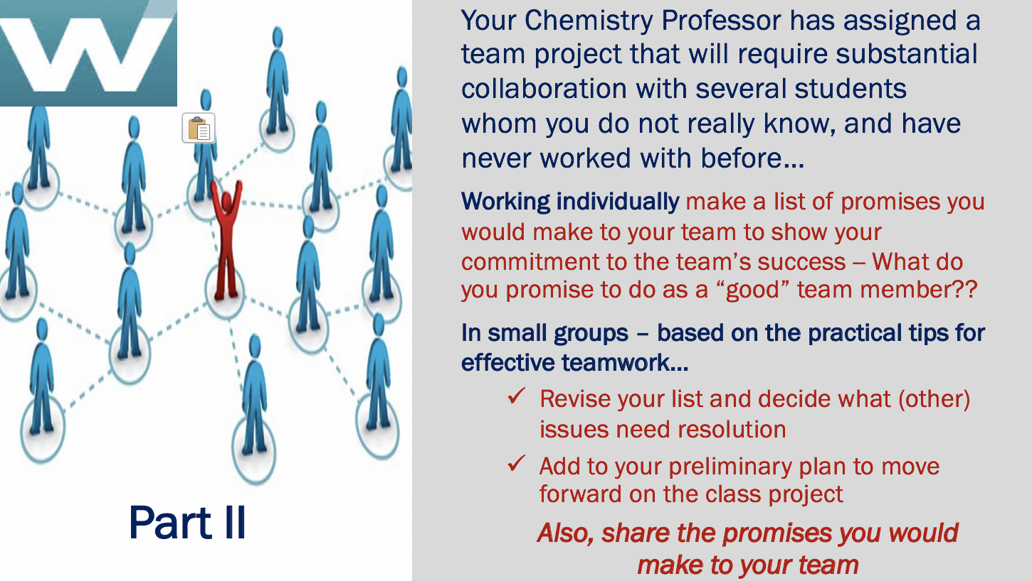

_______________________________________________________________________________________________________________________________________________________________________________________________________________________________________________________________________________________________________________________________________________________________________________________
_______________________________________________________________________________________________________________________________________________________________________________________________________________________________________________________________________________________________________________________________________________________________________________________
_______________________________________________________________________________________________________________________________________________________________________________________________________________________________________________________________________________________________________________________________________________________________________________________
_______________________________________________________________________________________________________________________________________________________________________________________________________________________________________________________________________________________________________________________________________________________________________________________
_______________________________________________________________________________________________________________________________________________________________________________________________________________________________________________________________________________________________________________________________________________________________________________________
_______________________________________________________________________________________________________________________________________________________________________________________________________________________________________________________________________________________________________________________________________________________________________________________
_______________________________________________________________________________________________________________________________________________________________________________________________________________________________________________________________________________________________________________________________________________________________________________________
_______________________________________________________________________________________________________________________________________________________________________________________________________________________________________________________________________________________________________________________________________________________________________________________

Homework: Lessons Learned - Working in High-performing Teams

_______________________________________________________________________________________________________________________________________________________________________________________________________________________________________________________________________________________________________________________________________________________________________________________
_______________________________________________________________________________________________________________________________________________________________________________________________________________________________________________________________________________________________________________________________________________________________________________________
_______________________________________________________________________________________________________________________________________________________________________________________________________________________________________________________________________________________________________________________________________________________________________________________
_______________________________________________________________________________________________________________________________________________________________________________________________________________________________________________________________________________________________________________________________________________________________________________________
_______________________________________________________________________________________________________________________________________________________________________________________________________________________________________________________________________________________________________________________________________________________________________________________
_______________________________________________________________________________________________________________________________________________________________________________________________________________________________________________________________________________________________________________________________________________________________________________________
_______________________________________________________________________________________________________________________________________________________________________________________________________________________________________________________________________________________________________________________________________________________________________________________
_______________________________________________________________________________________________________________________________________________________________________________________________________________________________________________________________________________________________________________________________________________________________________________________

Module: Developing Effective Presentation Skills

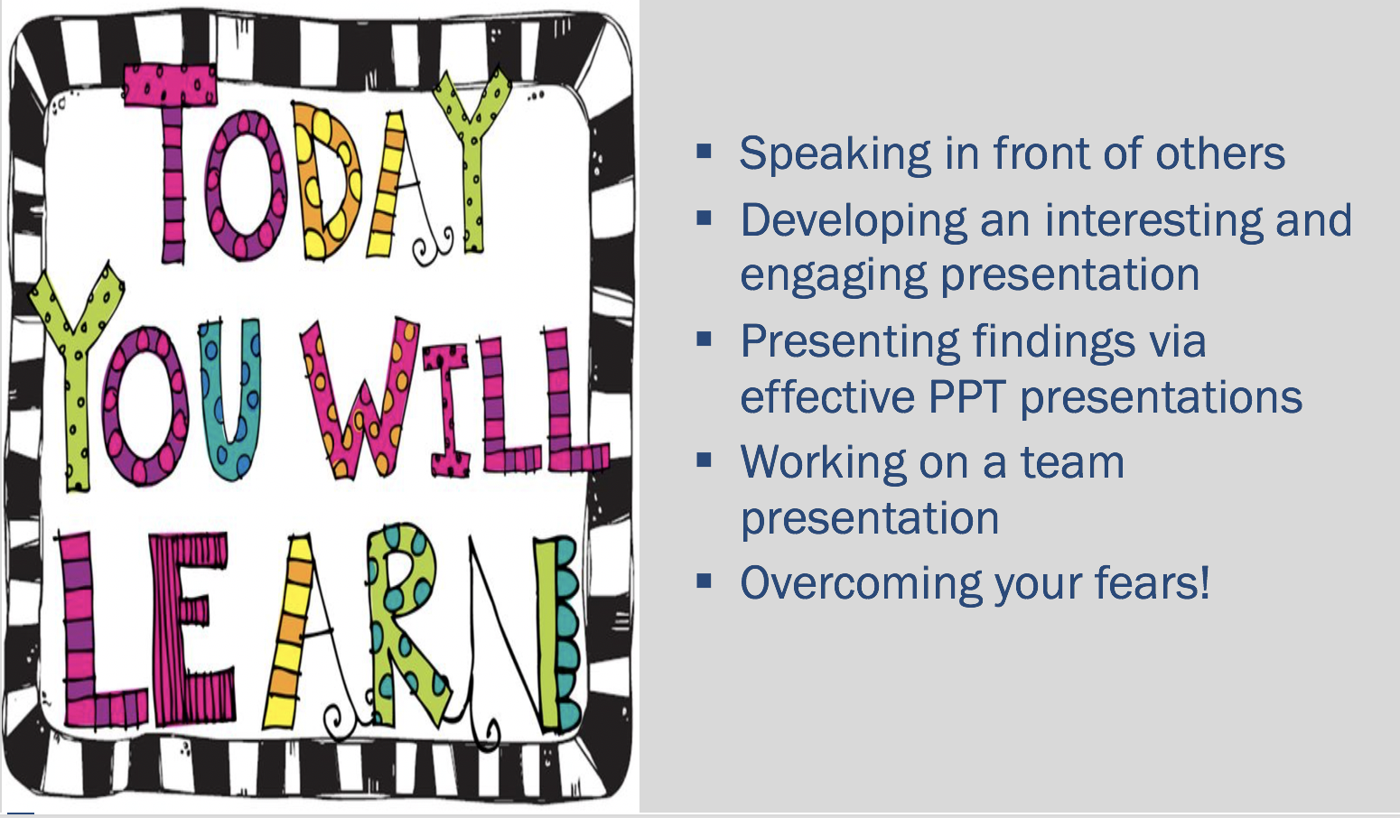

Activity: Assessing Body Language

Watch the physical movements (the skills at top of the rubric below) without listening to the content.

Score Bill Gates and the other two speakers, Bjorn Lomborg and Jamie Oliver, using a 1-3-5 rating scale across each of the six non-verbals and indicate why you awarded the particular scores.

1=bad
3= average
5=excellent

Speaker: | Professional Appearance | Facial Expression | Eye-Contact | Posture | Gestures | Movement
Bill Gates: Mosquitos, Malaria, and Education
Bjorn Lomberg: Set Global Priorities
Jamie Oliver: Teach Every Child About Food

_______________________________________________________________________________________________________________________________________________________________________________________________________________________________________________________________________________________________________________________________________________________________________________________
_______________________________________________________________________________________________________________________________________________________________________________________________________________________________________________________________________________________________________________________________________________________________________________________
_______________________________________________________________________________________________________________________________________________________________________________________________________________________________________________________________________________________________________________________________________________________________________________________
_______________________________________________________________________________________________________________________________________________________________________________________________________________________________________________________________________________________________________________________________________________________________________________________
_______________________________________________________________________________________________________________________________________________________________________________________________________________________________________________________________________________________________________________________________________________________________________________________

Homework: How Can I Help?

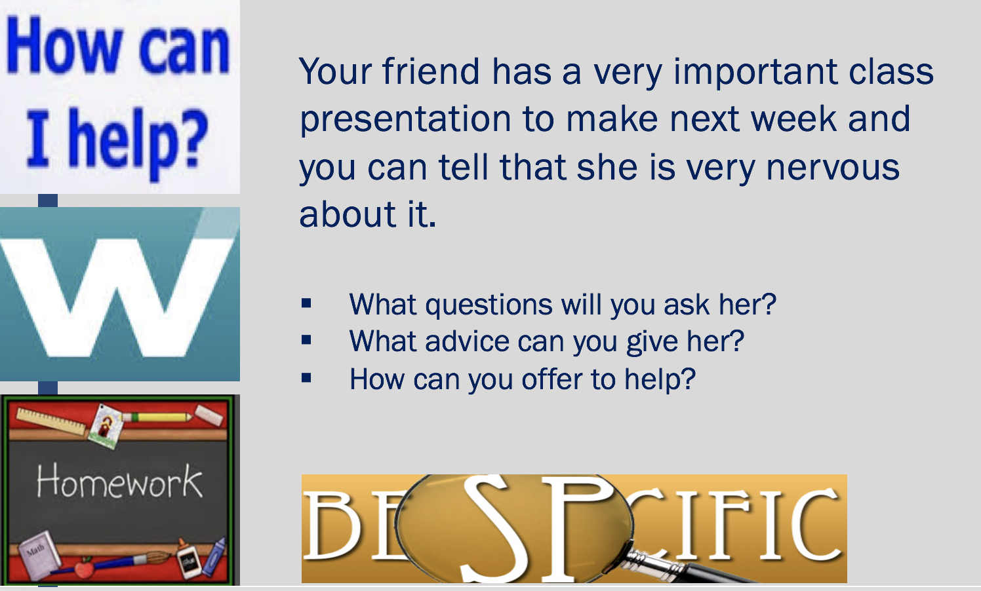

_______________________________________________________________________________________________________________________________________________________________________________________________________________________________________________________________________________________________________________________________________________________________________________________
_______________________________________________________________________________________________________________________________________________________________________________________________________________________________________________________________________________________________________________________________________________________________________________________
_______________________________________________________________________________________________________________________________________________________________________________________________________________________________________________________________________________________________________________________________________________________________________________________
_______________________________________________________________________________________________________________________________________________________________________________________________________________________________________________________________________________________________________________________________________________________________________________________
_______________________________________________________________________________________________________________________________________________________________________________________________________________________________________________________________________________________________________________________________________________________________________________________
_______________________________________________________________________________________________________________________________________________________________________________________________________________________________________________________________________________________________________________________________________________________________________________________
_______________________________________________________________________________________________________________________________________________________________________________________________________________________________________________________________________________________________________________________________________________________________________________________
_______________________________________________________________________________________________________________________________________________________________________________________________________________________________________________________________________________________________________________________________________________________________________________________

Homework: Lessons Learned - Developing Effective Presentations

_______________________________________________________________________________________________________________________________________________________________________________________________________________________________________________________________________________________________________________________________________________________________________________________
_______________________________________________________________________________________________________________________________________________________________________________________________________________________________________________________________________________________________________________________________________________________________________________________
_______________________________________________________________________________________________________________________________________________________________________________________________________________________________________________________________________________________________________________________________________________________________________________________
_______________________________________________________________________________________________________________________________________________________________________________________________________________________________________________________________________________________________________________________________________________________________________________________
_______________________________________________________________________________________________________________________________________________________________________________________________________________________________________________________________________________________________________________________________________________________________________________________
_______________________________________________________________________________________________________________________________________________________________________________________________________________________________________________________________________________________________________________________________________________________________________________________
_______________________________________________________________________________________________________________________________________________________________________________________________________________________________________________________________________________________________________________________________________________________________________________________
_______________________________________________________________________________________________________________________________________________________________________________________________________________________________________________________________________________________________________________________________________________________________________________________

Team Presentations - Time Management and Organizational Skills

Instructions
Students will be assigned into teams of approximately 4 students. Each student team will be responsible for developing and delivering a learning module for the class, on a topic related to Time Management and Organizational Skills. One topic will be randomly assigned to each team. You have very broad latitude on what you want to focus on, as long as your learning module is relevant to the topic you have been assigned.

Your goal is to facilitate the learning of your classmates with a 20-minute learning module supported with PPT slides. Consider the lessons you learned in the module about Effective Presentations to guide your work.

Make sure that you have a balance of content and active learning. Be as creative as possible. Role-plays, theatrical skits, short games, mini-cases, quizzes, videos and/or other interactive activities are strongly encouraged.

The success of your learning module will be based on ability to engage students in a relevant discussion, identification of important issues (and solutions if applicable), preparedness, quality of the presentation and PowerPoint slides, and contributions by all team members.

Content - Does the basic content of the learning module adequately cover the topic?
Level of detail - is the material presented at an appropriate level of detail? (Recognizing this is only a 20-minute module, it is best to “go deep” on a more narrow topic.)
Clarity - is the presentation easy to understand?
Organization - is the module well-organized?
Delivery - is the delivery engaging and interesting?
Engagement - Is the class actively involved?

I (and your team members) expect that each of you will contribute roughly the same amount of quality effort to this project, although it may be in very different ways. Work together in a way that capitalizes on your unique strengths. Some students excel in analyzing, organizing, planning, and follow-up, others in research, or writing, or using technology. However, all team members must actively lead the in-class discussion.

Module: Meeting Life’s Challenges with Confidence and Determination

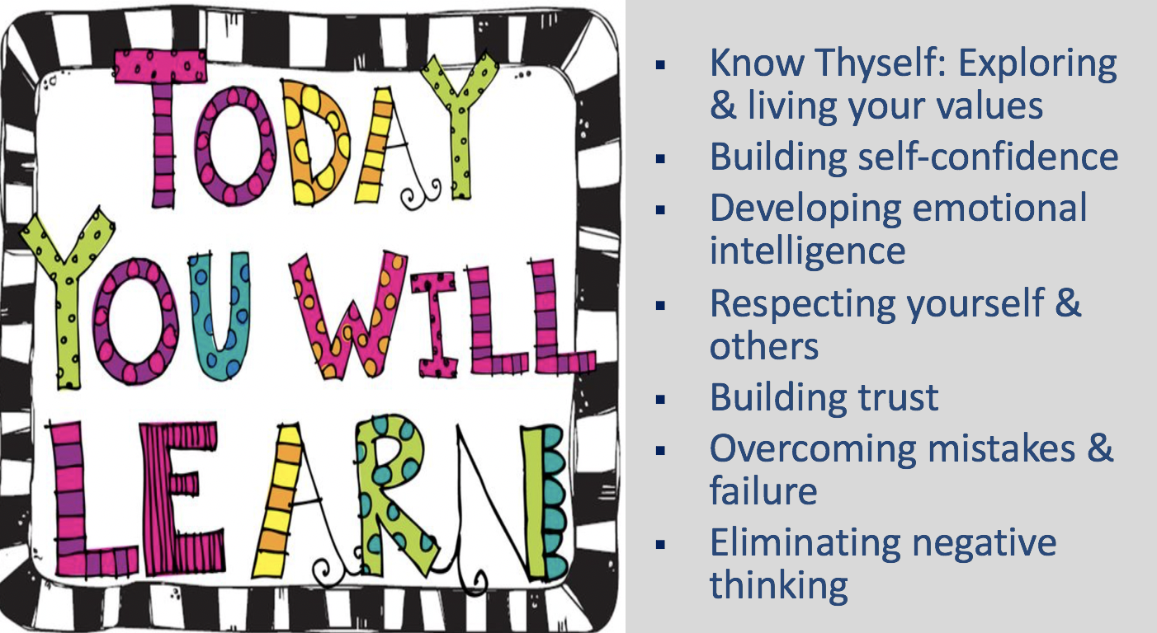

Activity: “Know thyself” Values, Social Identity & Vision

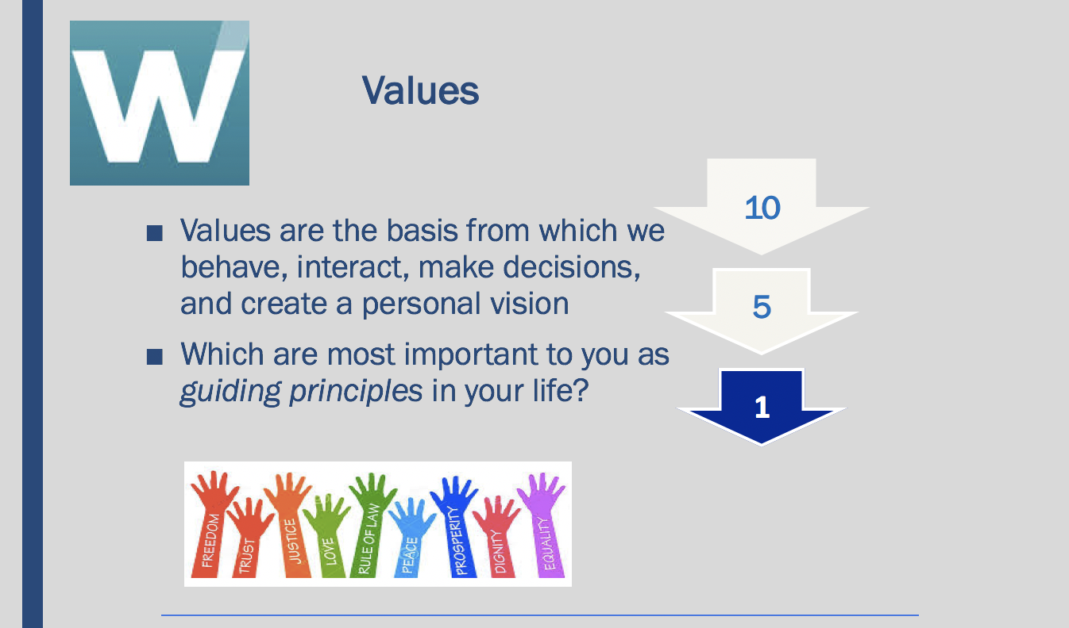

Values Exercise

The objective of this exercise is to help you clarify your values, or beliefs, at this time. Although our values and beliefs are relatively stable over time, they may change after deep reflection or after certain significant life events. Values are the basis from which we live, make decisions, behave, relate to others, and create a personal vision for our lives.

Attached is a list of about 50 values, beliefs or personal characteristics for your consideration. The following steps should help you identify which are most important to you as guiding principles in your life. You might find it useful to determine degrees of importance by considering whether you would be upset or elated if your present state or condition in life regarding a particular value would be significantly changed. Or, you might find it helpful to consider two values at a time, asking yourself about the relative importance of one over the other. The objective of this exercise is to help you clarify your values, or beliefs, at this time.

STEP #1:
- Please identify the 10 values that are most important to you.
- From this list of 10, identify the 5 that are the most important to you; and
- Rank each of the five most important (from 1 to 5), with “1” being THE most important of all.

You may add values if you do not see them on the list below.

ACHIEVEMENT | sense of accomplishment, success, contribution
AMBITIOUS | aspiring to promotion or progress within career
ADVENTURE | new and challenging experiences
AFFECTION | love, caring
BEAUTY | in nature, art or life
BROAD MINDED | open-minded
CHEERFUL | joyful
CLEAN | tidy, sanitary
COMPETENT | capable, effective
COMPETITIVENESS | winning, taking risks
COMFORTABLE LIFE | prosperous or easy life
COOPERATION | working well with others, teamwork
CREATIVITY | being imaginative, innovative
DISCIPLINED | self-controlled, restrained
DIVERSITY | appreciates differences
ECONOMIC SECURITY | steady, adequate income
EQUALITY | egalitarianism in life, equal opportunity for all
EXCITING LIFE | a stimulating or challenging life
FAME | being famous, well known
FAMILY HAPPINESS | nuclear and/or extended family that is happy
FAMILY SECURITY | nuclear and/or extended family that is safe
FORGIVING | willing to forget a judgment of others
FREEDOM | independence, free choice, self-reliant
FRIENDSHIP | close relationships, companionship
HAPPINESS | contentedness with life
HEALTH | being physically and mentally well
HELPFULNESS | assisting others, improving society
INNER HARMONY | being at peace with yourself
INTEGRITY | honesty, sincerity, genuineness
INVOLVEMENT | participating with others, belonging
INTELLECTUAL | conceptual, abstract, or symbolic
LOGICAL | rational
LOVING | affectionate, tender
LOYALTY | duty, respectfulness, obedience
NATIONAL SECURITY | protection from attack
ORDER | tranquility, stability, conformity
PEACE | a world at peace, without war or conflict
PERSONAL DEVELOPMENT | personal growth
PLEASURE | fun, an enjoyable, leisurely life-style
POLITE | courteous, well-mannered
POWER | control, authority, influence over others
RECOGNITION | social recognition, respect from others, status
RELATIONSHIPS | connections with or among others
RELIGION | strong religious beliefs
RESPONSIBLE | dependable, reliable
SALVATION | eternal peace
SELF-RESPECT | self-esteem, pride, sense of personal identity
SERVICE | work done to help others achieve
WEALTH | making money, getting rich
WISDOM | understanding life, discovering knowledge

STEP #2:
- Support why you selected the five most important values, answering the question “Why are each of these values so important to me?”

_____________________________________________________________________________________________________________________________________________________________________________________________________________________________________________________________________________________________________________________________________________________________________________________
_______________________________________________________________________________________________________________________________________________________________________________________________________________________________________________________________________________________________________________________________________________________________________________________
_______________________________________________________________________________________________________________________________________________________________________________________________________________________________________________________________________________________________________________________________________________________________________________________________________________________________________________________________________________________________________________________________________________________________________________________________________________________________________________________________________________________________________________________________________________________________________________________________________________________________________________________________________________________________________________________________________________________________________________________________________________
Social Identity
STEP 3:
- Map your “social identity” which includes your life context, life choices, and personal attributes - begin by simply describing your life context, personal attributes and significant choices you have made so far.

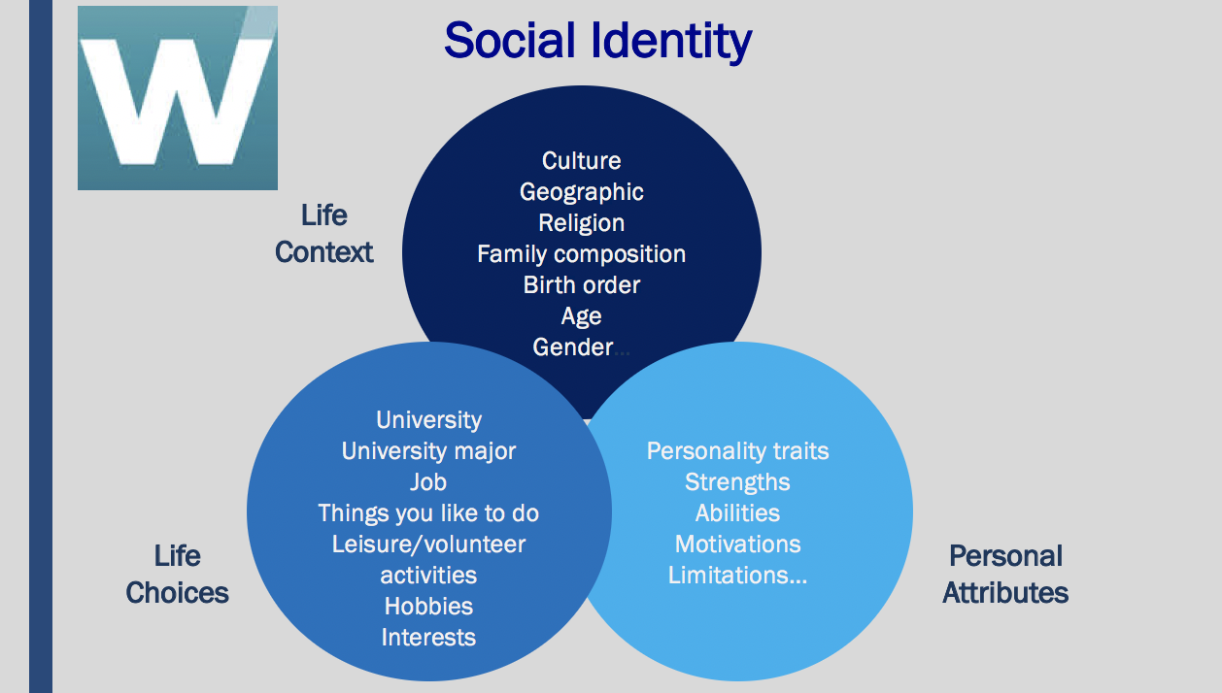
Source: Derived from the work of Dr. Jackie Stavros, Lawrence Technological University

Step 4:
Self-reflection-Values and Social Identity
- Write a one-two page biography of yourself articulating “who you are” and what is your “life story” as reflected in your social identity; meaning describe what personal characteristics, contextual factors, and life choices and experiences have most greatly influenced who you are as a person and professional.
- Reflect in writing on the following:
  - Do/how do your values and social identity influence one another?
  - How are your values reflected in the way you live your life and in the choices you have made?

_______________________________________________________________________________________________________________________________________________________________________________________________________________________________________________________________________________________________________________________________________________________________________________________
_______________________________________________________________________________________________________________________________________________________________________________________________________________________________________________________________________________________________________________________________________________________________________________________
______________________________________________________________________________________________________________________________________________________________________________________________________________________________________________________________________________________________________________________________________________________________________________________________________________________________________________________________________________________________________________________________________________________________________________________________________________________________________________________________________________________________________________________________________________________________________________
_______________________________________________________________________________________________________________________________________________________________________________________________________________________________________________________________________________________________________________________________________________________________________________________
______________________________________________________________________________________________________________________________________________________________________________________________________________________________________________________________________________________________________________________________________________________________________________________________________________________________________________________________________________________________________________________________________________________________________________________________________________________________________________________________________________________________________________________________________________________________________________
_______________________________________________________________________________________________________________________________________________________________________________________________________________________________________________________________________________________________________________________________________________________________________________________
________________________________________________________________________________________________________________________________________________________________________________________________________________________________________________________________________________________________________________________________________________________________________________________________________________________________________________________________________________________________________________________________________________________________________________________________________________________________________________________________________________________________________________________________________________________________________________________________________________________________________________________________________________________________________________________________________________________________________________________________________________________________________________________________________________________________________________________________________________________________________________________________________________________________________________

Self-reflection- Your personal vision

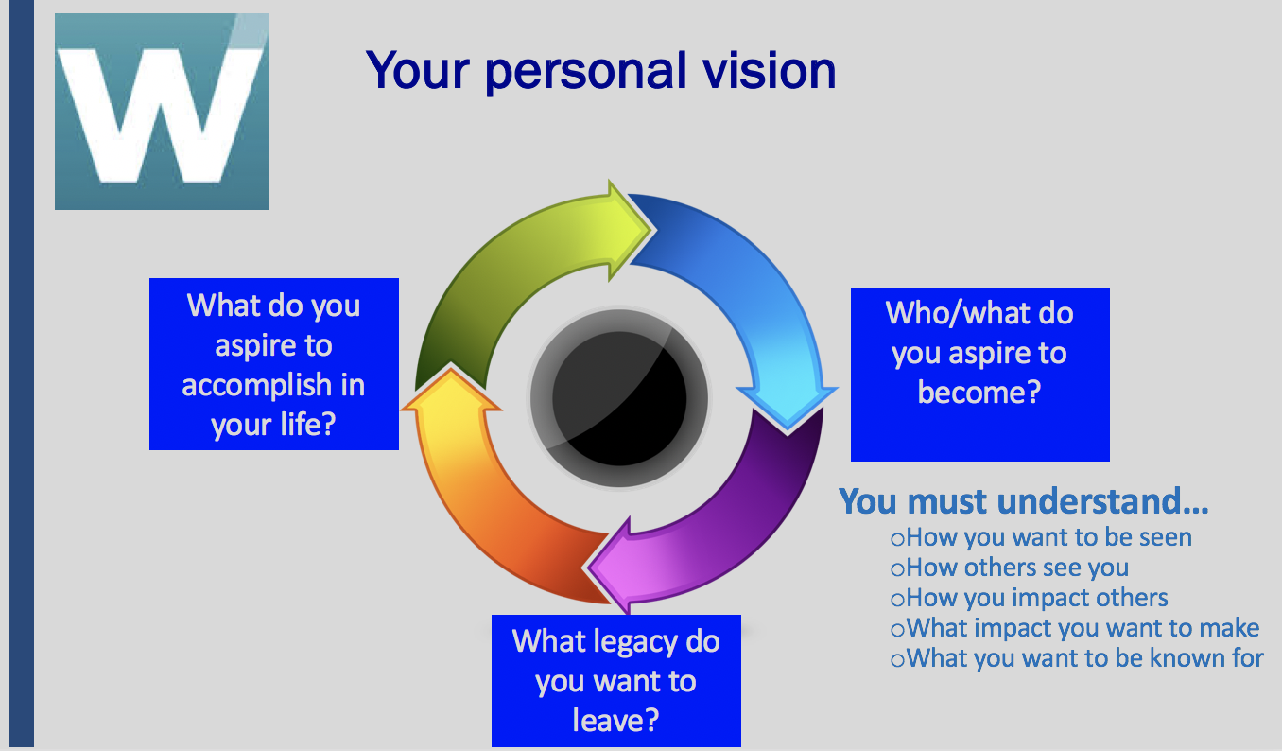

STEP 5:
- Incorporating your values and social identity, write a personal vision statement describing who/what you aspire to become, how you want to be known by others and what you aspire to accomplish in your life. What kind of person do you want to be and how do you want to live your life? What do you want to be remembered for?

_______________________________________________________________________________________________________________________________________________________________________________________________________________________________________________________________________________________________________________________________________________________________________________________
_______________________________________________________________________________________________________________________________________________________________________________________________________________________________________________________________________________________________________________________________________________________________________________________
______________________________________________________________________________________________________________________________________________________________________________________________________________________________________________________________________________________________________________________________________________________________________________________________________________________________________________________________________________________________________________________________________________________________________________________________________________________________________________________________________________________________________________________________________________________________________________
_______________________________________________________________________________________________________________________________________________________________________________________________________________________________________________________________________________________________________________________________________________________________________________________
_______________________________________________________________________________________________________________________________________________________________________________________________________________________________________________________________________________________________________________________________________________________________________________________
_______________________________________________________________________________________________________________________________________________________________________________________________________________________________________________________________________________________________________________________________________________________________________________________
_______________________________________________________________________________________________________________________________________________________________________________________________________________________________________________________________________________________________________________________________________________________________________________________

Homework: How to Increase your Self-Confidence

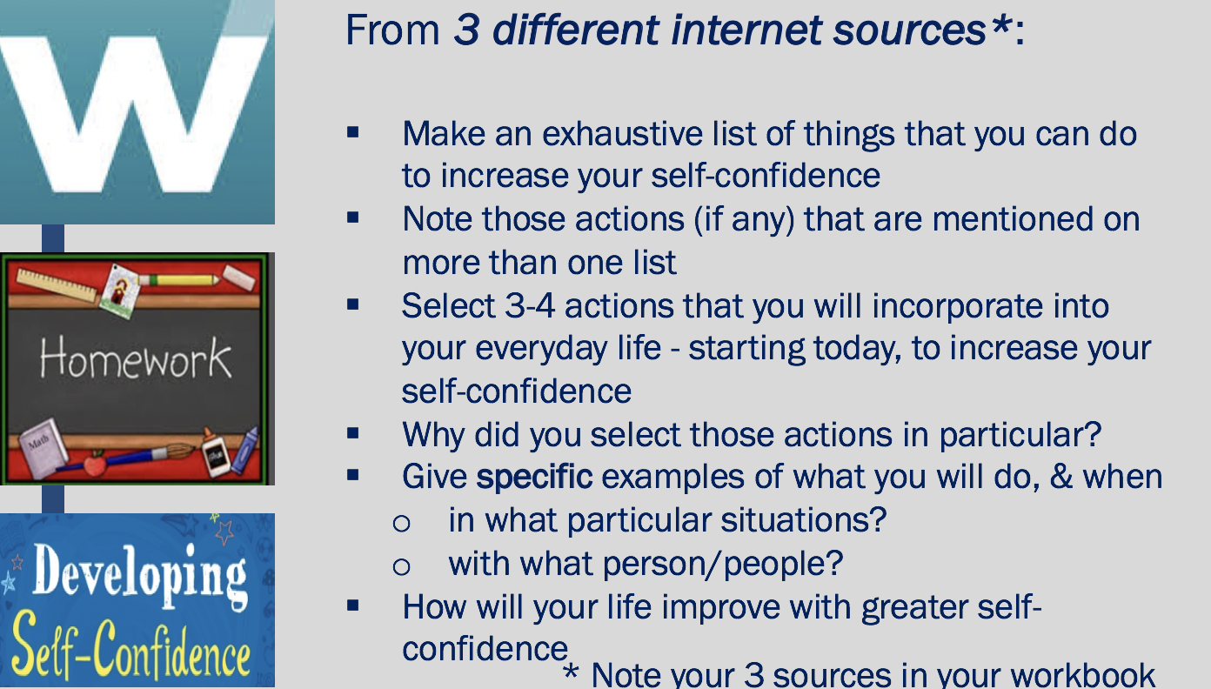

_______________________________________________________________________________________________________________________________________________________________________________________________________________________________________________________________________________________________________________________________________________________________________________________
_______________________________________________________________________________________________________________________________________________________________________________________________________________________________________________________________________________________________________________________________________________________________________________________
_______________________________________________________________________________________________________________________________________________________________________________________________________________________________________________________________________________________________________________________________________________________________________________________
_______________________________________________________________________________________________________________________________________________________________________________________________________________________________________________________________________________________________________________________________________________________________________________________
_______________________________________________________________________________________________________________________________________________________________________________________________________________________________________________________________________________________________________________________________________________________________________________________
_______________________________________________________________________________________________________________________________________________________________________________________________________________________________________________________________________________________________________________________________________________________________________________________
_______________________________________________________________________________________________________________________________________________________________________________________________________________________________________________________________________________________________________________________________________________________________________________________
______________________________________________________________________________________________________________________________________________________________________________________________________________________________________________________________________________________________________________________________________________________________________________________________________________________________________________________________________________________________________________________________________________________________________________________________________________________________________________________________________________________________________________________________________________________________________________
_______________________________________________________________________________________________________________________________________________________________________________________________________________________________________________________________________________________________________________________________________________________________________________________
_______________________________________________________________________________________________________________________________________________________________________________________________________________________________________________________________________________________________________________________________________________________________________________________
_______________________________________________________________________________________________________________________________________________________________________________________________________________________________________________________________________________________________________________________________________________________________________________________
_______________________________________________________________________________________________________________________________________________________________________________________________________________________________________________________________________________________________________________________________________________________________________________________

Video: An Exercise in Empathy

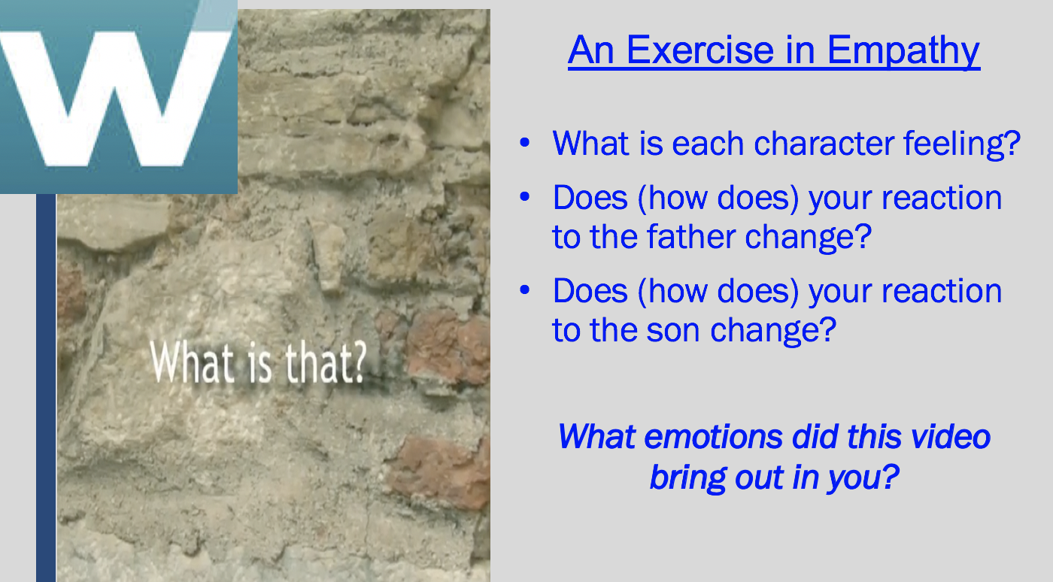

______________________________________________________________________________________________________________________________________________________________________________________________________________________________________________________________________________________________________________________________________________________________________________________
_______________________________________________________________________________________________________________________________________________________________________________________________________________________________________________________________________________________________________________________________________________________________________________________
_______________________________________________________________________________________________________________________________________________________________________________________________________________________________________________________________________________________________________________________________________________________________________________________

Activity: When your Emotions Worked Against You

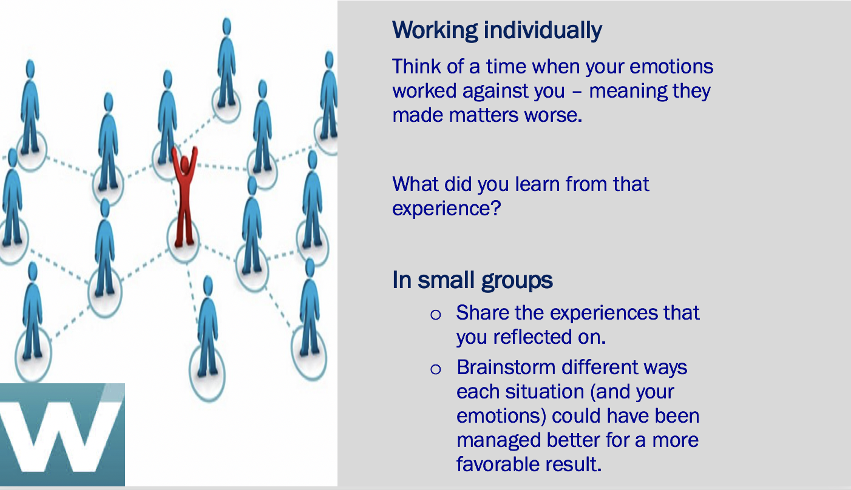

_______________________________________________________________________________________________________________________________________________________________________________________________________________________________________________________________________________________________________________________________________________________________________________________
_______________________________________________________________________________________________________________________________________________________________________________________________________________________________________________________________________________________________________________________________________________________________________________________
______________________________________________________________________________________________________________________________________________________________________________________________________________________________________________________________________________________________________________________________________________________________________________________________________________________________________________________________________________________________________________________________________________________________________________________________________________________________________________________________________________________________________________________________________________________________________________
_______________________________________________________________________________________________________________________________________________________________________________________________________________________________________________________________________________________________________________________________________________________________________________________
_______________________________________________________________________________________________________________________________________________________________________________________________________________________________________________________________________________________________________________________________________________________________________________________
_______________________________________________________________________________________________________________________________________________________________________________________________________________________________________________________________________________________________________________________________________________________________________________________
_____________________________________________________________________________________________________________________________________________________________________________________________________________________________________________________________________________________________________________________________________________________________________________________________________________________________________________________________________________________________________________________________________________

Activity: How Emotionally Intelligent Are You?

(EI) Emotional intelligence questionnaire
This self-assessment is designed to get you thinking about the various competences of emotional intelligence as they apply to you.
A high degree of emotional intelligence includes:
Self-awareness
The ability to recognize what you are feeling, to understand your habitual emotional responses to events and to recognize how your emotions affect your behavior and performance. When you are self-aware, you see yourself as others see you, and have a good sense of your own abilities and current limitations.
Managing emotions
The ability to stay focused and think clearly even when experiencing powerful emotions. Being able to manage your own emotional state is essential for taking responsibility for your actions, and can save you from hasty decisions that you later regret.
Motivating oneself
The ability to use your deepest emotions to move and guide you towards your goals. This ability enables you to take the initiative and to persevere in the face of obstacles and setbacks.
Empathy
The ability to sense, understand and respond to what other people are feeling. Self-awareness is essential to having empathy with others. If you are not aware of your own emotions, you will not be able to read the emotions of others.
Social Skill
The ability to manage, influence and inspire emotions in others. Being able to handle emotions in relationships and being able to influence and inspire others are essential foundation skills for successful relationships.
What to do
- Assess and score each of the questionnaire's statements.
1 indicates that the statement does NOT apply at all
2 indicates that the statement normally does not apply
3 indicates that the statement applies “sometimes” (about half the time)
4 indicates the statement usually applies
- indicates that the statement ALWAYS applies to you

- Total and interpret your results
Transfer your scores to the calculation table and total your results.
- Consider your results and identify one or two actions you can take immediately to strengthen your emotional intelligence. 3 = Applies half the time ~ 5
Remember to respond to these statements as accurately as possible, about how you generally behave. Your current emotional state can influence your answer.
____ 1 I realize immediately when I lose my temper
____ 2 I can 'reframe' bad situations quickly
____ 3 I am able to always motive myself to do difficult tasks
____ 4 I am always able to see things from the other person's viewpoint
____ 5 I am an excellent listener
____ 6 I know when I am happy
____ 7 I do not openly show emotions
____ 8 I am usually able to prioritize important activities to get them done
____ 9 I am excellent at empathizing with someone else's problem
____ 10 I never interrupt other people's conversations
____ 11 I usually recognize when I am stressed
____ 12 Others can rarely tell what kind of mood I am in
____ 13 I always meet deadlines
____ 14 I can tell if someone is not happy with me
____ 15 I am good at adapting and mixing with a variety of people
____ 16 When I am being 'emotional' I am aware of this
____ 17 I rarely lose my temper with other people
____ 18 I never waste time
____ 19 I can tell if a group of people are not getting along with each other
____ 20 People are the most interesting thing in life for me
____ 21 When I feel anxious I usually can account for the reason(s)
____ 22 Difficult people do not annoy me
____ 23 I am not evasive
____ 24 I can usually understand why people are being difficult towards me
____ 25 I like to meet new people and get to know what makes them act like they do
____ 26 I always know when I'm being unreasonable
____ 27 I can consciously alter my frame of mind or mood
____ 28 I believe you should do the difficult things first
____ 29 Other individuals are not 'difficult' just 'different'
____ 30 I need a variety of friends to make my life interesting
____ 31 Awareness of my own emotions is very important to me
____ 32 I do not let stressful situations or people affect me
____ 33 Delayed gratification is a virtue that I believe in
____ 34 I can understand if I am being unreasonable
____ 35 I like to ask questions to find out what it is important to people
____ 36 I can tell if someone has upset or annoyed me
____ 37 I rarely worry about school, work or life in general
____ 38 I believe in taking action each day
____ 39 I can understand why my actions sometimes offend others
____ 40 I see working with difficult people as simply a challenge to win them over
____ 41 I can let anger 'go' quickly so that it no longer affects me
____ 42 I can suppress my emotions when I need to
____ 43 I can always motivate myself even when I feel low
____ 44 I can sometimes see things from others' point of view
____ 45 I am good at reconciling differences with other people
____ 46 I know what makes me happy
____ 47 Others often do not know how I am feeling about things
____ 48 Motivation has been the key to my success
____ 49 Reasons for disagreements are always clear to me
____ 50 I generally build solid relationships with those I am around
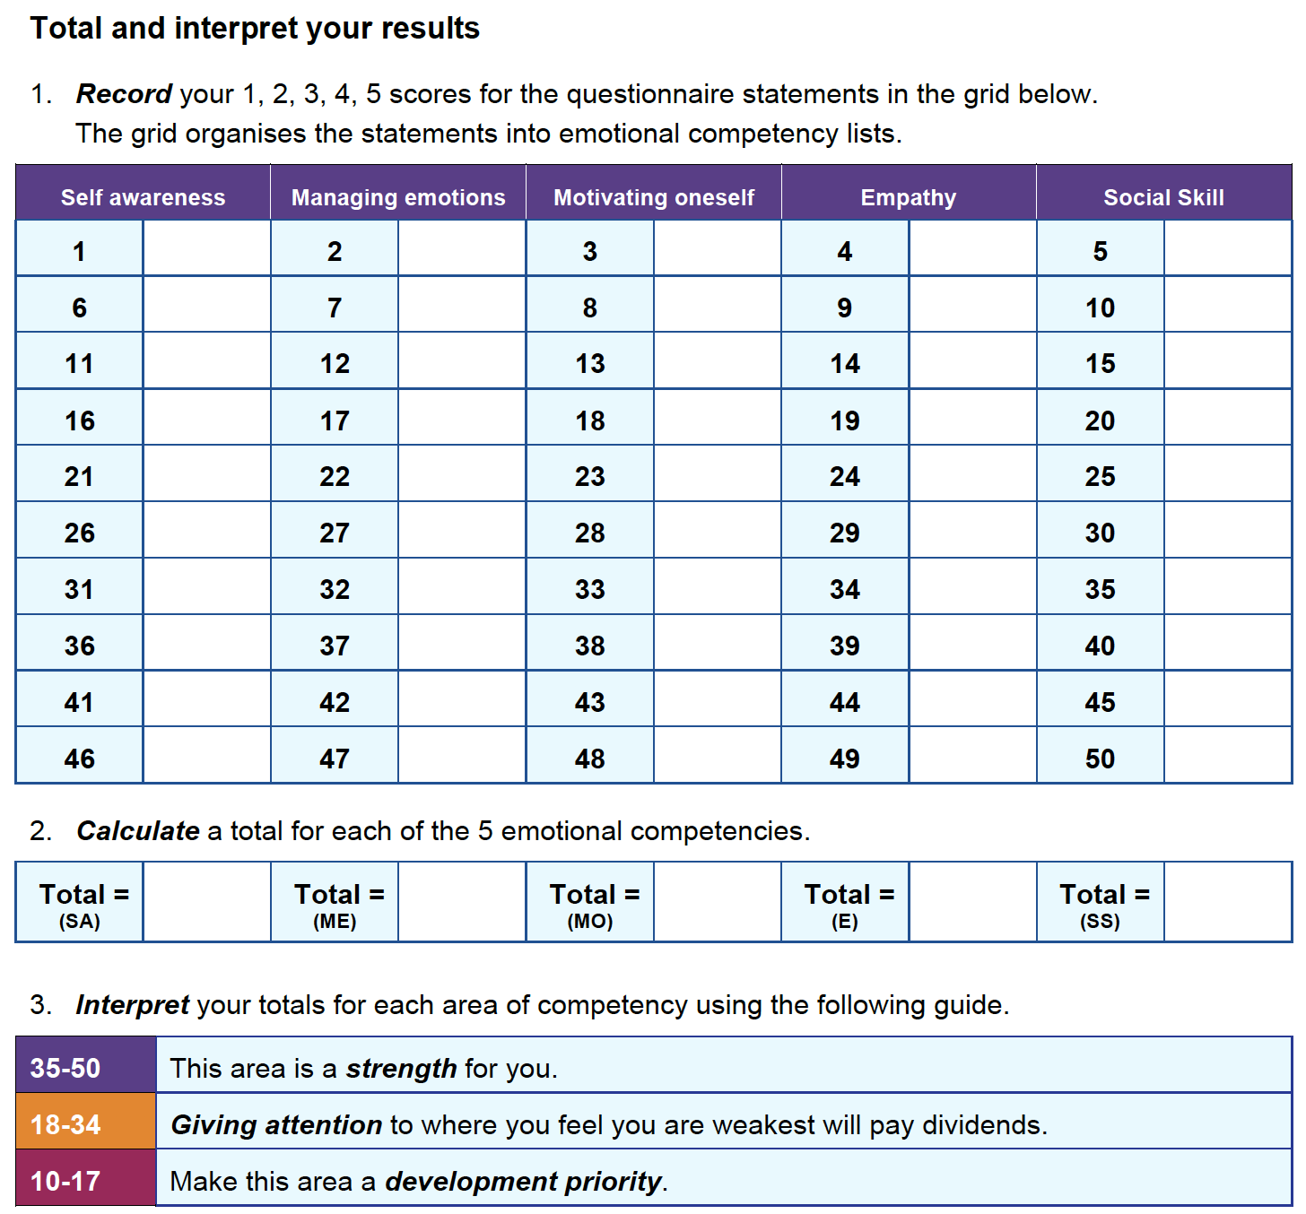

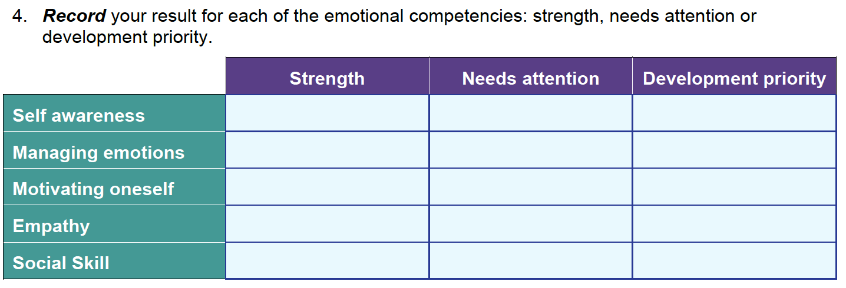
Read the brief article that follows, How to Increase your Emotional Intelligence, then consider your results and identify one or two actions you can take immediately to strengthen your emotional intelligence.

How to Increase Your Emotional Intelligence

A short guide to start making emotions work for you, instead of against you.

By Justin BarisoFounder, Insight@JustinJBariso

Emotional intelligence, also known as EI or EQ (for Emotional Intelligence Quotient), describes a person's ability to recognize emotions, to understand their powerful effect, and to use that information to guide thinking and behavior. Since EI helps you to better understand yourself--and others--a high EQ increases your chances for successfully achieving goals.
But is there a way to increase your emotional intelligence?
In their seminal research and publication, The Emotionally Intelligent Manager, professors David R. Caruso and Peter Salovey broke down four of the core skills involved in developing emotional intelligence:
1. Identifying your feelings and those of others
2. Using feelings to guide your own thinking and reasoning, along with others
3. Understanding how feelings might change and develop as events unfold
4. Managing to stay open to the data of feelings and integrate this into decisions and actions
Here are a series of practical steps that can help you develop these core skills, thereby increasing your EQ.

Reflect on your own emotions.
Take some time to sit down and reflect on your own use of emotions. For example, think about how you would typically respond if:
- You read an email that implies you made a mistake
- Someone blames you for something you feel is unfair
- Another driver cuts you off on the road
- Someone yelled at you
- You get angry if you think someone is criticizing you
- A close friend or associate begins to cry unexpectedly
By first identifying your own emotions and reactions, you become more mindful and start the process of building control.

Ask others for perspective.
Often, we don't realize that other people view us much differently than we view ourselves, and vice versa. It's not about right or wrong; it's simply understanding how perceptions differ, and the consequences those differences create.
By asking those close to us--like a family member or close friend or workmate--about our interactions with them, we can learn from their perspective. For example, we could think about a specific time when we were in a highly emotional state. Ask the other person: Did I act out of the ordinary during that time? Could you describe how?
Then, ask them to relate experiences regarding when they were going through an emotional situation.
You can ask:
- How did I deal with you at that time?
- Would you say I was sensitive to your feelings and emotions?
Getting the answers to these questions will help us to see ourselves more like others see us--and help us to understand others better, too. You can then use that knowledge to adjust your dealings with others. (Here's a little more on learning from others to build your own EQ.)

Be observant.
With this newly acquired knowledge, you can now be more observant of your current emotions. Your self-reflection and what others have shared will help you to be more in tune with what you're feeling.
If you make any new discoveries, make sure to repeat step one. You can even write down your experience; doing so will help clarify your thinking and keep you in "learning mode".

"The pause".
"The pause" may be as simple as taking a moment to stop and think before we act or speak. If everyone made that a practice, imagine how much shorter emails could be, how much time would be saved in meetings, and how many incendiary comments on social media would be eliminated.
But remember: The pause is easy in theory, difficult to practice.
Even if we're generally good at managing our emotions, factors like added stress or a bad day can inhibit our ability to do so at any given time. And we're not just talking about upsetting situations; we are often tempted to jump on opportunities that look really good at the time but that we haven't really thought through.
When you work on pausing before speaking or acting, you create a habit of thinking first.

Explore the "why".
Most of us would agree that qualities like empathy and compassion are valuable ingredients to healthy relationships. So, why do we often neglect to show those qualities when it matters most--like when we fail to show understanding to a close friend or partner when they're going through a difficult time?
Scientists have studied what psychologist and fellow author Adam Grant calls, "the perspective gap". In short, this term describes the fact that it's extremely challenging to put ourselves in another person's shoes. We often forget how specific situations feel, even if we've experienced very similar circumstances. (If we've never experienced something similar, you can imagine how that limits our perspective.)
So, how do we bridge the gap?
Demonstrating qualities such as empathy and compassion means that we try our best to see a situation through another person's eyes. But we have to go further than drawing on our own experiences; showing true empathy means exploring the "why":
- Why does this person feel the way (s)he does?
- What is he or she dealing with that I don't see?
- Why do I feel differently than (s)he does?
If you can't effectively answer those questions, consider working alongside the person for a period of time to truly understand what's going on, as viewed from that person's perspective. Doing so will help you see your team and family members, not as complainers, but more accurately for who they really are, struggling individuals that need help.

When criticized, don't take offense. Instead, ask: What can I learn?

Criticism is never easy to take. But the truth is, criticism is often rooted in truth--even when it's not delivered in an ideal manner. When you receive negative feedback, there are two choices: You can put your feelings aside and try to learn from the situation, or you can get angry and let emotion get the best of you.
When we are on the receiving end of criticism, whether it's delivered ideally or not, it's invaluable to consider the following:
- Putting my personal feelings aside, what can I learn from this alternate perspective?
- Instead of focusing on the delivery, how can I use this feedback to help me or my team improve?
There are times when you shouldn't listen to criticism--for example, when it's based on falsehood or given in a way that's meant to destroy your sense of self-worth. But in reality, that's not usually the case.
If your goal is to truly get better, don't let emotion close your mind to negative feedback. Instead, learn from it.
Practice, practice, practice.
Like any other skill or ability, practice makes...
Better. Of course, it's impossible to have perfect control over your emotions. And learning to improve your emotional intelligence isn't a process that happens overnight.
However, consistently practicing these steps will allow you to begin harnessing the power of emotions--and use that power to work for you, instead of against you.
PUBLISHED ON: APR 11, 2016

What are one or two actions you can take immediately to strengthen your emotional intelligence? Be specific. When, with who, etc.
________________________________________________________________________________________________________________________________________________________________________________________________________________________________________________________________________________________________________________________________________________________________________________
_______________________________________________________________________________________________________________________________________________________________________________________________________________________________________________________________________________________________________________________________________________________________________________________
______________________________________________________________________________________________________________________________________________________________________________________________________________________________________________________________________________________________________________________________________________________________________________________________________________________________________________________________________________________________________________________________________________________________________________________________________________________________________________________________________________________________________________________________________________________________________________
_______________________________________________________________________________________________________________________________________________________________________________________________________________________________

Activity: Relational Civility “Mirror” Measurement

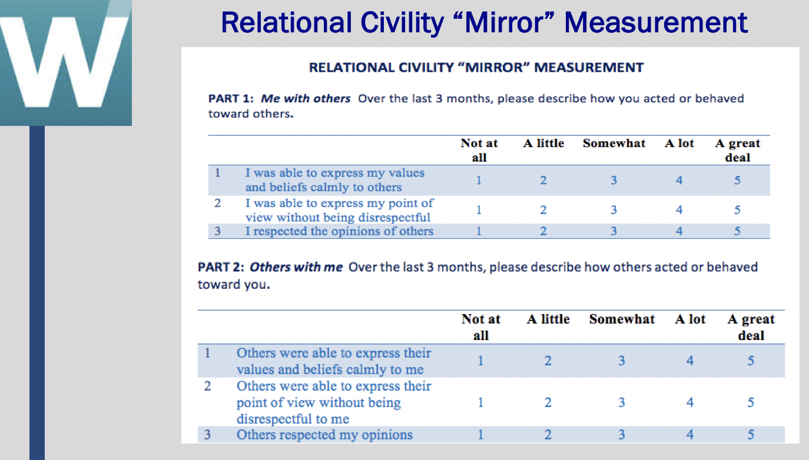

RELATIONAL CIVILITY “MIRROR” MEASUREMENT

Complete Part 1 and Part 2 of this questionnaire by circling the number that best corresponds to your experiences over the past three months; From 1 “Not at all” to 5 “A great deal”. As always, try to be as accurate as possible with your responses - how you really are, not how you wish you were, or think you should be. Note that Part A describes how you acted or behaved towards others and Part B describes how others acted and behaved towards you.

When you have completed both parts, score your results.

PART 1: Me with others Over the last 3 months, please describe how you acted or behaved toward others.
 |  | Not at all | A little | Somewhat | A lot | A great deal
1 | I was able to express my values and beliefs calmly to others | 1 | 2 | 3 | 4 | 5
2 | I was able to express my point of view without being disrespectful | 1 | 2 | 3 | 4 | 5
3 | I respected the opinions of others | 1 | 2 | 3 | 4 | 5
4 | I communicated my disagreement with others without being aggressive | 1 | 2 | 3 | 4 | 5
5 | I was polite toward others | 1 | 2 | 3 | 4 | 5
6 | I was generally kind toward others | 1 | 2 | 3 | 4 | 5
7 | I always behaved mannerly towards others | 1 | 2 | 3 | 4 | 5
8 | I made comments that validated others | 1 | 2 | 3 | 4 | 5
9 | I realized the effect of my words on others | 1 | 2 | 3 | 4 | 5
10 | I realized the effect of my behaviors on others | 1 | 2 | 3 | 4 | 5
11 | I was condescending towards someone | 1 | 2 | 3 | 4 | 5
12 | I paid little attention to someone | 1 | 2 | 3 | 4 | 5
13 | I paid little attention to someone else’s opinion | 1 | 2 | 3 | 4 | 5
14 | I made demeaning or derogatory remarks about someone | 1 | 2 | 3 | 4 | 5
15 | I addressed someone in derogatory terms | 1 | 2 | 3 | 4 | 5
16 | I ignored or excluded someone | 1 | 2 | 3 | 4 | 5

PART 2: Others with me Over the last 3 months, please describe how others acted or behaved toward you.
 |  | Not at all | A little | Somewhat | A lot | A great deal
1 | Others were able to express their values and beliefs calmly to me | 1 | 2 | 3 | 4 | 5
2 | Others were able to express their point of view without being disrespectful to me | 1 | 2 | 3 | 4 | 5
3 | Others respected my opinions | 1 | 2 | 3 | 4 | 5
4 | Others communicated their disagreement with me without being aggressive | 1 | 2 | 3 | 4 | 5
5 | Others were polite toward others | 1 | 2 | 3 | 4 | 5
6 | Others were generally kind toward me | 1 | 2 | 3 | 4 | 5
7 | Others always behaved mannerly toward me | 1 | 2 | 3 | 4 | 5
8 | Others made comments that validated me | 1 | 2 | 3 | 4 | 5
9 | Others realized the effect of their words on me | 1 | 2 | 3 | 4 | 5
10 | Others realized the effect of their behaviors on me | 1 | 2 | 3 | 4 | 5
11 | Others were condescending toward me | 1 | 2 | 3 | 4 | 5
12 | Others paid little attention to me | 1 | 2 | 3 | 4 | 5
13 | Others paid little attention to my opinion | 1 | 2 | 3 | 4 | 5
14 | Others made demeaning or derogatory remarks about me | 1 | 2 | 3 | 4 | 5
15 | Others addressed me in derogatory terms | 1 | 2 | 3 | 4 | 5
16 | Others ignored or excluded me | 1 | 2 | 3 | 4 | 5

Source: Adapted from De Fabio and Gori, 2016 and Cortina et al, 2001

SCORING
- For Parts 1 and 2 separately, compute the average of the 16 statements.
- When computing averages, reverse score items 11 through 16.

If you circled… When averaging count as…
- 5
- 4
- 3
- 2
- 1

Me with others Others with me
AVERAGE SCORE ____________ ____________

Reflection

Do I need to change the way I treat others? If so, how?

______________________________________________________________________________________________________________________________________________________________________________________________________________________________________________________________________________________________________________________________________________________________________________________________________________________________________________________________________________________________________________________________________________________________________________________________________________________________________________________________________________________________________________________________________________________________________________

Am I allowing others to treat me poorly? If yes, what can I do about it?

______________________________________________________________________________________________________________________________________________________________________________________________________________________________________________________________________________________________________________________________________________________________________________________________________________________________________________________________________________________________________________________________________________________________________________________________________________________________________________________________________________________________________________________________________________________________________________

Activity: Are you Trustworthy?

Answer the following questions (True/False)

____ I keep my promises. I am a person of my word.
____ I am reliable. I follow through on my commitments.
____ I am honest. I do not lie.
____ I keep secrets. I never betray a trust or confidence.
____ I have integrity and live according to my principles.
____ I am consistent in what I say and do, not trying to “pretend” to act like someone else to impress others.

Q: Are you totally trustworthy, or are there some areas you need to improve in? ______________________________________________________________________________________________________________________________________________________________________________________________________________________________________________________________________________________________________________________________________________________________________________________________________________________________________________________________________________________________________________________________________________________________________________________________________________________________________________________________________________________________________________________________________________________________________________

Homework: At the End of the Day…

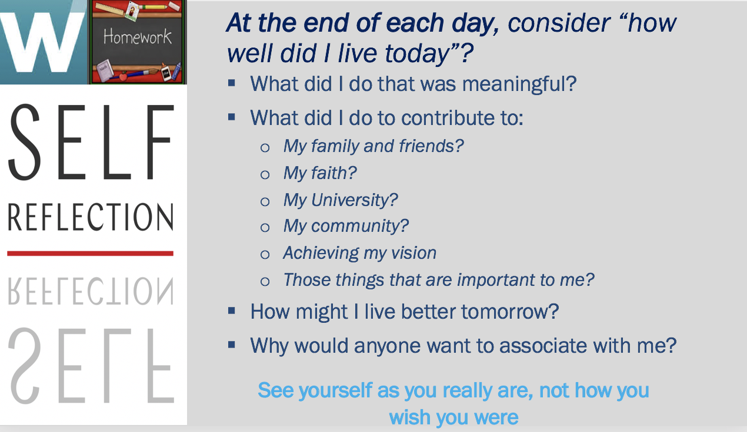

We have spent a great deal of time on self-reflection. Look back on this day and consider “How well did I live today”?

- What did I do that was meaningful?

- What did I do to contribute to:
  - My family and friends?
  - My faith?
  - My University?
  - My community?
  - Achieving my vision?
  - Those things that are important to me?

- How might I live better tomorrow?

- Why would anyone want to associate with me?

This is a habit that you should get into regularly. You may not always write something down, but spend a few moments every day, considering these questions.

______________________________________________________________________________________________________________________________________________________________________________________________________________________________________________________________________________________________________________________________________________________________________________________________________________________________________________________________________________________________________________________________________________________________________________________________________________________________________________________________________________________________________________________________________________________________________________
_______________________________________________________________________________________________________________________________________________________________________________________________________________________________________________________________________________________________________________________________________________________________________________________
______________________________________________________________________________________________________________________________________________________________________________________________________________________________________________________________________________________________________________________________________________________________________________________________________________________________________________________________________________________________________________________________________________________________________________________________________________________________________________________________________________________________________________________________________________________________________________
__________________________________________________________________________________________________________________________________________________________________________________________________________________________________________________________________________________________________________________________________________________________________________________________________________________________________________________________________

Homework: Lessons Learned - Meeting Life’s Challenges with Confidence and Determination

_______________________________________________________________________________________________________________________________________________________________________________________________________________________________________________________________________________________________________________________________________________________________________________________
_______________________________________________________________________________________________________________________________________________________________________________________________________________________________________________________________________________________________________________________________________________________________________________________
_______________________________________________________________________________________________________________________________________________________________________________________________________________________________________________________________________________________________________________________________________________________________________________________
_______________________________________________________________________________________________________________________________________________________________________________________________________________________________________________________________________________________________________________________________________________________________________________________
_______________________________________________________________________________________________________________________________________________________________________________________________________________________________________________________________________________________________________________________________________________________________________________________
_______________________________________________________________________________________________________________________________________________________________________________________________________________________________________________________________________________________________________________________________________________________________________________________
_______________________________________________________________________________________________________________________________________________________________________________________________________________________________
___________________________________________________________________________________________________________________________________________________________________________________________________________________________________________________________________________________________________________________________________________________________________________________________________________________________________________________________________________________________________________________________________________________________________________________________________________________________________________________________________________________________________

Module: Effective Interpersonal Communication

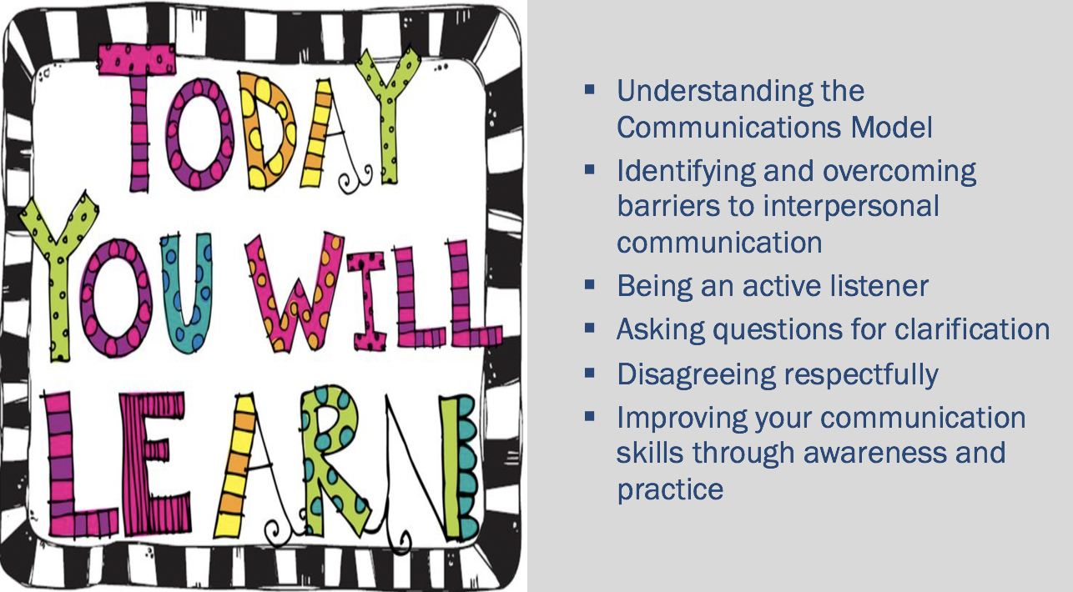

Activity: Let’s Draw
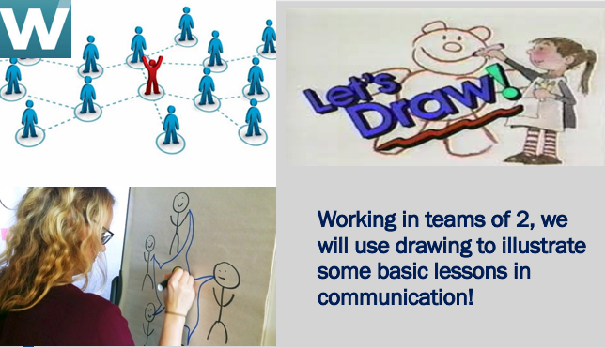

Drawing Lessons Improve Communication Skills: Listen, Interpret, Dr

Activity Part A
- Get into pairs of 2 and sit back-to-back, with a writing surfaces (desk) in front of you
- Decide who will be Student "A" and who will be Student "B." Write your letter in the top corner of a blank sheet of paper.
- All "A's”: Spend two minutes drawing something on your papers. You do not need to be good at drawing; even stick drawings will be fine.
- Partners may not look at or talk to each other during this part of the activity. While "A's" are drawing, "B's" should remain in their seats.
- For the next 5 minutes:
  - "B's", pick up your pens/pencils.
  - "A's" give a clear description of your drawing to your partner.
  - "B's" you can listen only to your partner’s instructions.
  - Each "B" will use the oral instructions to try to re-create his/her partner's drawing.
- Remember: The only means of communication is for each "A" to provide description of the drawing to his or her partner. "B's" can only listen and draw. They cannot ask questions.
- Show each other their drawings and discuss the results.

A’s Drawing

Activity Part B
- The second part of the activity is different from the first part.
- Resume your back-to-back positions.
- "B's", spend 3 minutes drawing on your papers. Draw something beyond a simple shape or two.
- Remain seated back-to-back.
- This time the "A's" are going to reproduce your partners' drawings, but the only way you can obtain information about those drawings is by asking yes or no questions.
- Show each other their drawings and discuss the results.

B’s Drawing

______________________________________________________________________________________________________________________________________________________________________________________________________________________________________________________________________________________________________________________________________________________________________________________
_______________________________________________________________________________________________________________________________________________________________________________________________________________________________________________________________________________________________________________________________________________________________________________________
_______________________________________________________________________________________________________________________________________________________________________________________________________________________________________________________________________________________________________________________________________________________________________________________
_____________________________________________________________________________________________________________________________________________________________________________________________________________________________________________________________________________________________________________________________________________________________________________________________________________________________________________________________________________________________________________________________________________

Activity: Contradicting Messages

Quickly write down the colors you see on the Powerpoint slide, not the words themselves. Proceed from top to bottom of column 1, then top to bottom of column 2.

_______________________________________________________________________________________________________________________________________________________________________________________________________________________________________________________________________________________________________________________________________________________________________________________
_________________________________________________________________________________________________________________________________________________________________________________________________________________________________
______________________________________________________________________________________________________________________________________________________
_______________________________________________________________________________________________________________________________________________________________________________________________________________________________________________________________________________________________________________________________________________________________________________________

Activity: The Train Left the Station

Listen carefully to the story being read. Pay close attention because at the end of the story you are going to be asked a question about the situation being described. You might want to make notes as the story is read.

_______________________________________________________________________________________________________________________________________________________________________________________________________________________________________________________________________________________________________________________________________________________________________________________
_______________________________________________________________________________________________________________________________________________________________________________________________________________________________________________________________________________________________________________________________________________________________________________________
_______________________________________________________________________________________________________________________________________________________________________________________________________________________________________________________________________________________________________________________________________________________________________________________

Activity: Choosing your Words Carefully - Late for the Movies, Again…

Mini-Case:
You have made plans to go to a movie with a friend. It’s a movie that you really want to see. The movie is very popular so you need to go early to be sure you get tickets and good seats. You explain this to your friend and ask him to come by your house at 7:00pm, which is early for the 8:00pm movie start. 7:00pm comes and passes, and no sign of your friend. At 7:40pm he arrives with an excuse for being late. By this time, you know it’s too late to get tickets for the movie. You are furious. This is not the first time this sort of situation has happened with this friend.
Individually: Write a script of what you would say to your friend in this situation. Do not write what you think you should say. Rather, try to think of similar experience you have had in the past, and express how you would typically respond. Also, anticipate how your friend might react to your words.
_______________________________________________________________________________________________________________________________________________________________________________________________________________________________________________________________________________________________________________________________________________________________________________________
_______________________________________________________________________________________________________________________________________________________________________________________________________________________________________________________________________________________________________________________________________________________________________________________
_______________________________________________________________________________________________________________________________________________________________________________________________________________________________________________________________________________________________________________________________________________________________________________________
_______________________________________________________________________________________________________________________________________________________________________________________________________________________________________________________________________________________________________________________________________________________________________________________
_______________________________________________________________________________________________________________________________________________________________________________________________________________________________________________________________________________________________________________________________________________________________________________________
_______________________________________________________________________________________________________________________________________________________________________________________________________________________________________________________________________________________________________________________________________________________________________________________
_________________________________________________________________________________________________________________________________________________________________________________________________________________________________

Activity: Listening Bad Habits

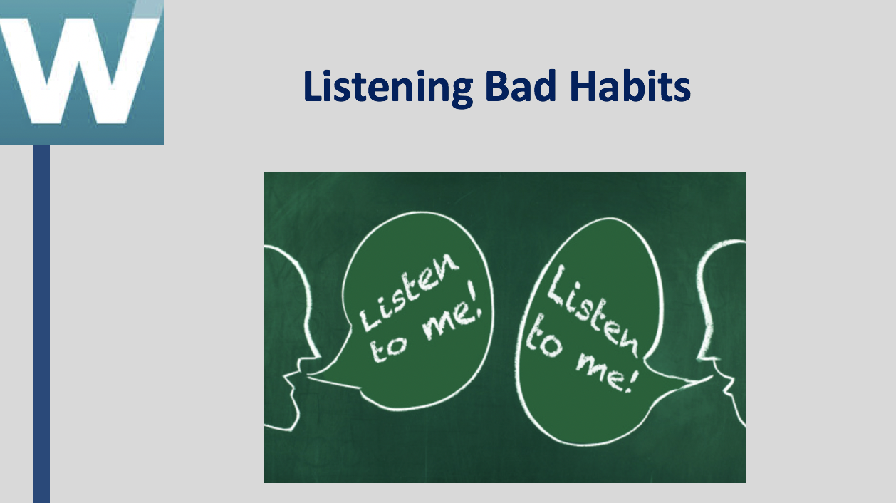

Listening Bad Habits
Following is a list of ten bad habits of listening. Check those listening bad habits that you are sometimes guilty of committing when communicating with others. Be honest with yourself!
____ I interrupt often or try to finish the other person’s sentences.
____ I jump to conclusions.
____ I am often overly “parental” and answer with advice, even when advice is not requested.
____ I make up my mind before I have all the information.
____ I do not give any response.
____ I am impatient.
____ I lose my temper when I hear things I do not agree with.
____ I try to change the subject to something that relates to my own experiences.
____ I try to change the subject to something I am interested in.
____ I think more about my reply while the other person is speaking, than what she/he is saying.

_______________________________________________________________________________________________________________________________________________________________________________________________________________________________________________________________________________________________________________________________________________________________________________________
_______________________________________________________________________________________________________________________________________________________________________________________________________________________________________________________________________________________________________________________________________________________________________________________
______________________________________________________________________________________________________________________________________________________________________________________________________________________________________________________________________________________________________________________________________________________________________________________________________________________________________________________________________________________________________________________________________________________________________________________________________________________________________________________________________________________________________________________________________________________________________________
_______________________________________________________________________________________________________________________________________________________________________________________________________________________________________________________________________________________________________________________________________________________________________________________

Activity: Interpersonal Communication Skills Inventory
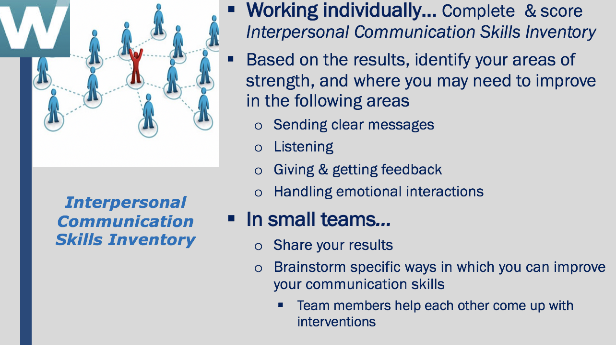
Interpersonal Communication Skills Inventory
This Interpersonal Communication Skills Inventory is designed to provide you with some insights into your communication strengths and potential areas for development. By answering each question candidly, you will receive a profile that displays your level of competence in four key communication areas:
- Sending clear messages
- Listening
- Giving and Getting Feedback
- Handling Emotional Interactions
How to Complete the Inventory
To complete this inventory, read each statement carefully and honestly assess how often the particular statement applies to you. Place a check mark in the column that best describes the frequency -- Usually, Sometimes, or Seldom
Complete all four sections of the inventory.
Section 1
 | Usually | Sometimes | Seldom
1. Is it difficult for you to talk to other people?
2. When you are trying to explain some- thing, do others tend to put words in your mouth, or finish your sentences for you?
3. In conversation, do your words usually come out the way you would like?
4. Do you find it difficult to express your ideas when they differ from the ideas of people around you?
5. Do you assume that the other person knows what you are trying to say, and leave it to him/her to ask you questions?
6. Do others seem interested and attentive when you are talking to them?
7. When speaking, is it easy for you to recognize how others are reacting to what you are saying?
8. Do you ask the other person to tell you how she/he feels about the point you are trying to make?
9. Are you aware of how your tone of voice may affect others?
10. In conversation, do you look to talk about things of interest to both you and the other person?
SCORE: SECTION 1 TOTAL ________
Section 2
 | Usually | Sometimes | Seldom
11. In conversation, do you tend to do more talking than the other person does?
12. In conversation, do you ask the other person questions when you don’t understand what they’ve said?
13. In conversation, do you often try to figure out what the other person is going to say before they’ve finished talking?
14. Do you find yourself not paying attention while in conversation with others?
15. In conversation, can you easily tell the difference between what the person is saying and how he/she may be feeling?
16. After the other person is done speaking, do you clarify what you heard them say before you offer a response?
17. In conversation, do you tend to finish sentences or supply words for the other person?
18. In conversation, do you find yourself paying most attention to facts and details, and frequently missing the emotional tone of the speakers’ voice?
19. In conversation, do you let the other person finish talking before reacting to what she/he says?
20. Is it difficult for you to see things from the other person’s point of view?
SCORE: SECTION 2 TOTAL ________
Section 3
 | Usually | Sometimes | Seldom
21. Is it difficult to hear or accept constructive criticism from the other person?
22. Do you refrain from saying some- thing that you think will upset someone or make matters worse?
23. When someone hurts your feelings, do you discuss this with him/her?
24. In conversation, do you try to put yourself in the other person’s shoes?
25. Do you become uneasy when someone pays you a compliment?
26. Do you find it difficult to disagree with others because you are afraid they will get angry?
27. Do you find it difficult to compliment or praise others?
28. Do others remark that you always seem to think you are right?
29. Do you find that others seem to get defensive when you disagree with their point of view?
30. Do you help others to understand you by saying how you feel?
SCORE: SECTION 3 TOTAL ________
Section 4
31. Do you have a tendency to change the subject when the other person’s feelings enter into the discussion? | Usually | Sometimes | Seldom
32. Does it upset you a great deal when someone disagrees with you?
33. Do you find it difficult to think clearly when you are angry with someone?
34. When a problem arises between you and another person, can you discuss it without getting angry?
35. Are you satisfied with the way you handle differences with others?
36. Do you sulk for a long time when someone upsets you?
37. Do you apologize to someone whose feelings you may have hurt?
38. Do you admit that you’re wrong when you know that you are/were wrong about something?
39. Do you avoid or change the topic if someone is expressing his or her feelings in a conversation?
40. When someone becomes upset, do you find it difficult to continue the conversation?
SCORE: SECTION 4 TOTAL ________
Scoring Key
Go back and look over your responses to each question. In front of each question, write the appropriate score (1, 2 or 3) using the Scoring Table below. For example, if you answered “Seldom” to Question 1, you would get 3 points. Write the number 3 in front of Question 1 on the inventory. If you answered “Usually” to Question 2, you would get 0 points and would write the number 0 in front of Question 2 on the inventory. Score all 10 questions in each section this way.
After scoring all questions, go back to Section 1. Total the score of Section 1 and put that number on the line “Score Section 1 Total.” Proceed to total all scores for all other sections.
Enter your TOTAL score for all 4 sections here: ________
Scoring Table
Question | Usually | Sometimes | Seldom |  | Question | Usually | Sometimes | Seldom
1 | 0 | 1 | 3 |  | 21 | 0 | 1 | 3
2 | 0 | 1 | 3 |  | 22 | 3 | 1 | 0
3 | 3 | 1 | 0 |  | 23 | 3 | 1 | 0
4 | 0 | 1 | 3 |  | 24 | 3 | 1 | 0
5 | 0 | 1 | 3 |  | 25 | 0 | 1 | 3
6 | 3 | 1 | 0 |  | 26 | 0 | 1 | 3
7 | 3 | 1 | 0 |  | 27 | 0 | 1 | 3
8 | 3 | 1 | 0 |  | 28 | 0 | 1 | 3
9 | 3 | 1 | 0 |  | 29 | 0 | 1 | 3
10 | 3 | 1 | 0 |  | 30 | 3 | 1 | 0
11 | 0 | 1 | 3 |  | 31 | 0 | 1 | 3
12 | 3 | 1 | 0 |  | 32 | 0 | 1 | 3
13 | 0 | 1 | 3 |  | 33 | 0 | 1 | 3
14 | 0 | 1 | 3 |  | 34 | 3 | 1 | 0
15 | 3 | 1 | 0 |  | 35 | 3 | 1 | 0
16 | 3 | 1 | 0 |  | 36 | 0 | 1 | 3
17 | 0 | 1 | 3 |  | 37 | 3 | 1 | 0
18 | 0 | 1 | 3 |  | 38 | 3 | 1 | 0
19 | 3 | 1 | 0 |  | 39 | 0 | 1 | 3
20 | 0 | 1 | 3 |  | 40 | 0 | 1 | 3
Interpersonal Communication Profile
Look at your score for each section as one indication of the degree to which you effectively communicate. Plot your scores on the table below using an “X” for each section score. Draw a line to connect them column to column. This will create a profile of your strengths and opportunities for improvement.
- Scores in the 1 > 15 range indicate areas of your communication skills that need improvement.
- Scores in the 16 > 21 range indicate areas of communication skills that need more consistent attention.
- Scores in the 22 > 30 range indicate areas of strength or potential strength.
Score Section 1 Total Sending Clear Messages | Score Section 2 Total Listening | Score Section 3 Total Giving and Getting Feedback | Score Section 4 Total Handling Emotional Interactions
30 | 30 | 30 | 30
29 | 29 | 29 | 29
28 | 28 | 28 | 28
27 | 27 | 27 | 27
26 | 26 | 26 | 26
25 | 25 | 25 | 25
24 | 24 | 24 | 24
23 | 23 | 23 | 23
22 | 22 | 22 | 22
21 | 21 | 21 | 21
20 | 20 | 20 | 20
19 | 19 | 19 | 19
18 | 18 | 18 | 18
17 | 17 | 17 | 17
16 | 16 | 16 | 16
15 | 15 | 15 | 15
14 | 14 | 14 | 14
13 | 13 | 13 | 13
12 | 12 | 12 | 12
11 | 11 | 11 | 11
10 | 10 | 10 | 10
9 | 9 | 9 | 9
8 | 8 | 8 | 8
7 | 7 | 7 | 7
6 | 6 | 6 | 6
5 | 5 | 5 | 5
4 | 4 | 4 | 4
3 | 3 | 3 | 3
2 | 2 | 2 | 2
1 | 1 | 1 | 1
Area(s) of Strength:
_______________________________________________________________________________________________________________________________________________________________________________________________________________________________________________________________________________________________________________________________________________________________________________________
_______________________________________________________________________________________________________________________________________________________________________________________________________________________________________________________________________________________________________________________________________________________________________________________
______________________________________________________________________________________________________________________________________________________________________________________________________________________________________________________________________________________________________________________________________________________________________________________________________________________________________________________________________________________________________________________________________________________________________________________________________________________________________________________________________________________________________________________________________________________________________________

Area(s) of Improvement:

_______________________________________________________________________________________________________________________________________________________________________________________________________________________________________________________________________________________________________________________________________________________________________________________
_______________________________________________________________________________________________________________________________________________________________________________________________________________________________________________________________________________________________________________________________________________________________________________________
______________________________________________________________________________________________________________________________________________________________________________________________________________________________________________________________________________________________________________________________________________________________________________________________________________________________________________________________________________________________________________________________________________________________________________________________________________________________________________________________________________________________________________________________________________________________________________

Activity: Interpersonal Communication Skills - Developing an Improvement Plan

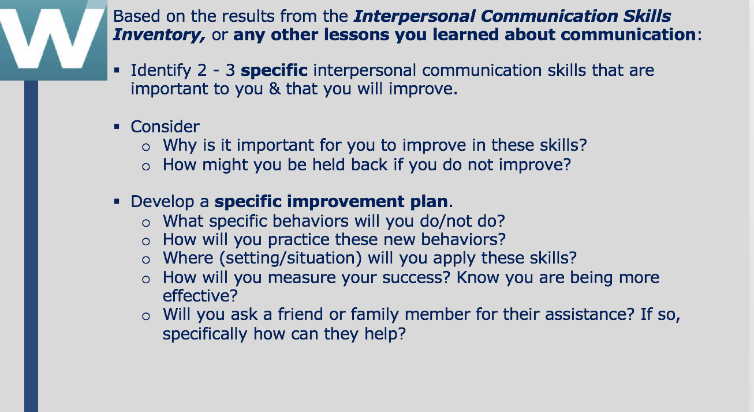
_______________________________________________________________________________________________________________________________________________________________________________________________________________________________________________________________________________________________________________________________________________________________________________________
_______________________________________________________________________________________________________________________________________________________________________________________________________________________________________________________________________________________________________________________________________________________________________________________
______________________________________________________________________________________________________________________________________________________________________________________________________________________________________________________________________________________________________________________________________________________________________________________________________________________________________________________________________________________________________________________________________________________________________________________________________________________________________________________________________________________________________________________________________________________________________________
_______________________________________________________________________________________________________________________________________________________________________________________________________________________________________________________________________________________________________________________________________________________________________________________
______________________________________________________________________________________________________________________________________________________________________________________________________________________________________________________________________________________________________________________________________________________________________________________________________________________________________________________________________________________________________________________________________________________________________________________________________________________________________________________________________________________________________________________________________________________________________________
_______________________________________________________________________________________________________________________________________________________________________________________________________________________________________________________________________________________________________________________________________________________________________________________

Homework: Improving your Communication by Observing Others

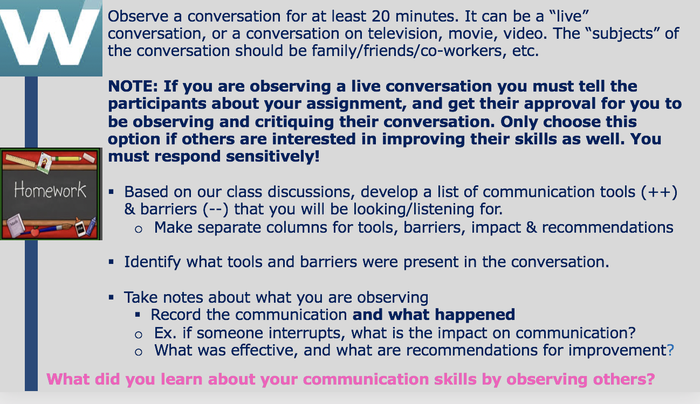
_______________________________________________________________________________________________________________________________________________________________________________________________________________________________________________________________________________________________________________________________________________________________________________________
_______________________________________________________________________________________________________________________________________________________________________________________________________________________________________________________________________________________________________________________________________________________________________________________
______________________________________________________________________________________________________________________________________________________________________________________________________________________________________________________________________________________________________________________________________________________________________________________________________________________________________________________________________________________________________________________________________________________________________________________________________________________________________________________________________________________________________________________________________________________________________________
_______________________________________________________________________________________________________________________________________________________________________________________________________________________________________________________________________________________________________________________________________________________________________________________
___________________________________________________________________________________________________________________________________________________________________________________________________________________________________________________________________________________________________________________________________________________________________________________________________________________________________________________________________________________________________________________________________________________________________________________________________________________________________________________________________________________________________________________________________________________________________________________________________________________________________________________________________________________________________________________________________________________________________________________________________________________________________________________________________________________________________________________________________________________________________________________________________________________________________________________________________________________________________________________________

Homework: Lessons Learned - Effective Interpersonal Communication

_______________________________________________________________________________________________________________________________________________________________________________________________________________________________________________________________________________________________________________________________________________________________________________________
_______________________________________________________________________________________________________________________________________________________________________________________________________________________________________________________________________________________________________________________________________________________________________________________
_______________________________________________________________________________________________________________________________________________________________________________________________________________________________________________________________________________________________________________________________________________________________________________________
_______________________________________________________________________________________________________________________________________________________________________________________________________________________________________________________________________________________________________________________________________________________________________________________
_______________________________________________________________________________________________________________________________________________________________________________________________________________________________________________________________________________________________________________________________________________________________________________________
_______________________________________________________________________________________________________________________________________________________________________________________________________________________________________________________________________________________________________________________________________________________________________________________
_______________________________________________________________________________________________________________________________________________________________________________________________________________________________________________________________________________________________________________________________________________________________________________________
__________________________________________________________________________________________________________________________________________________________________________________________________________________________________________________________________________________________________________________________________________________________________________________________________________________________________________________________________

Individual Student “TED” Talks

Each student is going to prepare and give their own personal “TED” Talk. Here are the particulars:

- 5-6 minute talk with about 2 minutes for questions from the audience
- The talk must be built around an idea or story. Any idea or story you want to share, but it must be something important to you, and hopefully to the audience (other students) as well
- Up to five PPT slides can be used, but they should be for a backdrop only, not to talk from
- Review several TED Talks to get a feeling for them. However, each individual has their own idea and style, you are not trying to copy anyone, just trying to get a sense of what a TED talk is all about.
- Don't forget… Practice, practice, practice

